My visit to Jells Park
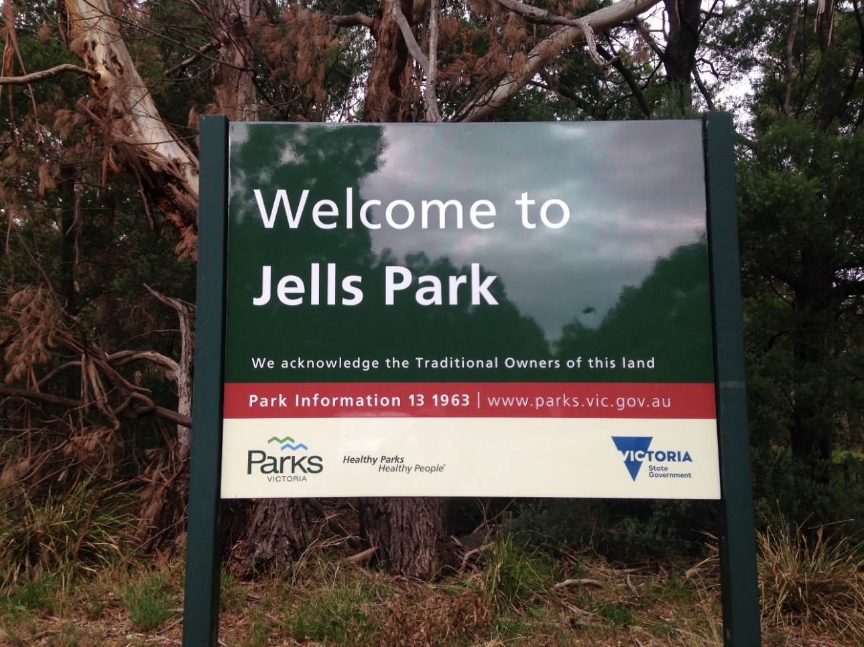

When I arrive at the park, we will park in the carpark. I need to stay close to my adult to stay safe.
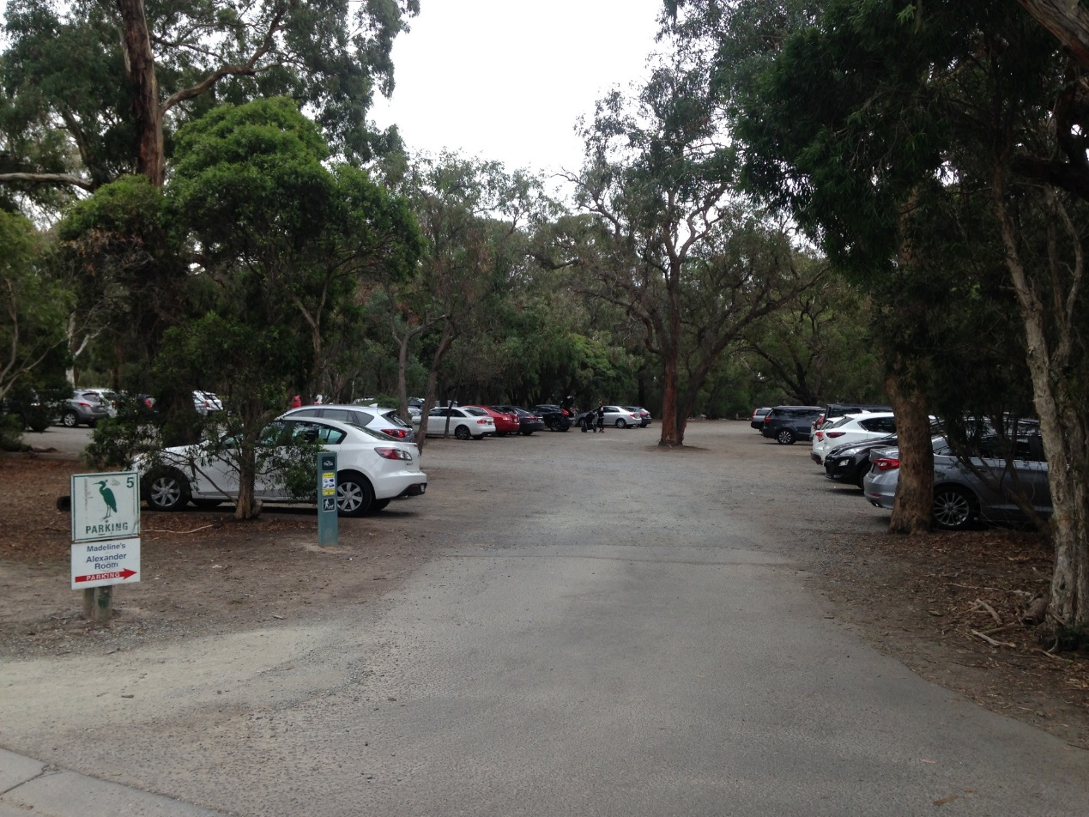

I must stay with my adult when crossing the road.

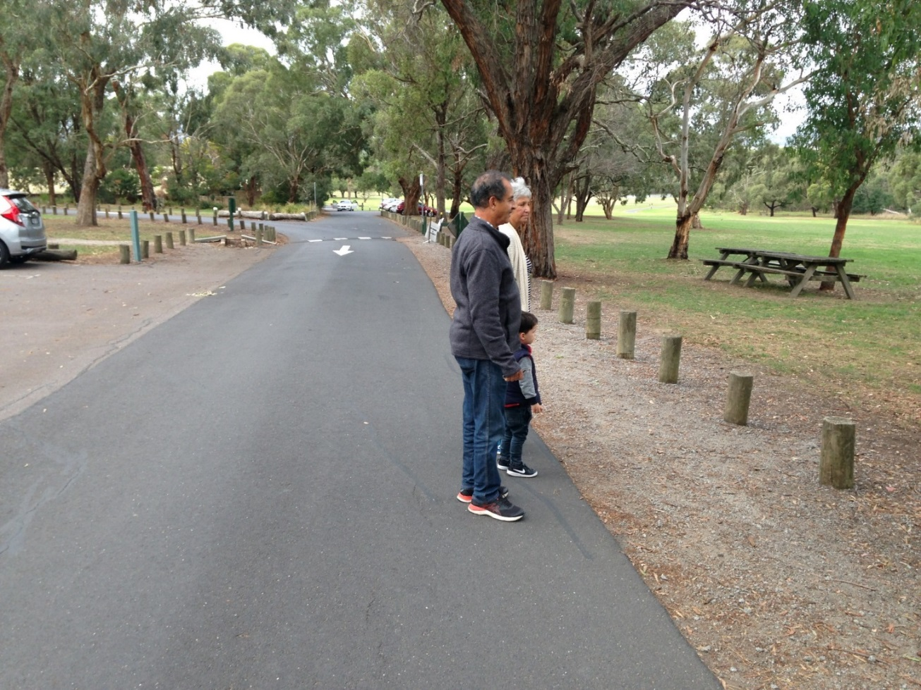

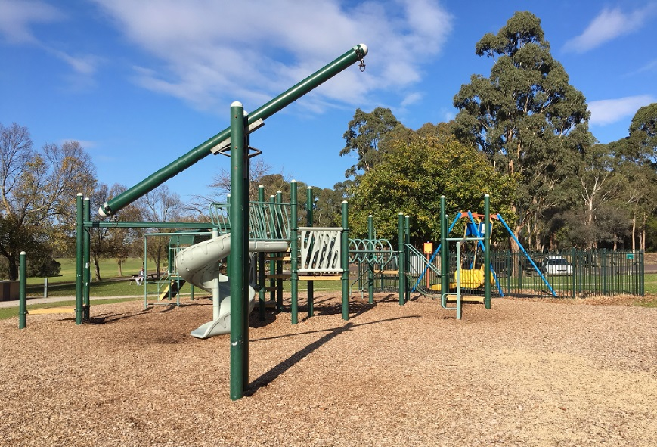
I can play in the playgrounds. There are 3 playgrounds to choose from.

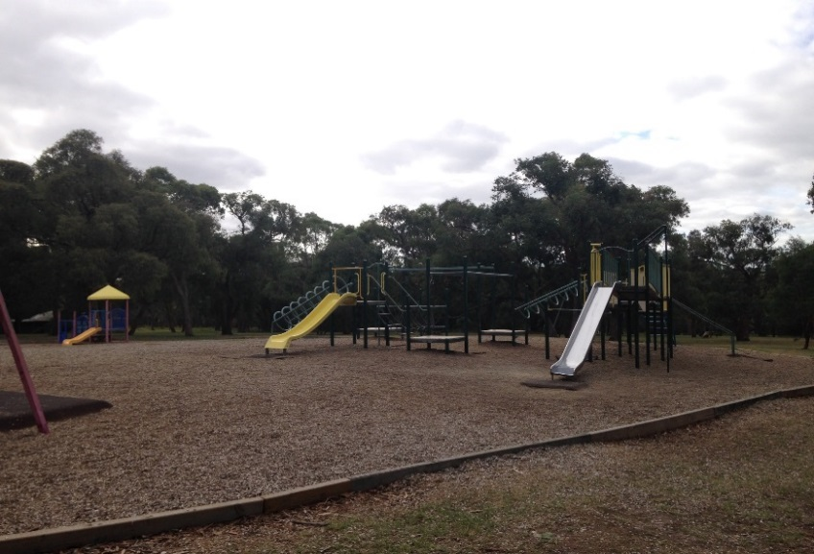
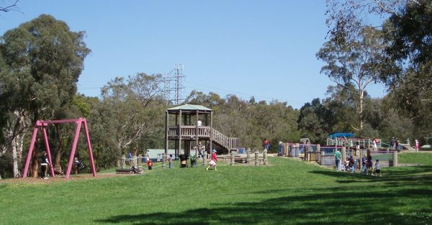

I can ride my bike or scooter on the path. I will share this path with other people.
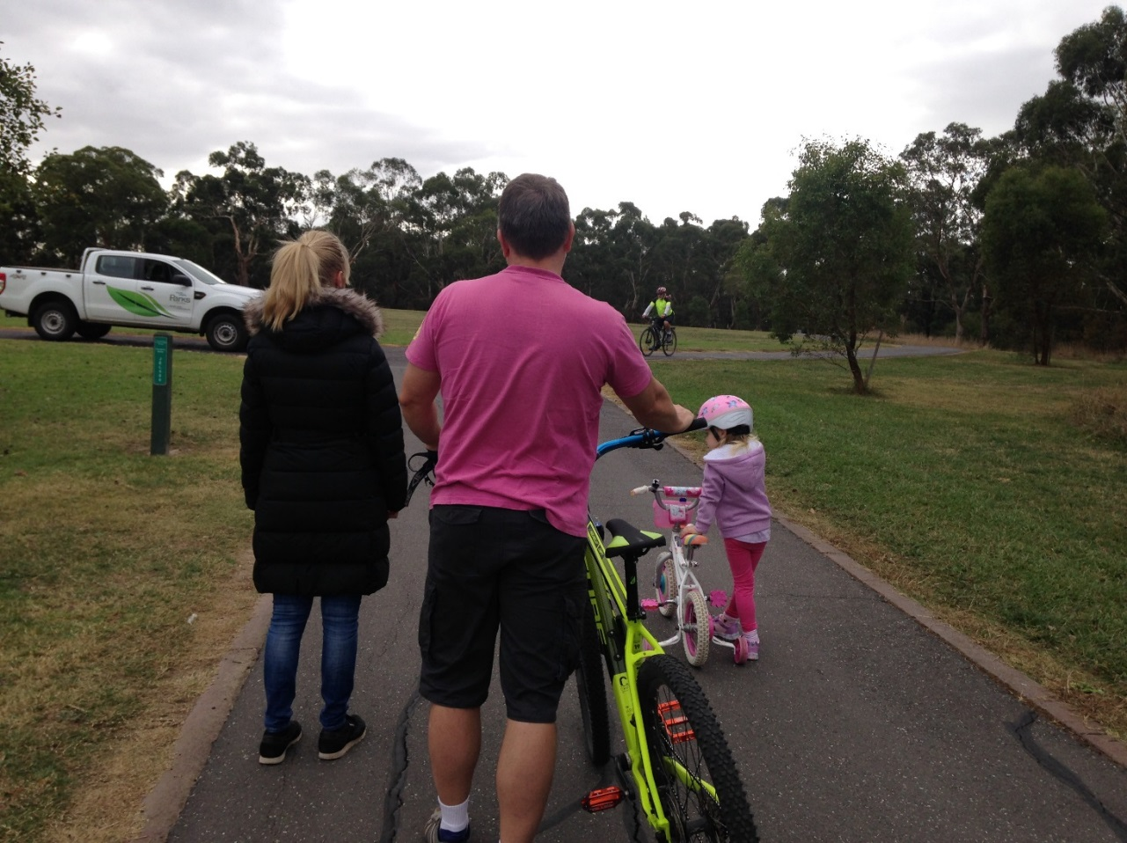

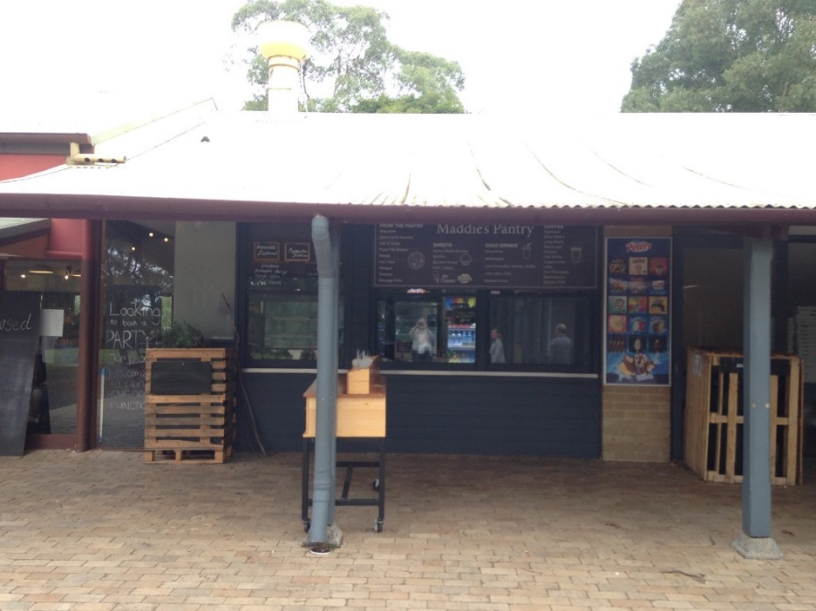
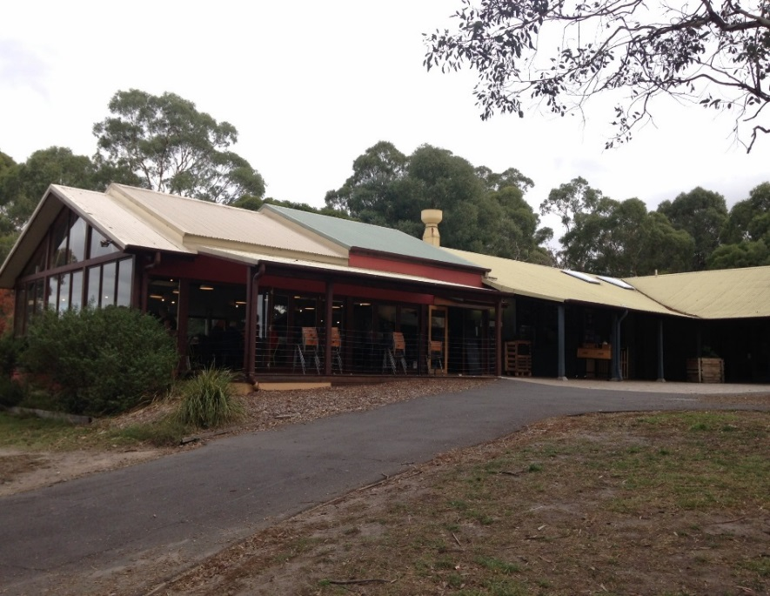
There is a café and restaurant at Jells Park. I can buy a snack or drink.

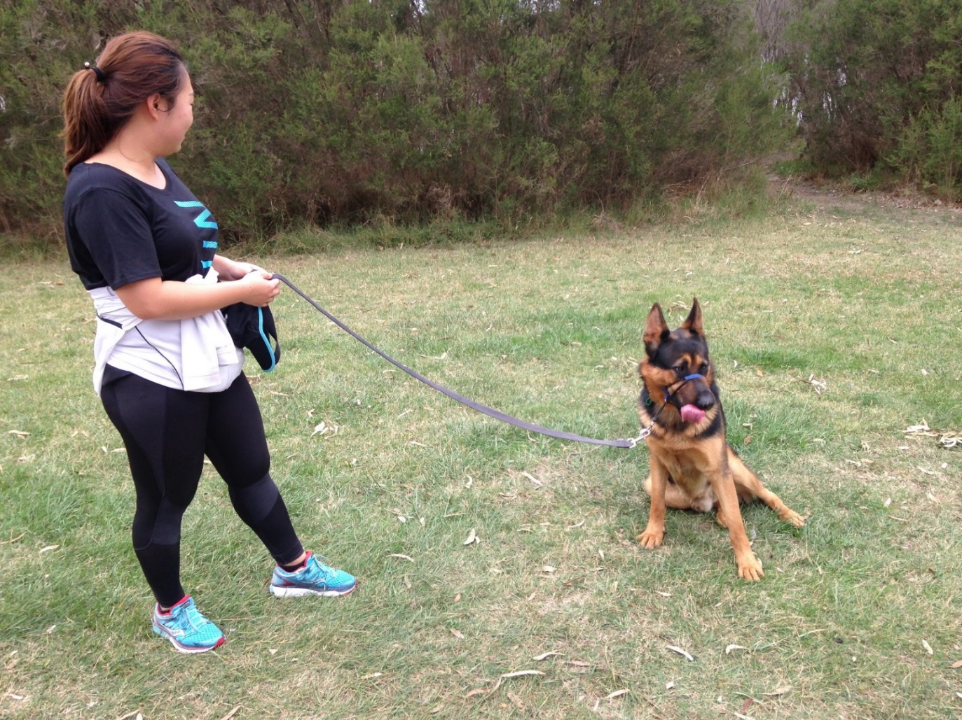
I can walk the dog. I may meet dogs at the park. I will ask the owner first before patting their dog.

I can go for a walk. I will stay with my adult at all times.
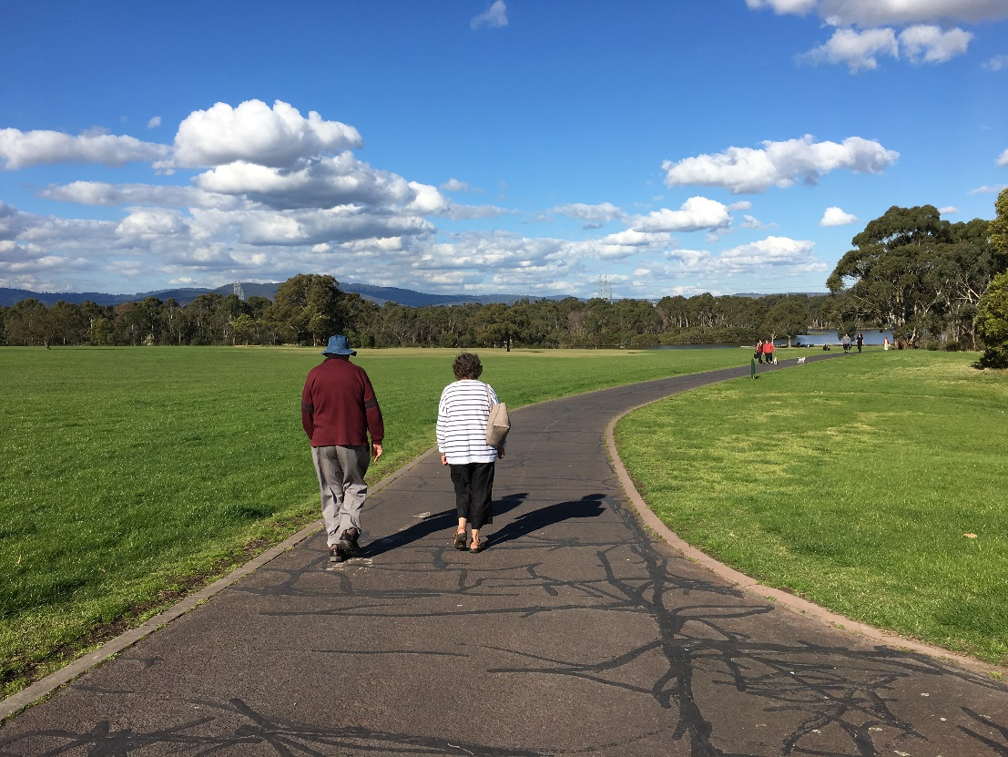

I can visit the lake. I can walk on the jetty and the beach. I must stay with my adult to be safe. This lake is for birds and fish to live in.
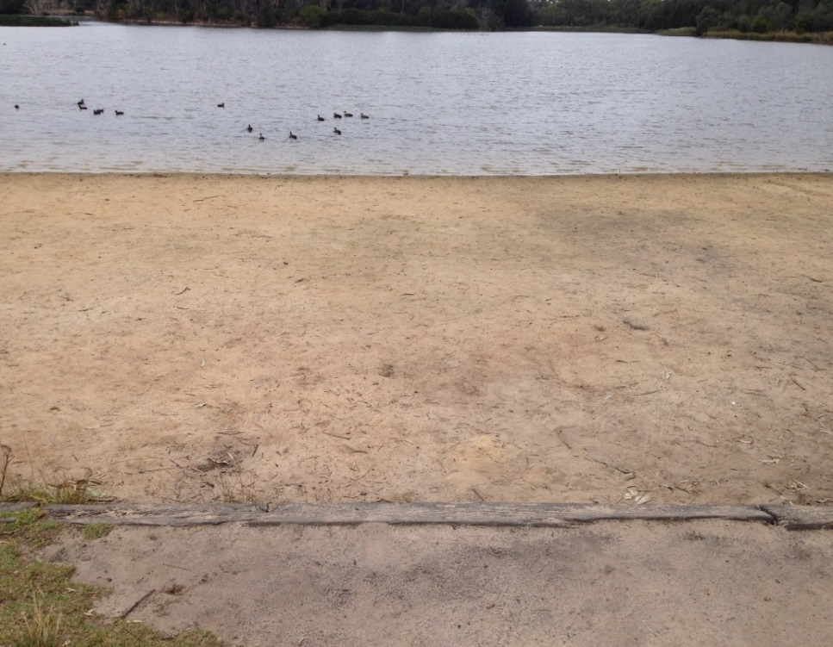
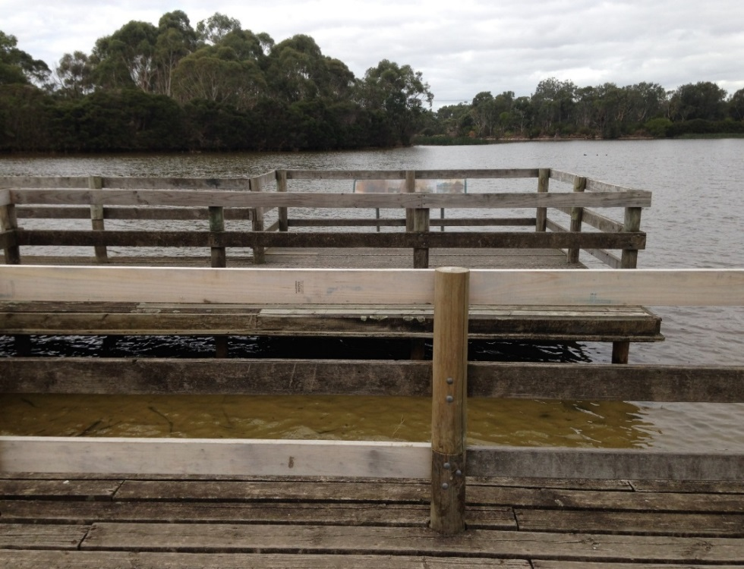

I need to follow the rules at Jells Park. I will keep my food with me. This keeps the birds safe and happy.
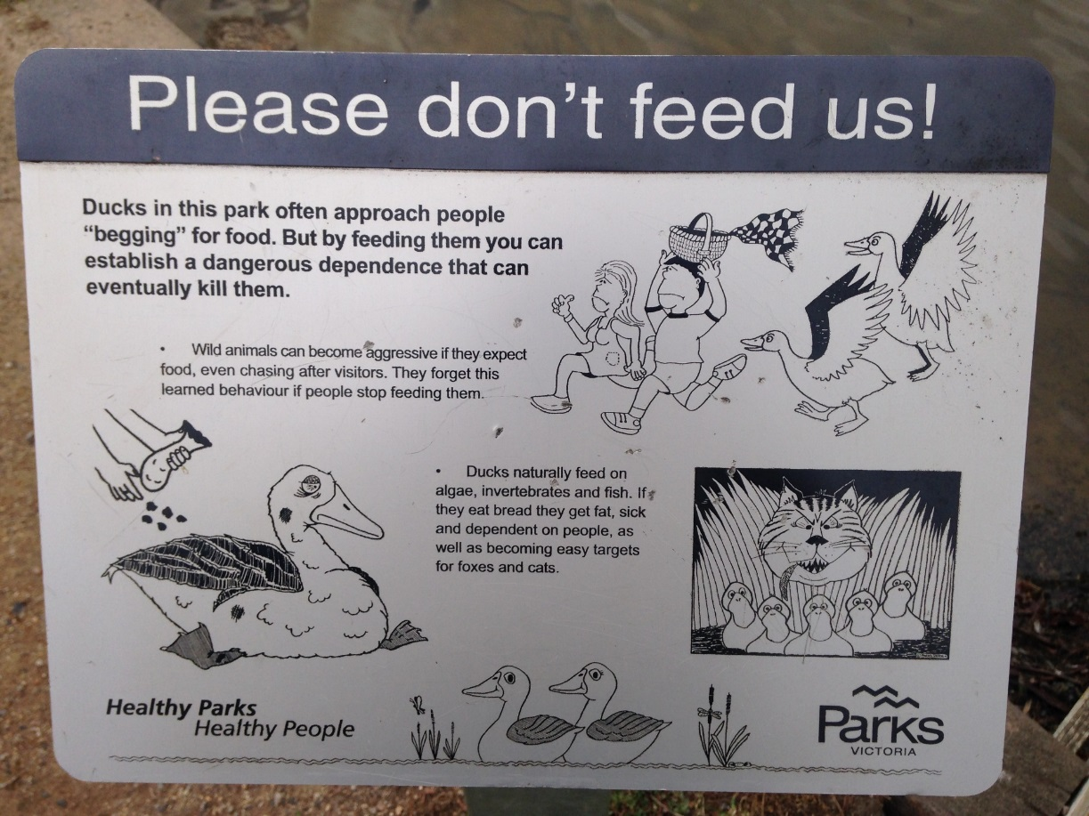
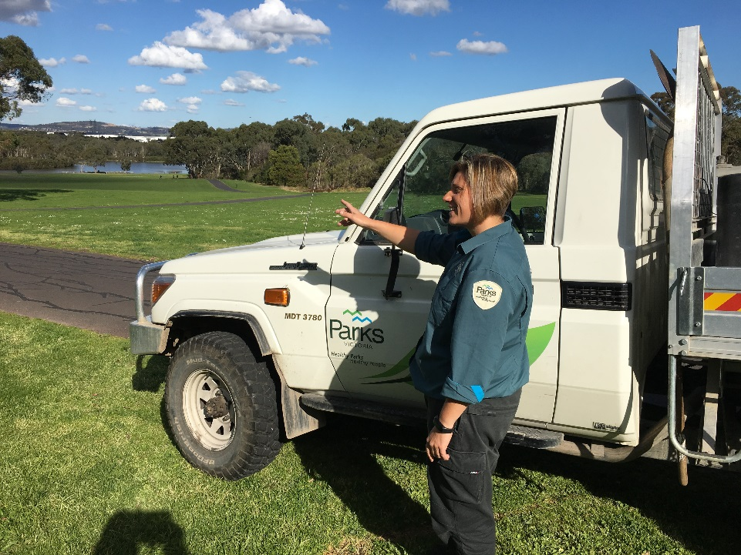
There are people who work at Jells Park. They are called Park Rangers. They wear a uniform. I can ask questions about the park.

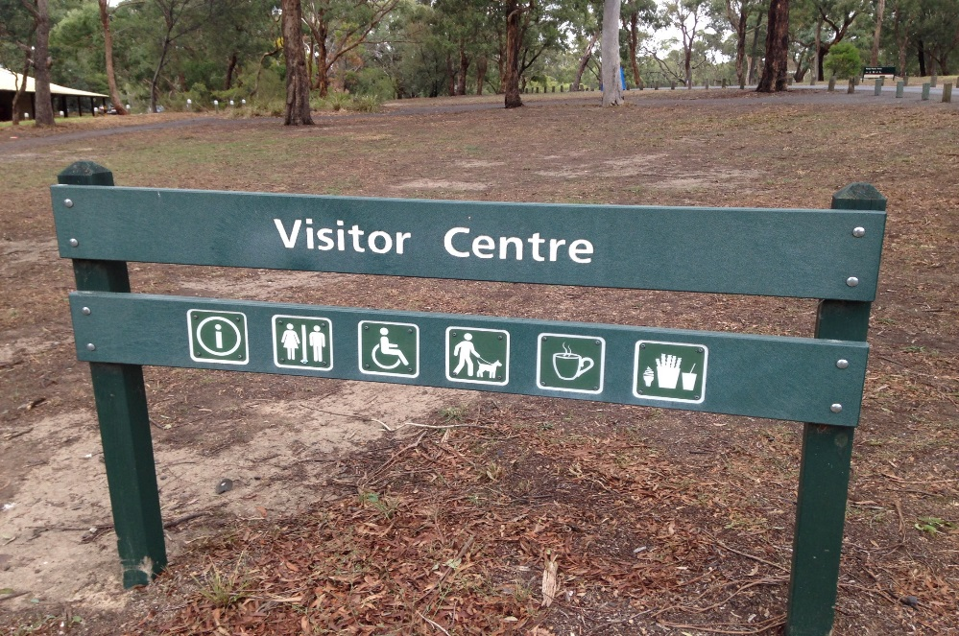
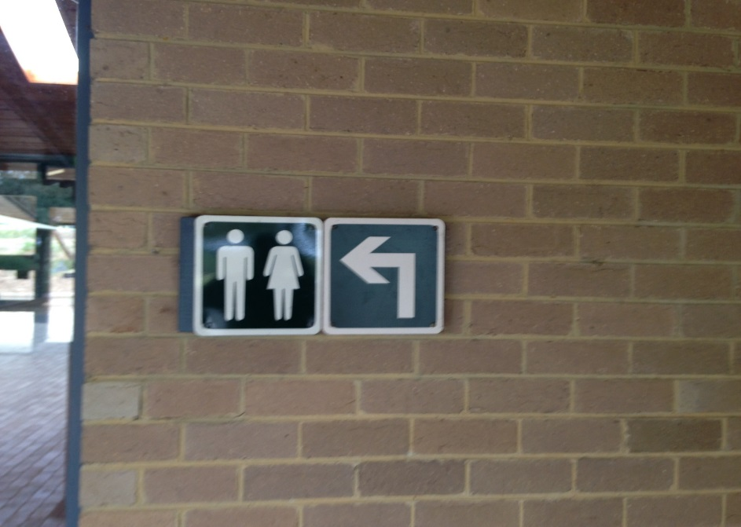
The signs will tell me where I need to go.

There are big power lines at the park. They may make a buzzing sound.
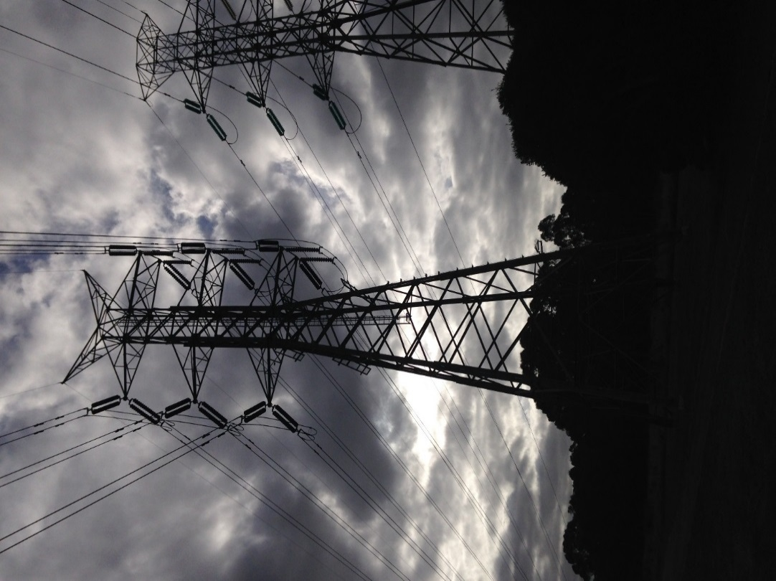

I had fun at Jells Park.
