**PROTECTION OF THE**

**ALPINE NATIONAL PARK**

Feral Horse Action Plan

November 2021

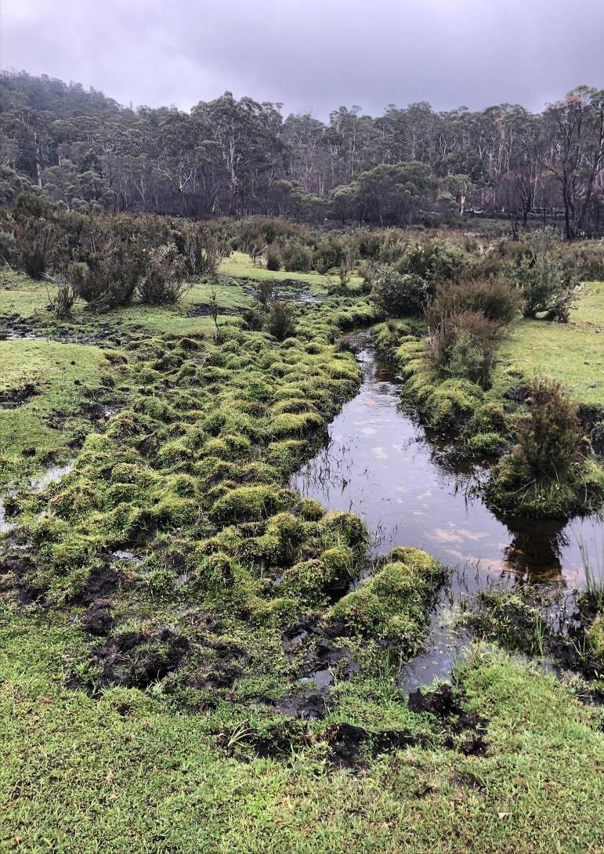

Authorised and published by Parks Victoria

Level 10, 535 Bourke Street, Melbourne VIC 3000

Copyright © 2021 Parks Victoria.

**For further information** Phone: 13 1963

**Copies** may be downloaded from the [Parks Victoria website www.parks.vic.gov.au](http://www.parks.vic.gov.au/)



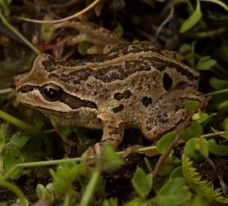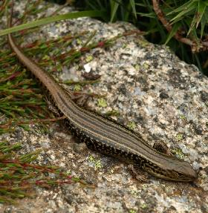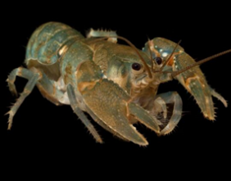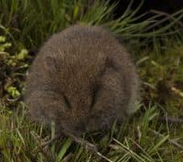

Protection of the Alpine National Park:

Feral Horse Action Plan

November 2021

**Disclaimer**

This plan is prepared without prejudice to any negotiated or litigated outcome of any native title determination applications covering land or waters within the plan’s area. It is acknowledged that any future outcomes of native title determination applications may necessitate amendment of this plan; and the implementation of this plan may require further notifications under the procedures in Division 3 of Part 2 of the *Native Title Act 1993* (Cwlth).

The plan is also prepared without prejudice to any future negotiated outcomes between the Government/s and Traditional Owner Communities. It is acknowledged that such negotiated outcomes may necessitate amendment of this plan.

Every effort has been made to ensure that the information in this plan is accurate. Parks Victoria does not guarantee that the publication is without flaw of any kind and therefore disclaims all liability for any error, loss or other consequence that may arise from you relying on any information in the publication.

**Iterations**

The first iteration of this plan was approved by Parks Victoria in June 2018, as *Protection of the Alpine National Park: Feral Horse Strategic Action Plan [2018-2021]*.

**This document may be cited as:**

Parks Victoria 2021. *Protection of the Alpine National Park: Feral Horse Action Plan 2021*. Parks Victoria: Melbourne, Australia.

**Photo credits**

Photos © Parks Victoria except as noted below where

copyright belongs to the credited photographer or institution.

Front cover:

Heavily pugged peatland alongside an eroding stream, with grassy vegetation mown down to ground level by feral horses, Forlorn Hope, Alpine National Park.

Alpine Water-skink, *Eulamprus kosciuskoi*, Graeme Worboys

Tooarrana (Broad-toothed Rat), *Mastacomys fuscus mordicus*, David Paul, Museums Victoria, Alpine Tree Frog, *Litoria verreauxii alpina*, David Paul, Museums Victoria, Alpine Spiny Crayfish, *Euastacus crassus*, David Paul, Museums Victoria

Page 4: Mount Nelse, Henrik Wahren; Page 7: Alpine Water-skink, *Eulamprus kosciuskoi,* Bodowski, ([creative commons license CC BY-NC 4.0](https://creativecommons.org/licenses/by-nc/4.0/)); Alpine Tree Frog, *Litoria verreauxii alpina,* David Paul, Museums Victoria; Page 8: Tooarrana (Broad-toothed Rat), *Mastacomys fuscus mordicus*, David Paul, Museums Victoria; Alpine Water-skink, *Eulamprus kosciuskoi*, David Paul, Museums Victoria; Alpine Bog Skink, *Pseudemoia cryodroma*, (a) Luis Mata, ([creative commons license CC BY-NC 4.0](https://creativecommons.org/licenses/by-nc/4.0/)); Alpine Bog Skink, *Pseudemoia cryodroma,* (b)Owen Lishmund, ([creative commons license CC BY-NC 4.0](https://creativecommons.org/licenses/by-nc/4.0/)); Alpine Spiny Crayfish, *Euastacus crassus*, David Paul, Museums Victoria; Guthega Skink, *Liopholis guthega*, DH Fischer, ([creative commons license CC BY-NC 4.0](https://creativecommons.org/licenses/by-nc/4.0/));

Back cover:

Native Cat Flat, Alpine National Park in March 2021 - showing the effects of overgrazing and trampling by feral horses, with grassy vegetation grazed down to the ground surface, streambank vegetation completely removed, trampling evident along the complete length of the stream, and the only remaining habitat for wetland-dependent fauna occurring within the fenced exclosures.

# Executive summary

Feral horses are causing serious long-term damage to alpine, subalpine, montane and floodplain environments. The population of feral horses in these environments is rapidly increasing and urgent action is required to halt the dramatic escalation in the feral horse population and rate of ecosystem decline.

This damage includes the destruction of habitat critical to many threatened plant and animal species, damage to waterways, degradation of fragile vegetation, and soil disturbance that results in erosion or compaction. To prevent further impacts and enable impacted areas to recover, and meet obligations under the *National Parks Act 1975* (Vic.), *Flora and Fauna Guarantee Act 1988* (Vic.) (the FFG Act), and the *Environment Protection and Biodiversity Conservation Act 1999* (Cwlth) (the EPBC Act) horse populations need to be reduced significantly, with some populations removed entirely. This plan outlines Parks Victoria’s approach to this urgent issue and describes progress over the last three years.

Feral horse management is a part of an integrated approach to reducing the impacts of a range of introduced animals in the Alpine National Park including deer, pigs and other non-native species. The goals of feral horse management are to reduce the severe impacts of horses on threatened alpine vegetation communities and fauna habitats, particularly to riverine wetlands, alpine peatlands and streambanks; protect Aboriginal cultural heritage; and conduct horse management humanely and safely.

Implementing the *Protection of the Alpine National Park: Feral Horse Action Plan 2021* will enable the achievement of the strategy set out in the *Greater Alpine National Parks Management Plan* *(2016)*, for the humane control of feral horses to reduce their impacts; including removing small, isolated populations and preventing spread into new areas using the most humane, safe and effective techniques, including lethal and non-lethal methods.

The *Feral Horse Action Plan 2021* builds on the results of the *Protection of the Alpine National Park – Feral Horse Strategic Action Plan 2018-21,* and focuses on how feral horses will be managed in the Alpine National Park, and adjacent State forests from 2021. The ongoing threats described in the original Action Plan, compounded by other events such as the 2019-2020 bushfire season necessitate stronger actions to achieve horse population reduction.

The Plan’s actions have been developed in response to the following findings: (i) a very low interest and uptake from the community in feral horse rehoming, despite repeated advertising and direct approaches by Parks Victoria calling for expressions of interest to take on rehomed horses; (ii) the 2019-20 bushfires having greatly impacted large areas of the Victorian Alps, resulting in significant loss of threatened native alpine wildlife and unique habitats and increasing their vulnerability to the impacts of feral horses; and, (iii) the 2019 Australian Alps aerial feral horse survey finding that horse numbers in the Victorian section of the Australian Alps had doubled in the five-year period from 2014 to 2019, from around 2300 to 5000 horses.

In the context of these changes, and to achieve the goals outlined above for humane feral horse control, Parks Victoria will:

* continue to trap feral horses for rehoming to the extent that suitable rehoming applicants can be found.
* implement the most humane, safe and effective horse control techniques, including using professional shooters, to remove feral horses ranging across areas of high conservation value.
* conduct all horse management operations according to strict standards for animal welfare and public safety.
* periodically repeat surveys of feral horse populations in the eastern Alps and in the Bogong-Cobungra area.
* monitor the condition of sensitive vegetation and habitats including alpine mossbeds, peatlands and streambanks.

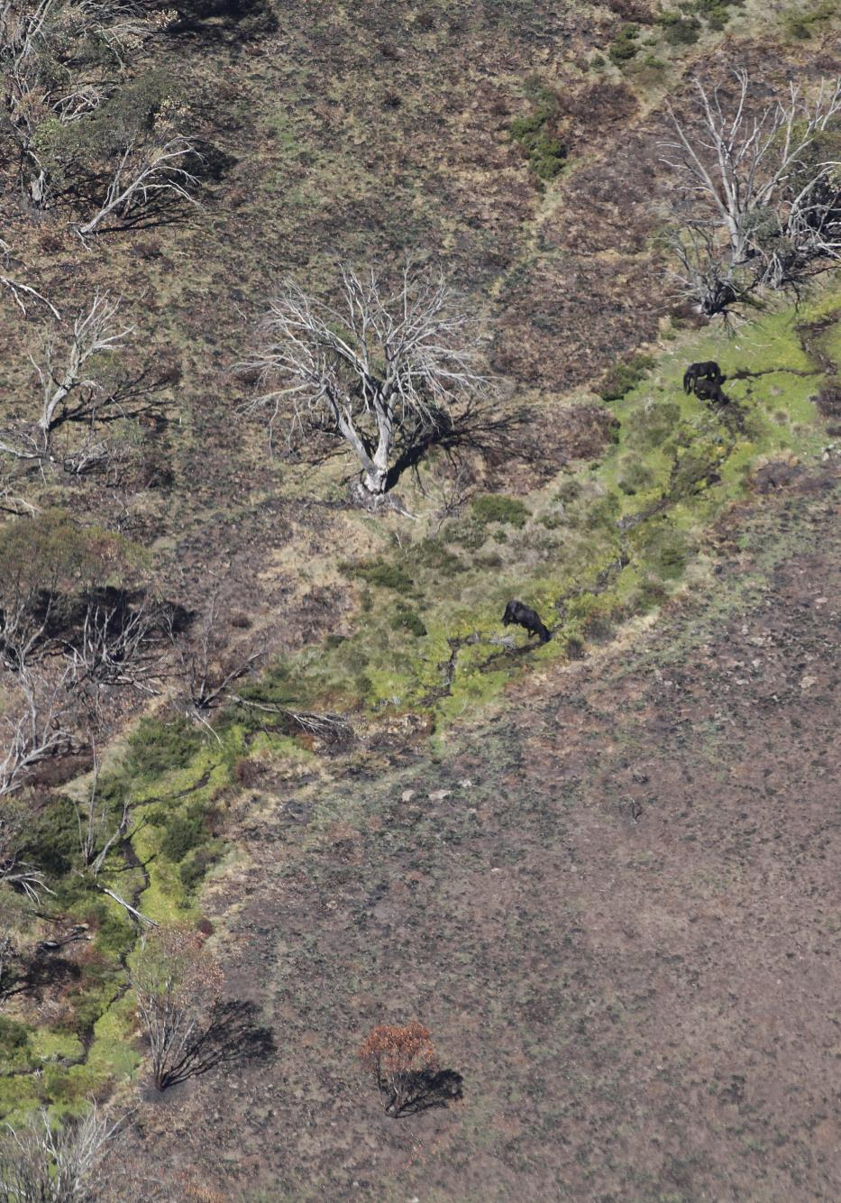

**Caption:** Feral horses grazing in an unburnt stream running through an area burnt during Black Summer bushfires, eastern Alps, Alpine National Park.

Contents

Executive summary v

1 Introduction 2

1.1 Plan purpose 3

1.2 Strategy 3

1.3 Objectives for conservation and humane feral horse control 3

2 Threats from feral horses 5

2.1 Traditional Owners 5

2.2 Ecosystems at risk 6

2.3 Species at risk 8

2.4 Catchments at risk 11

2.5 Geographic scope 12

3 Background to this plan 16

3.1 Legislative and planning context 16

3.2 Black Summer (2019 – 2020) Bushfires 18

3.3 Feral Horse Strategic Action Plan 2018-21 21

3.4 Control of deer and feral pigs 22

3.5 Preparation of this plan 23

4 Feral horse control methods 25

4.1 Humaneness of feral horse control methods 25

4.2 Capture and removal of live horses 26

4.3 Population reduction 29

4.4 Fenced exclusion 31

5 Management actions 33

5.1 Control of feral horses 33

5.2 Euthanasia 36

6 Monitoring, evaluation and review 38

6.1 Monitoring and evaluation 38

6.2 Review 39

7 References 43

Appendix 1 - Maps 49

Maps 1 & 2 – Locality maps – Bogong-Cobungra and Eastern Alps 49

Map 3 – Burn severity (across feral horse-occupied area) 49

Appendix 2 52

Threatened species and communities 53

Appendix 3 56

Biosecurity approach 56

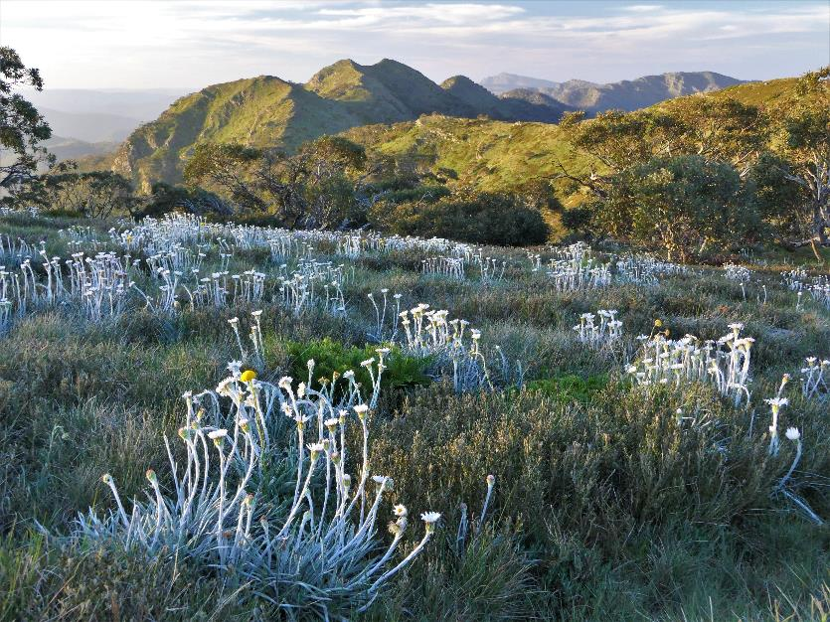

**Caption:** Native grasses, wildflowers and snowgum thriving on Mount Howitt, a horse-free section of the Alpine National Park.

# Introduction

The purpose of this plan is to improve the management of feral horses in the Alpine National Park, and reduce the damage they cause to vulnerable natural and cultural values, and water and catchment qualities of the Victorian Alps. The need for a revision of the 2018-21 Action Plan is also driven by recent increases in the size and distribution of feral horse populations, the impact on habitats from the Black Summer bushfires, and the limitations to date of management methods that have been used.

This plan addresses the intent of future management over the next 10 years, identifying the additional actions required to address these changes as well as to achieve the 15-year goals of feral horse management in the Victorian Alps described in the *Greater Alpine National Parks Management Plan (2016)*. These are to: reduce the severe damage caused by feral horses to threatened alpine vegetation communities and the native flora and fauna they support, particularly riverine wetlands, alpine peatlands and streambanks; protect Aboriginal cultural heritage; and, conduct feral horse management humanely and safely. During this plan’s 10-year timeframe, it may be necessary to adapt these actions. This will be done on the basis of the best scientific evidence and advice.

The overarching purpose, strategy, outcomes and actions are outlined in this section and further detail about the approach, background and control methods are described in subsequent sections.

## Plan purpose

The purpose of this plan is to:

* describe the desired conservation outcomes, and specify the management actions required to achieve them;
* summarise the damage caused by feral horses on the environment, and why they need to be humanely managed;
* describe the available methods for feral horse control and how they will be used to safely and humanely reduce feral horse populations and their impacts; and
* summarise the process for monitoring, evaluation and review on the implementation of feral horse control.

## Strategy

The strategy for humane feral horse control that the *Greater Alpine National Parks Management Plan (2016)* sets out is to:

* prevent new populations of feral horses establishing across the planning area;
* remove isolated populations of feral horses where eradication is feasible;
* contain and reduce feral horse numbers in core, larger populations in the Alpine National Park to prevent spread and minimise impacts on high-value vegetation communities and fauna habitats;
* consider all control options and use the most humane, safe and effective techniques, including lethal and non-lethal methods; and
* cooperate with the Department of Environment Land Water and Planning and NSW National Parks and Wildlife Service to remove populations from adjacent forest areas and Kosciuszko National Park.

## Objectives for conservation and humane feral horse control

To protect the environment from the impacts of feral horses, control programs will be focussed on achieving defined conservation and animal welfare outcomes. The long-term conservation outcomes and horse control objectives are specified below, as well as a summary of the indicators, measures and deliverables for humane feral horse control. These remain consistent with those specified in the 2018-21 Action Plan and are the basis for monitoring and evaluation (see *Section 6 – Monitoring, evaluation and review*).

### Outcomes:

Successful implementation of the plan will contribute to the following long-term outcomes:

* Regeneration or recovery of alpine peatlands and streambanks.
* Improved distributions and abundances of vulnerable or threatened native fauna and flora species.
* Protection of Aboriginal cultural sites and places.
* Horse management conducted safely and humanely.

### Measuring progress:

Progress in achieving the required levels of protection for natural values and animal welfare can be evaluated using the following **indicators**:

* A significant reduction in the established eastern Alps feral horse population, removal of isolated populations and prevention of new populations of feral horses becoming established.
* The most humane, safe and effective horse control methods available will be used.

The effectiveness of control programs can be assessed using the following **measures:**

* Reduction in pugging and streambank collapse caused by feral horses.
* Reduction in grazing damage on significant, regenerating or restored vegetation.
* Minimise adverse impacts on horse welfare in the design and application of the selected horse control methods.

### Deliverables:

The following **outputs** will be delivered to contribute to achieving the identified outcomes:

* Removal of all feral horses from the Bogong High Plains.
* Significant reduction in the eastern Alps population through annual removals, particularly in areas of high conservation value.
* Populations prevented from spreading (contained), through surveillance and targeted removals of new mobs.
* Maximise animal welfare outcomes through clear standard operating procedures and monitoring of on ground activities.
* Meet community demand in providing captured horses to rehoming locations that comply with suitable standards for animal welfare.

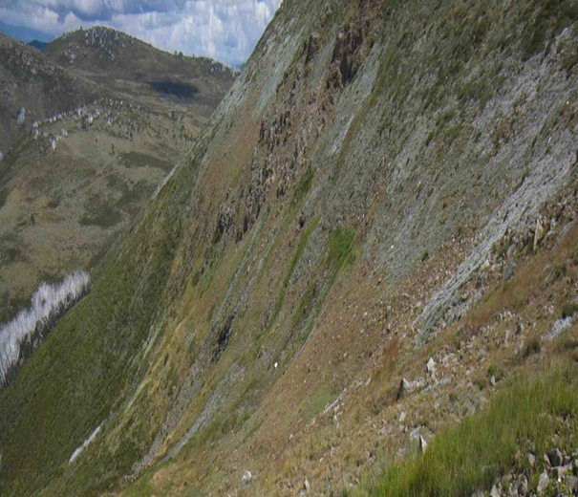

**Caption:** Late snow patch areas and site of the Small Star-plantain (*Plantago glacialis*)*,* Mount Nelse, Bogong High Plains, Alpine National Park

# Threats from feral horses

Australia has an estimated 400,000 feral horses, the world’s largest wild population. In Victoria, feral horses are present in a widespread population occurring in the eastern Alps extending into the northwest section of the Snowy River. A separate smaller population occurs on the Bogong High Plains with a population of unknown size in the adjacent Cobungra Crown land to the south-east of the Bogong High Plains. These populations, while situated predominantly within the Alpine National Park, extend into adjacent parks, State forests, reserves and private land.

As large animals with big, hard hooves, feral horses cause immense ecological damage, particularly in the fragile high country of the Australian Alps. The impacts of feral horses on environmental values are described in some detail in Sections 6 and 8 of the *Protection of the Alpine National Park – Feral Horse Strategic Action Plan 2018-21* and by the Australian Academy of Science (Worboys et al. 2018). These impacts, and risks to Aboriginal cultural heritage values, are summarised below.

## Traditional Owners

Aboriginal people have lived in the high country of Victoria for tens of thousands of years. Physical evidence of occupation along with stories, language and memories continue to link Aboriginal people to the alpine parks and lands. The Bidawal, Dhudhuroa, Gunaikurnai, Jaithmathang, Taungurong and Nindi-Ngudjam Ngarigu Monero are the First Peoples of the mountains and the rivers of the Alpine National Park, and through their cultural traditions, they still identify it as their Traditional Country.

### Aboriginal cultural heritage values

Areas occupied by horses can be rich in Aboriginal cultural values. Aboriginal cultural values may be both tangible (visible) and intangible (lore) and are a significant part of the Greater Alpine parks. Over 600 places and associated objects are recorded from the Victorian Alps in Aboriginal Victoria’s site registry. Following the 2003 Great Alpine Fire, large areas of bush that had previously proven difficult to penetrate for Aboriginal cultural heritage surveys became accessible and an extensive site survey of locations was commissioned. The archaeological work teams found extensive tangible evidence at 350 new sites spread across fourteen alpine areas (Freslov et al. 2004). These sites exist as part of the landscape and are managed in their original place. As most of these sites are not publicised, protection from human intrusion comes from the confidentiality of the locations. The alpine high plains and river flats within the planning area are very important to Traditional Owners. Feral horses pose an ongoing risk to those landforms and more broadly to the health of Country.

## Ecosystems at risk

### The unique ecosystems of the Victorian Alps

Across Australia, alpine ecosystems are rare and unique, making up only 0.03% of the entire country. The Victorian Alps are therefore exceptionally important for conservation and biodiversity and have a wealth of high-value components, such as rare and endangered fauna and flora, and essential ecosystem services that provide water to downstream waterways and significant stores of soil carbon.

Many of the vegetation communities in the Victorian Alps are endemic, rare or endangered. Alpine Sphagnum Bogs and Associated Fens are listed as a threatened ecological community under the EPBC Act, and threatened communities listed under the FFG Act include the Alpine Bog Community, the Fen (Bog Pool) Community, the Alpine Snowpatch Community and the *Caltha introloba* Herbland Community. Many individual species are listed under the FFG Act, including the critically endangered Mountain Burr-daisy.

Alpine mossbeds and peatlands are an endangered and specialised community occurring mostly on the high plains, occupying permanently wet sites along drainage lines and valley floors or surrounding seepage areas on hillsides. Most of the alpine mossbeds in the Victorian Alps occur in the Alpine National Park, and are scattered across the park. The greatest concentration is found on the Bogong High Plains, however, other significant examples are found in association with high elevation streams and wetlands across the eastern and southern Alps. They generally cover about 1 to 10 hectares but are widely scattered. Peat, which comprises decomposed plant matter, develops very slowly under the sphagnum moss, with deep beds of peat commonly dated at 3-4000 years old.

Alpine vegetation is often fragile and sensitive to disturbance. The Greater Alpine National Parks Management Plan (2016) defines five broad ecosystems for the planning area, with feral horse populations considered a high priority threat to four of these ecosystems: grasslands, snow-gum woodlands, heathlands, and peatland communities. Specifically, tussock grasslands, herblands, peatlands and sphagnum bogs hold together soils that are high in organic matter and crucial to hold moisture throughout the year. In particular, sphagnum mosses hold many times their weight in water, which is then released slowly throughout the year, providing a constant flow through the dryer months. Alpine mossbeds further provide filtration for water that feeds the tiny mountain streams in the headwaters of the Murray River. Undisturbed, these damp areas are naturally fire resistant because of their extremely high moisture content, and also provide fragile habitats for a wide range of native wildlife species, including a number of endangered species.Damage to these mosses releases water in larger bursts and scours away soil, causing localised droughts in summer. Maintaining vegetation is critical to minimise erosion and retain water in alpine water catchments.

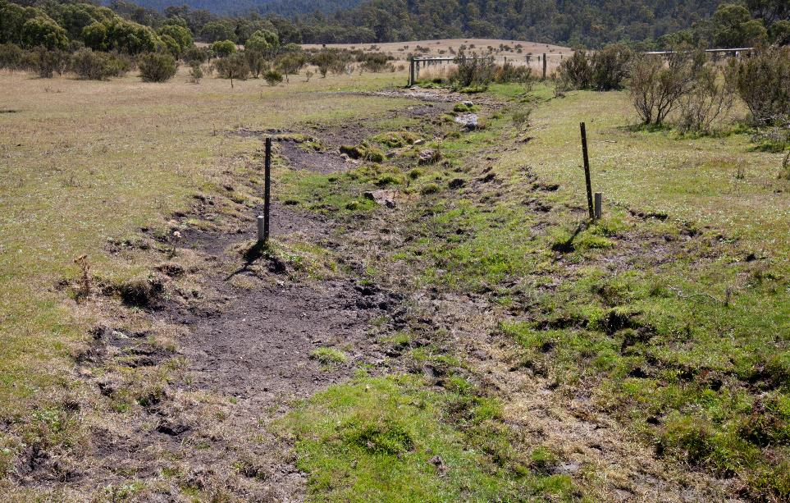

**Caption:** A small stream at the origin of the Murray River, eroded and denuded of vegetation by grazing and pugging by feral horses, Cowombat Flat, Alpine National Park.

### Damage from feral horses and other feral animals

Australia’s ecosystems have evolved over hundreds of thousands to millions of years in the absence of the heavy, hard-hooved animals (feral horses and deer) that have been introduced in the last two centuries. Such animals can cause significant damage to soils, vegetation communities, stream and river banks, and wetland zones (Dyring 1990, Clemann 2009, Walter 2003, Driscoll et al., 2019, Robertson et al. 2019). Damage to sensitive alpine ecosystems include selective grazing, trampling, pugging, degradation of waterways and water quality, removal of vegetation and exposure of bare ground, soil compaction, stream-bank slumping, opening tracks through vegetation, distribution of weeds and resultant loss of habitat for native wildlife. A combination of climate change effects, recreation activities, and other invasive species puts significant additional pressures on these natural, but now changing, landscapes (SAC 2011).

The physical impact of horses on the structure of alpine sphagnum mossbeds causes damage that cannot be repaired in the presence of horses. Even in the absence of horses, restoration and recovery of these habitats can take decades, due to slow rates of vegetation growth and organic matter accumulation (McDougall 2005).

Feral horse presence in these areas crushes the mosses, pugs the soil and channels the water. Pugging is the repeated incision of small deep pits in soft soil caused by hard hooves, exposing and compacting soil structure. Muddy depressions are created where moss and other vegetation cover is removed, and the hydrology of these areas is changed from a slow, soaking seepage, to a quick flow of water that erodes the soils. As a result, the mossbed is drained, and becomes dry and more fire-prone. Ultimately, horses cause the alpine mossbeds to become hard-packed soils that support neither the original plants nor the vegetation structure needed by resident threatened wildlife species. Direct grazing of vegetation and trampling damage also degrades habitats that are important for the survival of many threatened species and communities. Specific examples of the threatened species impacted by feral horses are illustrated on the next two pages.

The detailed evidence of the environmental damage of feral horses is well-documented. The impacts on a range of threatened species and communities led to the listing of “Degradation and loss of habitats caused by feral Horses (*Equus caballus*)” as a potentially threatening process under the *Victorian Flora and Fauna Guarantee Act 1988* (see *Appendix 2*).

## Species at risk

Animals that depend on the complexity and intactness of the unique alpine vegetation communities include amphibians, reptiles, invertebrates and mammals, some of which are entirely restricted to alpine environments and many of which are endangered. Small mammals such as the Tooarrana (also known as the Broad-toothed Rat) and the Smoky Mouse are listed in Victoria as vulnerable and endangered respectively, and some populations of Smoky Mouse in Victoria are believed to have been lost altogether, making their known alpine population more important than ever.

A number of reptile and amphibian species in the Victorian Alps are particularly vulnerable to disturbance, as they are highly specialised for alpine and subalpine environments and are entirely dependent on the health of the ecosystem to persist, particularly in winter. Many of these species rely on intact sphagnum mosses and grassy tussocks to nest, breed and overwinter. In the absence of healthy vegetation, these already restricted species experience a further reduction in available habitat. Species that are endangered in Victoria include the Alpine She-Oak Skink, the Alpine Water Skink, the Alpine Bog Skink, the Tussock Skink and the Glossy Grass Skink, of which most are also listed as endangered according to the IUCN Red List. The Guthega Skink, which is found only in the Bogong High Plains, is critically endangered in Victoria, as are both the Spotted Tree Frog and the Alpine Tree Frog.

Ongoing disturbance to alpine ecosystems compounds the effects of climate change, which can include periods of low or very high rainfall, drought, increased bushfire frequency and intensity, and rising temperatures. For species that are range restricted to cool, moist alpine environments, climate change reduces their available habitat, and further disturbance to the vegetation and habitat structure on which they depend will only hasten the rate of their decline.

At a conference co-convened by the Australian Academy of Science on 8 November 2018, leading Australian scientists presented scientific evidence clearly demonstrating that feral horses in alpine national parks have already caused widespread and, in some cases, irreparable damage to wetlands and streams (Worboys et al. 2018). Vegetation structure has been damaged, stream morphology degraded, alpine wetlands drained, populations of Tooarrana (Broad-toothed Rat) eliminated, and habitat for populations of native fish negatively impacted (ibid). This has followed the long interest and involvement of the Australian Academy of Science in the scientific significance and conservation protection of the Australian Alps, since the publication of a catchment condition report (AAS 1957), which called for the removal of all stock animals in catchments above 1350m.

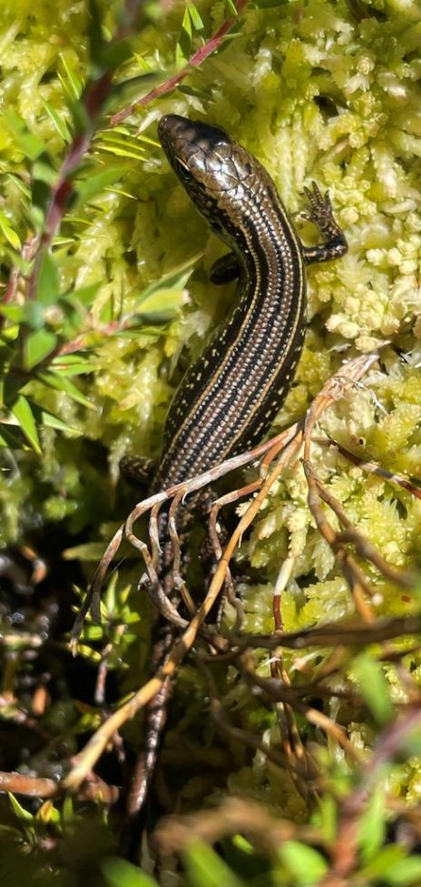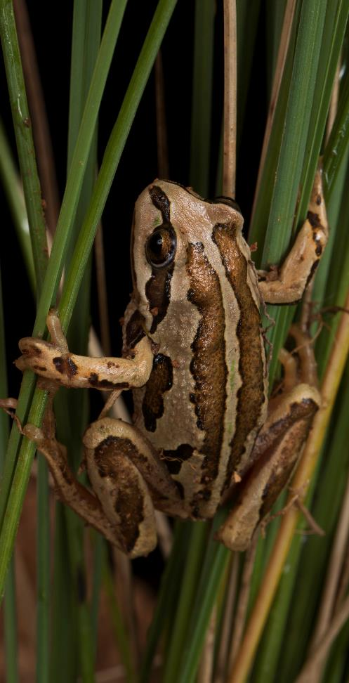

**Caption: Left:** The critically endangered Alpine Water Skink, *Eulamprus kosciuskoi*, is dependent on alpine sphagnum peatland, in and under which it creates its burrow systems to survive when winter snows cover the area. **Right:** The critically endangered Alpine Tree Frog, *Litoria verreauxii alpina*, relies on alpine sphagnum peatlands and ponds for feeding and reproduction. Trampling of these areas by heavy, sharp horse hooves creates a muddy morass unsuitable for feeding. The destruction of submerged vegetation on which the Alpine Tree Frog eggs are laid makes it impossible for the frogs to reproduce.

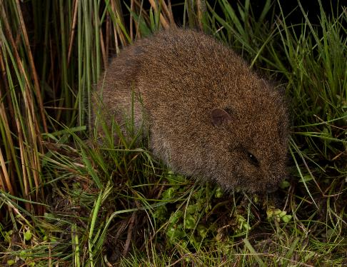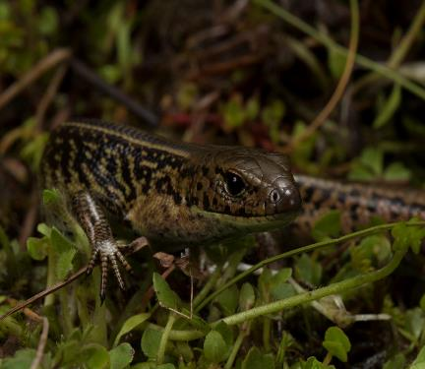

**Caption: Left:** Endangered Tooarrana, *Mastacomys fuscus*. **Right:** Critically endangered Alpine Water Skink, *Eulamprus kosciuskoi*.

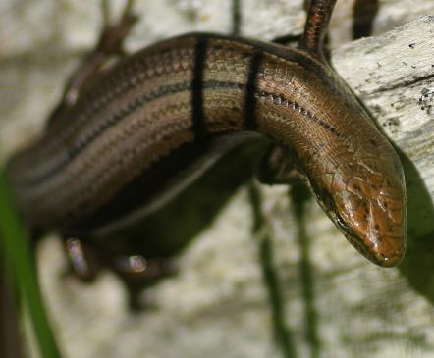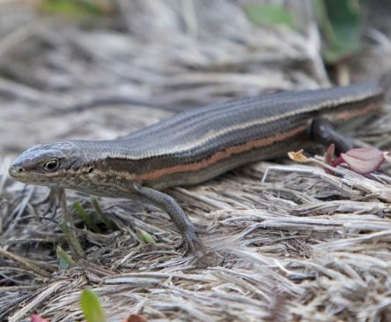

**Caption:** Two examples of the Endangered Alpine Bog Skink, *Pseudemoia cryodroma*.

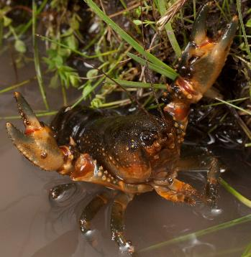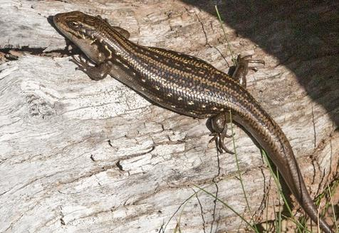

**Caption: Left:** Threatened Alpine Spiny Crayfish, *Euastacus crassus*, that live in streams in these areas cannot survive in muddy and channelised streams that become polluted with horse manure. **Right:** The critically endangered Guthega Skink, *Liopholis guthega*, makes its warrens in tussock and ground vegetation habitats in the Bogong High Plains. Such warrens are dependent on undisturbed soil structure and will be destroyed by the trampling of feral horses.

**Text accompanying images:** The grassy tussocks surrounding the delicate high-altitude waterways and wetlands are crucial habitat for small native mammals, such as the endangered Tooarrana, as well as reptiles, such as the endangered Alpine She-oak Skink, *Cyclodomorphus praealtus*, and the Alpine Bog Skink, providing shelter, protection and food.

In areas that are subject to snow cover, small species like the Tooarrana rely on the above ground vegetation structure to provide airspace in which to survive. Feral horses trampling and grazing on the grassy tussocks will result in the removal of the tussocks from the habitat. If grazing removes the tussock grass down to ground level, local populations of the Tooarrana will be at risk of extinction.

## Catchments at risk

The Australian Alps provides an annual average of 9600 gigalitres of high-quality water to the Murray-Darling Basin, contributing an ecosystem service of national economic, social and environmental importance. It was estimated in 2005 that the value of water flowing from the Victorian Alpine National Park’s catchments, when all social and production benefits were considered, was worth as much as $110 million annually (PV 2015).

In 2010, a catchment condition assessment of the Australian Alps was undertaken (Worboys & Good 2011). The assessment identified that the existing effects of climate change, as well as soil erosion, pest animals and weeds were degrading the natural condition of the catchments and thus water quality, water yield and water flow regimes. The 2010 catchment condition assessment found that without substantial management interventions to deal with these threats, the provision of high-quality water was likely to be compromised, with the Australian Alps catchments delivering water of poorer quality and often in large sudden flows rather than gradual releases.

Climate change projections predict that by mid-century, maximum temperatures in the Ovens-Murray region are expected to show a median increase of 2.4°C, with a median of 25% decrease in annual rainfall totals (under a high emissions scenario) (Clarke et al. 2019). A warmer climate is also expected to bring more heavy rainfall events. Under these conditions, the ability of natural vegetation cover and forest litter to hold soils in place, to allow water infiltration, and to provide stability to steep mountain slopes is critical.

Vegetation in a natural condition helps prevent rapid run-off, soil erosion and slope instability and assists in maintaining water quality through filtration. In the alpine area, damaged vegetation can lead to rapid incision, undercutting, tunnelling and headwater erosion of the alpine humus soils. The erosion caused by populations of feral horses, feral pigs, and deer occurring in the Alps catchments is thus of particular concern.

This concern has been validated by the most extensive study to assess the impacts of horses throughout public land in the Australian Alps, undertaken by Robertson et al. (2019). Their study demonstrated that feral horses are significantly degrading the condition of drainage lines across this range. Almost all sites assessed within the broad feral horse distribution showed evidence of horse presence, and all of the sites in poorest condition were occupied by horses. They found that on average, about 28 metres of the streambed in each 50-metre site they measured had a moderate to high sediment load in horse-present sites, compared to horse-free sites where banks were stable due to the presence of undisturbed fringing vegetation.

The study concluded the loss of stability, modification of stream banks and vegetation structure caused by feral horses not only have a direct negative impact on water quality, they also have significant negative impacts on the conservation of fauna dependant on these habitats.

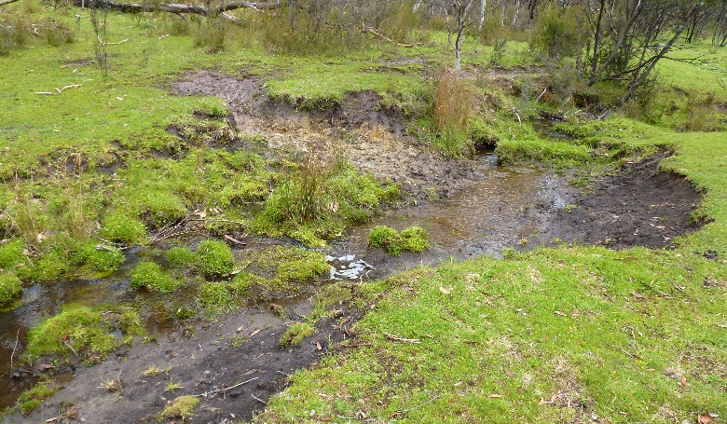

**Caption:** Streambank collapse, with damaged fringing vegetation and high sediment load reducing water quality, source of the Murray River, in the Alpine and Kosciuszko national parks.

## Geographic scope

### Bogong–Cobungra area

The Bogong-Cobungra area includes the Bogong High Plains (including Mount Nelse) in the Alpine National Park, and State forest to the south and south east of the Bogong High Plains in the Cobungra and Victoria river valleys (see *Appendix 1, Map 1)*. Feral horse populations are continuous across the different public land tenures of this area.

The Bogong High Plains contains a large proportion, 28%, of the high-altitude wetlands ecological vegetation division occurring across the Victorian Alps. This comprises some of Victoria’s most endangered ecological vegetation classes, as well as comprising the FFG-listed Alpine Bog Community and Fen (Bog Pool) Community and the EPBC-listed Alpine Bogs and Associated Fens.

Mount Nelse is a high point on the northern side of the Bogong High Plains, and contains Alpine snow patch herbfields, a threatened ecosystem in the International Union for Conservation of Nature (IUCN) Red List of Ecosystems (IUCN-CEM 2016; Williams et al 2015). Alpine snow patch herbfields are very important as refugia for dwarf alpine plant species in the face of climate change. Feral horses have been expanding their range on the Bogong High Plains, with a population establishing in the Mount Nelse area since 2016. As an implementation priority of the 2018-21 Action Plan for protecting snow patch and also to prevent further spread, this population has now been removed.

An aerial double-count survey undertaken by Parks Victoria in May 2018 estimated that 109 feral horses were present in the southern Bogong High Plains. Another feral horse population survey of the Bogong High Plains was conducted in June 2021, and the report to be publicly released (see *Section 6*).

Since the 2018 survey, given limited levels of removal and ongoing horse population growth, it is likely that the population has increased. Even low densities of horses can cause substantial damage in a short time, as demonstrated by the substantial damage caused by feral horses during their presence in the Mount Nelse area (Tolsma and Shannon 2018). To prevent this damage to high-altitude wetlands and snow patch herbfields across the Bogong High Plains, it is essential that feral horses are completely removed from this area.

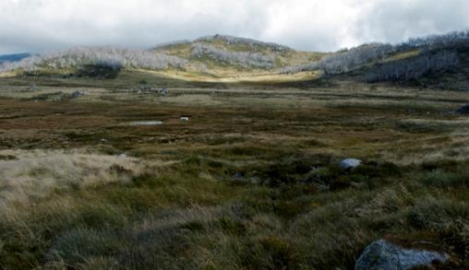

**Caption:** Bogong High Plains, Alpine National Park.

The complete removal of feral horses from the Bogong High Plains eliminates future horse-related damage to the environment and limits any welfare impacts from managing feral horses to the number removed over a short time frame, rather than treating animals in perpetuity. Removing the whole population is highly feasible due to the low numbers.

However, since the feral horse populations are continuous across the Bogong-Cobungra area, adjacent populations in State forest in the Cobungra area bounding the Alpine National Park are likely to reinvade the Bogong High Plains without ongoing control. It is likely this will require coordinated action across tenure. This would also protect the high-altitude wetlands that occur in State forests, some of which are subject to restoration efforts, as well as FFG-listed species and communities that have been protected with exclusion fencing.

Ultimately, complete removal of feral horses from across the Bogong-Cobungra area would achieve permanent protection of environmental values across this area.

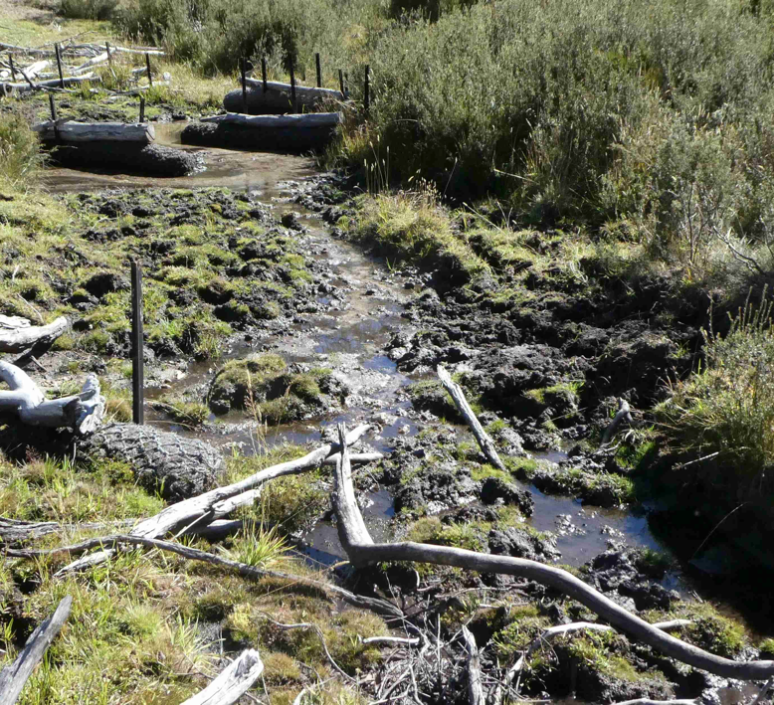

**Caption:** Restoration efforts to mitigate waterway and streamside vegetation damage caused by feral horses, Cobungra State Forest.

### Eastern Alps

The horse-occupied area of the eastern Victorian Alps extends from Tom Groggin in the north, to the Nunniong Plains in the south, and to the eastern extremity of the Alpine National Park with occasional observations as far as the Deddick Valley (see *Appendix 1, Map 2)*. Feral horses occur across the Alpine National Park and adjoining State forests.

Horses favour wetlands and streams at certain times of the year because of the availability of the ‘green pick’ vegetation or the accessibility of stream bank vegetation not covered by winter snow. In the wet areas of the eastern Alps, where there are many horses, pugging is a commonly observed impact. It creates incisions that are microhabitats for weed invasion, and accelerates drying out and erosion. In bogs, peatlands and floodplains, streambank slumping and vegetation loss leads to waterway degradation and streambank collapse as an eventual consequence of horse movements through these areas.

The muddied waters created from waterway erosion and the removal of filtering vegetation negatively impacts alpine and riverine aquatic species including the diverse invertebrates that a wide range of native fishes, frogs, reptiles and native spiny crayfish rely on for food.

To examine the magnitude and extent of feral horse damage to alpine streams and wetlands, a survey technique known as ‘Ephemeral Drainage Line Assessment’ (Tongway and Ludwig 2011) has been adapted by Robertson et al. (2019) to assess condition across treeless alpine drainage lines, both ephemeral and perennial, and inclusive of grasslands, bogs, fens, and other wetlands across the Australian Alps. Nine indicators (variables) were measured, all relating to soil and stream stability, and vegetation cover. The baseline condition of all variables related to soil and stream stability was significantly worse in horse-present sites than in horse-free sites.

A survey of feral horse abundance across the Australian Alps in 2019 found that over the period 2014 – 2019, the population occurring across the eastern Victorian Alps and the southern part of Kosciuszko National Park almost doubled, from 4316 to 8518 (Cairns 2019).

Damage to high-altitude wetlands and streams was already being documented in 2011-2013 when the fieldwork for the alpine drainage line assessment was being done, a few years before the feral horse population was estimated to be 4316, in 2014. Therefore, to reduce measures of active erosion and damage to streambanks and wetlands, the annual rate of feral horse removal in the eastern Alps needs to be significantly increased, to reduce the population to numbers below those recorded in the area prior to 2014. However, even under increased management, feral horses may persist in difficult terrain and remote areas of the Alpine National Park and adjacent Victorian State forests and NSW alpine areas.

To ensure horse removal is based on the best possible information and data, another feral horse population survey of the eastern Alps will be conducted in 2021 (see *Section 6*) to understand current population and further inform management.

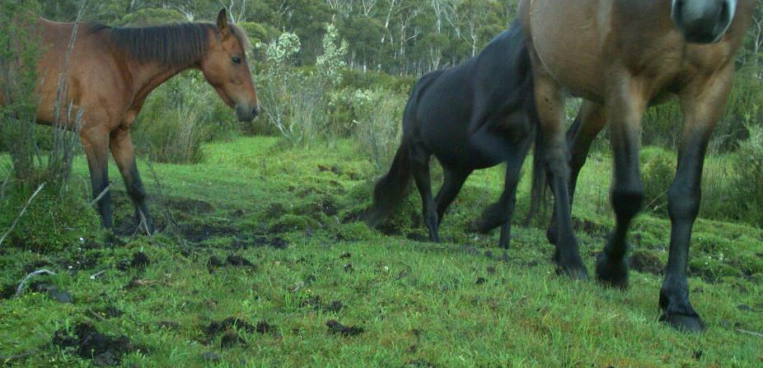

**Caption:** Feral horses trampling a peatland, damaging vegetation and soil structure, eastern Alps, Alpine National Park.

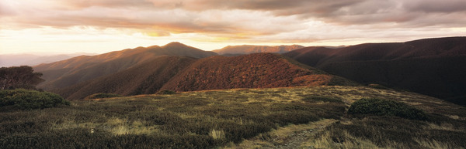

**Caption:** Mount Feathertop from the Razorback, Alpine National Park.

# Background to this plan

## Legislative and planning context

Parks Victoria has obligations under Victorian and Commonwealth legislation in the management of feral horses in the Alpine National Park. Parks Victoria was established as a public authority on 3 July 1998 under Section 4 of the *Parks Victoria Act 1998* (Vic), which gives Parks Victoria direct responsibility for the land it manages, as well as for preparing land management plans. Parks Victoria also has obligations under other statutes. Under the *National Parks Act 1975* (Vic) (s 17(2)(a)), Parks Victoria has the control and management of each National park and State park, and must ensure that each such park is controlled and managed in a manner that will (among other things):

1. preserve and protect the park in its natural condition for the use, enjoyment and education of the public;
2. preserve and protect indigenous flora and fauna in the park; and
3. exterminate or control exotic fauna in the park.

The Alpine National Park is reserved under Schedule 2 of the *National Parks Act 1975* (Vic.). Section 17(2)(d) of the National Parks Act also requires Parks Victoria to prepare a plan of management in respect of each National park and State park. To meet this obligation for the Alpine National Park, and other national parks in the planning area, Parks Victoria prepared the *Greater Alpine National Parks Management Plan* (the management plan), which was adopted in December 2016, having been tabled in the Victorian Parliament on 1 September 2016. Section 4.1.1 of the management plan sets out a strategy for humane feral horse control, to reduce their impacts, including removing small, isolated populations and preventing spread into new areas, as detailed at *Section 1.2*.

For Victoria’s 500,000-hectare Alpine National Park, the management plan is also the overarching land management plan. As is also the case for other large national parks, there are several single issue or thematic subsidiary strategies, action plans, policies and guiding documents that sit under this plan. For the Alpine National Park, this includes the *Protection of the Alpine National Park - Feral Horse Action Plan 2021.*

The control of feral horses, as directed by the management plan, is necessary because of the significant damage they cause to the alpine environment. These adverse impacts are recognised in the formal listing of ‘Degradation and loss of habitats caused by feral horses (*Equus caballus*)’ as a Threatening Process under the *Flora and Fauna Guarantee Act 1988* (Vic), and as a component of the listing of ‘Novel biota and their impact on biodiversity’ as a Key Threatening Processes under the *Environment Protection and Biodiversity Conservation Act 1999* (Cwlth).

Feral horses are exotic fauna, and damage the environment in two broad ways: via direct herbivory (consumption of native plants), in particular grazing impacts on threatened species and ecological communities; and through degradation of natural habitats, including fouling of waterholes, accelerating erosion and trampling and consuming native vegetation.

The management of feral horses is intended to protect threatened ecosystems, habitats and species, including those listed under the EPBC Act 1999 or the FFG Act (as well as others listed on the Victorian Advisory and IUCN lists).

The control of feral horses is consistent with Australia’s current national strategy, *Australia’s Strategy for Nature 2019–2030* (CoA 2019). As Australia is a Party to the (international) Convention on Biological Diversity, the national biodiversity strategy and action plan is Australia’s national plan to implement the Convention’s Strategic Plan and the Aichi biodiversity targets. Reducing the severe damage caused by feral horses to natural heritage values will also contribute to the Victorian Government’s goals for *Protecting Victoria’s Environment – Biodiversity 2037*: “Victoria’s natural environment is healthy, and has functioning plant and animal populations, improved habitats and resilient ecosystems, even under climate change” (DELWP 2017). It is also consistent with Victoria’s *Invasive Plants and Animals Policy Framework* (DEPI 2010; *Appendix 3*) which presents the overarching Victorian Government approach to the management of existing and potential invasive species within the context of the *Biosecurity Strategy for Victoria* (DEPI 2009).

The Australian Alps National Parks and Reserves (12 national parks and other reserves) are collectively included on the National Heritage List and protected in accordance with the values (and locations) identified in the listing under the EPBC Act (CoA 2008). This listing recognises the Australian Alps as having outstanding heritage value for both natural and cultural features, including the features related to the pioneering history of the high country.

On 8 May 2020, the Federal Court of Australia delivered its judgement (FCA 2020) on whether the removal of horses by Parks Victoria compromised cultural heritage values associated with horses in the Alpine National Park, as defined by the Australian Alps National Parks National Heritage Listing. The judgement accepted that feral horses had severe impacts on the biodiversity values of the Victorian Alps and decided that the removal of feral horses would not have a significant impact on the national heritage values of the Australian Alps.

Planning for the management of feral horses in the Victorian Alpine National Park occurs in the context of the management of feral horses across the Australian Alps. Currently, this is occurring in the form of: early detection and removal of any feral horses entering the Namadgi National Park in the Australian Capital Territory (EPSDD 2020); and post-bushfire removal of the wild horse population of the fire-affected northern plains of the Kosciuszko National Park in New South Wales (EES 2020).

The application of feral horse control methods is governed by legislation including the *Prevention of Cruelty to Animals Act 1986* (Vic) and the *Livestock Management Act 2010* (Vic), and various codes of practice and standard operating procedures. These are discussed in more detail in *Section 4 – Feral horse control methods*.

## Black Summer (2019 – 2020) Bushfires

Australia’s warmest year on record was 2019, with the annual national mean temperature 1.52°C above average. It was also the country’s driest year on record since 1900, with national total rainfall 40% below the 1961–1990 average. Serious multi-year rainfall deficiencies also impacted many parts of Australia including eastern Victoria (BOM 2020). In the lead up to Black Summer, all states and territories set record high values for fire weather risk as measured by the Forest Fire Danger Index (BOM 2019).

The Black Summer bushfires impacted 130,000 hectares of the Alpine National Park. About 44% of the total horse-occupied area in the Alpine National Park of 179,000 hectares was fire affected (*see App. 1 - Map 3*).

Many native alpine species that were already threatened will have had both their numbers and areas of occupancy significantly reduced by the bushfires. The fires have placed additional pressures on both unburnt and recovering fire-affected areas and their resident native species and habitats.

The damage being caused to critically endangered native alpine plants and wildlife by, in particular, feral horses and deer, is now being significantly increased and compounded in the aftermath of the bushfires. This is occurring in at least the following three ways:

* In unburnt areas, remaining threatened native plants, animals and ecological communities now have much higher conservation significance, as they now represent greatly reduced populations of already threatened species. Therefore, any damage is also of greater significance.
* Feral horses and deer are concentrating in and/or moving into the reduced areas of unburnt vegetation and compounding damage caused to waterways, threatened species and habitats.
* As burnt alpine areas slowly recover, waterways and native plant and animal species and their habitats are highly vulnerable to trampling and grazing pressures. However, feral horses and deer are moving back into these recovering areas as green returns to these landscapes.

Increased vulnerability of threatened alpine wildlife species due to the bushfires has been formally recognised by ecological experts. In a rapid analysis of impacts of the bushfires on animal species and the prioritisation of species for management response undertaken by the federal Wildlife and Threatened Species Bushfire Recovery Expert Panel (DAWE 2020), the Tooarrana (Broad-toothed Rat), Guthega Skink and Alpine She-oak Skink were all rated as being at an increased risk of decline as a consequence of the bushfires. Other rare and endangered species, such as the Alpine Bog Skink, were similarly assessed to be more at risk of decline.

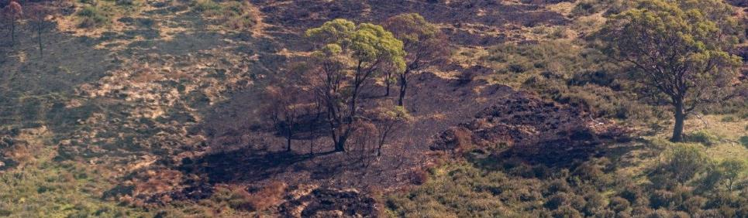

**Caption:** Burnt grassland/peatland mosaic with fire-killed and bleached mossbeds, Forlorn Hope Plain, Alpine National Park.

Remnant unburnt habitats, particularly along sensitive high-altitude alpine waterways, are extremely important to the landscape in its recovery from the bushfires. If these habitats survive, they will be primary sources for flora and fauna repopulation of habitats in areas that were burnt during the bushfires. Further, the maintenance of unburnt refuges in the best possible condition makes the landscape more resilient to other climate-related threats.

As to the burnt habitats, alpine streamsides and sphagnum mossbeds that have been burnt are highly vulnerable to feral horse incursions and can be highly attractive as new growth regenerates. This new growth represents recovering vegetation structure that is critical for the persistence and recolonisation of ground-dwelling fauna, including threatened reptiles and native mammals. The post-fire recovery of these habitats will be severely impeded by the presence of feral horses and other pest species.

Following the Black Summer Bushfires, Parks Victoria communicated its intention to commence using professional ground shooters to target free-ranging feral horses in areas of high conservation value, particularly targeted towards areas recovering from bushfire impacts and forming refuge for remaining threatened species, with emergency habitat protection the key priority.

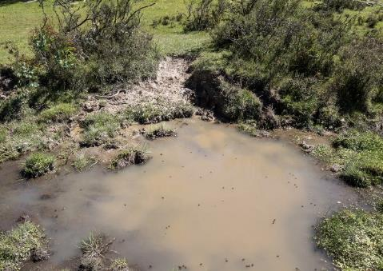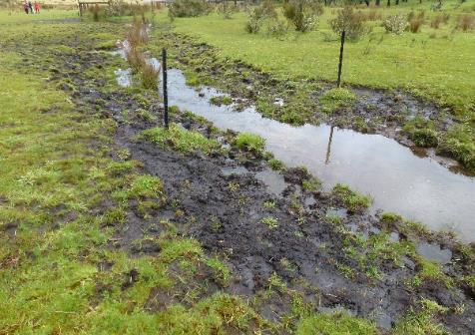

**Caption: Left:** Suspended mud and poor water quality, Cowombat Flat, Alpine National Park. **Right:** Extensive pugging, Murray River, Cowombat Flat, Alpine National Park.

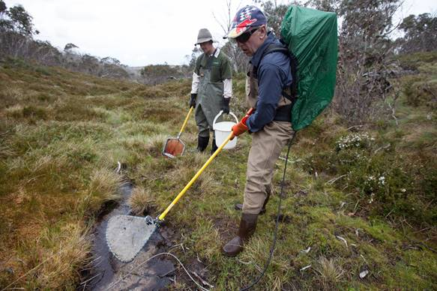

**Caption:** Waterway prior to bushfires showing the rich habitat and water filtration provided by sphagnum moss, grasses and sedges growing over the valley floor, Davies Plain, Alpine National Park.

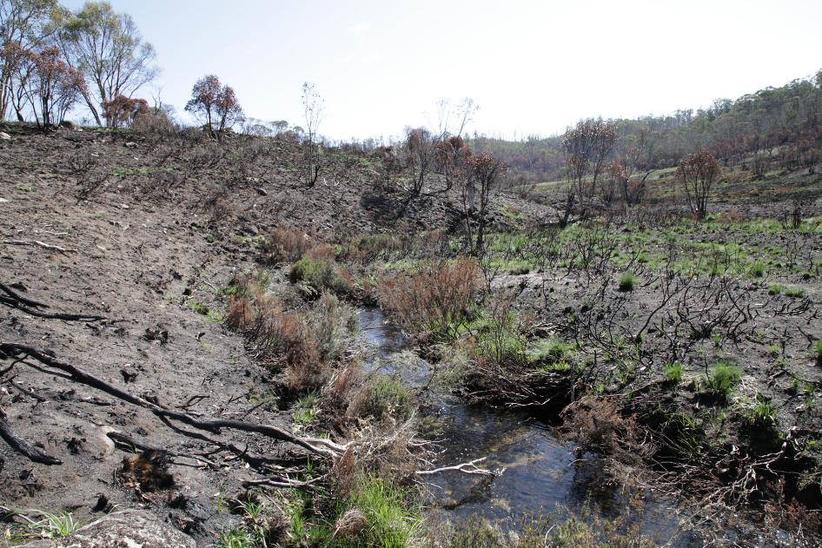

**Caption:** Highly vulnerable fire-impacted waterways, Davies Plain, Alpine National Park, 27 February 2020.

## Feral Horse Strategic Action Plan 2018-21

From 2008 to 2018, between 150 and 200 horses were removed annually from the Alpine National Park. This was not sufficient to reduce the overall annual population or mitigate the damage caused by feral horses in the Alpine National Park and other contiguous areas.

In June 2018, the *Protection of the Alpine National Park – Feral Horse Strategic Action Plan 2018-21* (the 2018-21 Action Plan) was released. The 2018-21 Action Plan was developed following several years of engagement with community-based advisory groups, interviews with key peak and regional interest groups, a Victorian community perception survey, and the release of information sheets and background papers.

Substantial challenges to implementation were encountered during the first two years of the 2018-21 Action Plan, from July 2018 to June 2020, limiting achievement of the objectives and Year One and Year Two targets of the 2018-21 Action Plan.

Constraints and delays

1. During the 17-month period which began on 13 December 2018 while Federal Court of Australia (Melbourne) considered the legal action brought against Parks Victoria, a Court Order limited Parks Victoria to the capture of a small (<20) isolated mob of horses in the northern Bogong High Plains at Mount Nelse, and a maximum of 200 horses to be taken from the eastern Alps. A decision in Parks Victoria’s favour was handed down on 8 May 2020 (FCA 2020).
2. In the summer of 2019/20 bushfires burnt ~750,000 hectares between the North-East and Gippsland DELWP fire regions, with large fires burning 130,000 hectares across north and eastern sections of the Alpine National Park. Feral horse capture was limited during, and following, the bushfire season as contractors’ access to some capture sites in the North-East and Gippsland was restricted.
3. Further court cases occurred in May-June 2020 requiring the suspension of operations for capture and removal, and suspending the proposed use of highly skilled professionals to ground shoot free-ranging feral horses in the fire affected area of the Alpine National Park. The Supreme Court of Victoria dismissed the challenge to Parks Victoria’s introduction of lethal control on 29 May 2020, and leave to appeal the decision was subsequently denied in the Victorian Supreme Court - Court of Appeal on 25 June 2020 (VSCA 2020).
4. COVID-19 pandemic: following on from the bushfires the rapid development of COVID-19 and subsequent mandatory health controls, a cautious approach was taken by Parks Victoria and its contractors to any further feral horse capture and removal and agreed operational protocols were established to ensure consistency with directives of the Chief Health Officer.

Results

During the period of the 2018-21 Action Plan to February 2021:

* 57 feral horses were removed by trapping, from Mount Nelse and the eastern Alps;
* 83 feral horses were removed by roping from the eastern Alps.

Between December 2019 and September 2020, there were three rounds of public advertisement seeking expressions of interest (EOIs) to rehome feral horses. In response, Parks Victoria received over 300 enquiries which manifested in 10 completed EOIs from suitable applicants, and offers to rehome between 38 and 51 feral horses per year (between both Alpine and Barmah national parks). As a result of the invitation to express interest in the rehoming of feral horses Parks Victoria is aware of other horse groups and individuals interested in taking a small number of horses from the Bogong High Plains and other Victorian Alps locations.

The results of the five-yearly Australian Alps national parks (AAnp) feral horse aerial population survey were published in October 2019. The survey methods and analysis were independently reviewed and validated by experts in the analytical techniques used from the CSIRO and St Andrews University in Scotland prior to the final report publication. The survey indicated that the overall Australian Alps feral horse population is large, widespread and continues to increase in size, with the estimated overall feral horse population within the combined surveyed areas more than doubling in the five years between the 2014 and 2019 surveys. One of the survey areas, the Byadbo-Victoria block, covers the feral horse-occupied area across the eastern Victorian Alps and the southern part of the NSW Kosciuszko National Park. In this area, the feral horse population increased from 4316 to 8518 indicating an annual rate of increase of 15% (Cairns 2019). With 60% of this area occurring in Victoria, the 2019 eastern Alps population was estimated to be approximately 5000.

While it is not known what level of mortality may have occurred in the Victorian feral horse population during the bushfires over the 2019-20 summer, following the bushfires, large numbers of feral horses were observed and photographed foraging on severely grazed treeless plains and congregating in very narrow strips of unburnt habitat along sensitive high-altitude waterways, where suitable feed for feral horses remained available. In the Kosciusko National Park, post-bushfire surveys estimated a reduction in the population compared to a year earlier, possibly due to effects of bushfire and drought, movement of animals out of the park, and differences in survey technique (EES 2020). At an estimated 14,000 animals (in Spring 2020), the population of wild horses in the Kosciusko National Park remains significant, despite recent periods of severe drought and extreme bushfires. In Victoria following the fire, large numbers of feral horses were observed and photographed on severely grazed treeless plains and congregating in very narrow strips of unburnt habitat along sensitive high-altitude waterways, where suitable feed for feral horses remained available.

## Control of deer and feral pigs

The sensitive vegetation communities of the Victorian Alps are highly vulnerable to hard-hooved species, including deer, pigs and goats as well as feral horses. As part of the protection of these threatened communities, a multispecies approach is required to control the distribution and impact of pest species.

Parks Victoria is currently implementing the *Integrated Management Plan for Feral Pigs in the Greater Alpine National Parks* (ENRM 2018), designed to provide clear direction and priority actions for the management of feral pig populations across the Greater Alpine National Parks. Feral pig trapping and shooting programs are ongoing.

On 30 October 2020, the Victorian Government released the Victorian Deer Control Strategy to address the impacts of deer on key environmental, agricultural and Aboriginal cultural heritage values and public safety. Deer control in the Alpine National Park is primarily managed using professional shooters or accredited volunteer hunters under the direction of Parks Victoria, as part of a strategic control program. Such programs currently focus on protecting key biodiversity values from the impacts of deer. While ground shooting has mainly been used to control deer, aerial shooting is also now being used in Victoria to deliver deer control in inaccessible and remote terrain where ground shooting is impractical. An integrated approach that utilises professional ground and aerial shooting is required to deliver effective deer control over varied landscapes.

As part of the Victorian Government’s bushfire biodiversity response and recovery program, Parks Victoria applied large-scale aerial and ground shooting operations to nine fire-affected parks, including the Alpine National Park, from late 2019 through 2021 removing deer, feral pigs and foxes from high biodiversity-value locations across more than 200,000 hectares to support the recovery of threatened species and habitats.

## Preparation of this plan

The preparation of this plan is based on the principles of adaptive management, whereby the knowledge and experience gained from the implementation and review of the *Protection of the Alpine National Park – Feral Horse Strategic Action Plan 2018-21* have informed the development of management actions in the current plan. This plan focuses on achieving the objectives laid out in the *Greater Alpine National Parks Management Plan (2016)*, and forms part of the broader multispecies approach to protect the biodiversity of the Victorian Alps. From 26 March to 23 April 2021, a draft of the current plan was released for community engagement, and the views and feedback expressed by the community on the draft have also been considered in the finalisation of the plan.

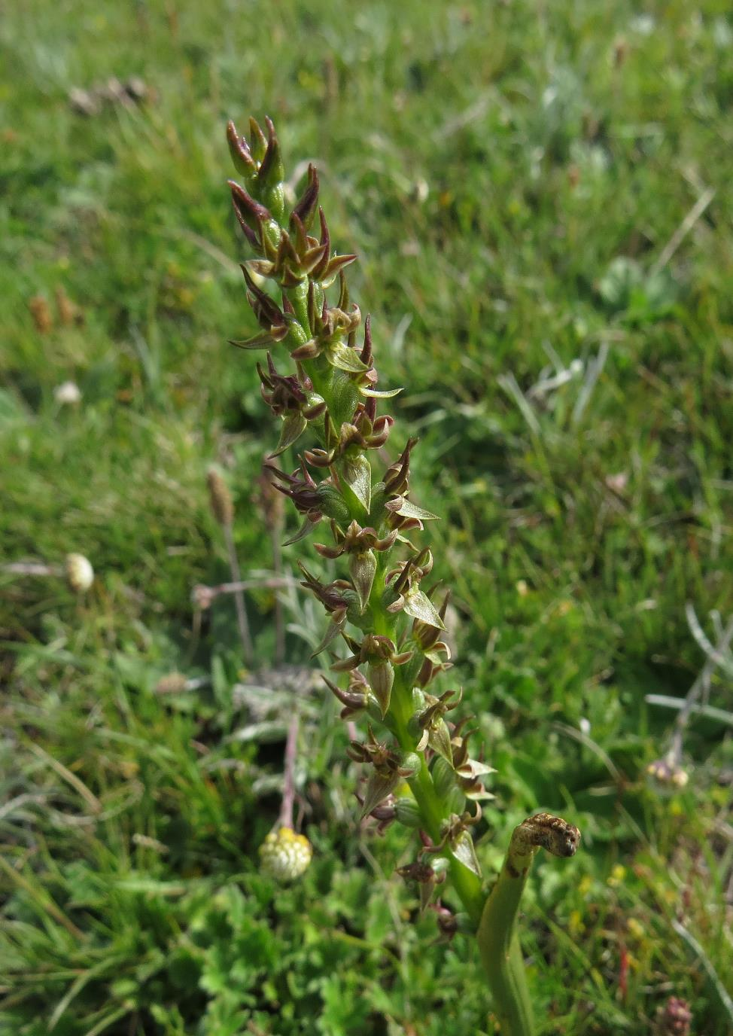

**Caption:** Endangered in Victoria, the Curled Leek Orchid, *Prasophyllum retroflexum*, is found at only a single location on the Nunniong Plains, where it is protected from grazing and trampling by exclusion fencing.

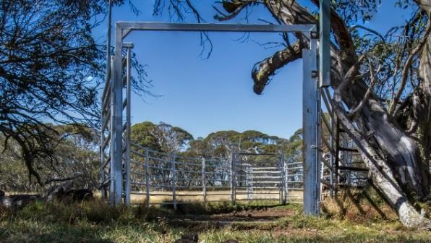

**Caption:** Trap yard, Bogong High Plains, Alpine National Park.

# Feral horse control methods

A range of potential methods exist for the control or removal of feral horse populations, including non-lethal methods such as removal of horses for domestication, exclusion fencing or fertility control, and lethal methods such as in-situ shooting or removal for slaughter in an abattoir or knackery. Historically, trapping, shooting and brumby running (roping) have been used in the Victorian Alps to control feral horse populations since their introduction to the region in the nineteenth century.

**In deciding which methods should be applied in the contemporary control or removal of feral horses from the Alpine National Park, various factors need to be considered, including humaneness, efficacy, cost, practicality, operator and public safety, and environmental impact.**

## Humaneness of feral horse control methods

In Victoria, animal welfare standards are regulated through the *Prevention of Cruelty to Animals Act 1986* and *Prevention of Cruelty to Animals Regulations 2019*. The *Code of Practice for the Welfare of Horses* (DJPR 2019) has been developed to provide information to improve good welfare practices, encourage the considerate treatment of horses, and set the minimum level of conduct required to avoid cruelty to horses.

The *Australian Animal Welfare Standards and Guidelines — Land Transport of Livestock* (AHA 2012) also provides relevant standards for horse transport. Other standard operating procedures (SOPs) are created as guides for applying various control techniques, addressing animal welfare issues applicable to each technique.

Consideration of animal welfare in the management of invasive animals is essential to ensure that control techniques are performed humanely. The ‘humaneness’ of a pest animal control method refers to the overall welfare impact that the method has on an individual animal. A relatively more humane method will have less impact than a relatively less humane method. Humaneness is assessed according to the *Model for assessing the relative humaneness of pest animal control methods* (Sharp and Saunders 2011), which assesses overall welfare impact based on five domains:

|  |  |
| --- | --- |
| 1. Thirst/hunger/malnutrition | 4. Behavioural/interactive restriction |
| 2. Environmental challenge | 5. Anxiety/fear/pain/distress |
| 3. Injury/disease/functional impairment |  |

The model uses a two-part assessment to examine (A) (for lethal and non-lethal methods) the impact of a control method on overall welfare and the duration of this impact; and (B) (for lethal methods only) the effects of the killing method on welfare by evaluating the intensity of suffering and duration of suffering caused by the technique.

The humaneness of feral horse control methods were assessed in 2015 by a Humaneness Assessment Panel (HAP 2015), which found that all potential methods for the control of feral horses have some adverse impact on horse welfare. Choosing appropriate methods therefore requires careful consideration of how to mitigate those impacts. Where culling is assessed to be necessary based on a scientific understanding of the environmental impacts, and the relative benefits and disadvantages of various control options, the most humane methods must be employed (AVA, 2013).

As new technologies or best practice emerge, Parks Victoria will consider their adoption depending on their humaneness, efficacy, cost, practicality, operator and public safety, and environmental impact.

## Capture and removal of live horses

### Trapping

Trapping involves establishing temporary or semi-permanent trap yards at water points or by salt or feed as an enticement. Once horses are inside the trap yard, a tripwire triggers the closure of the entry gate. Trap yards are established in areas with trees and shade to provide shelter for captured horses. Trapping can be an appropriate method of capture where trapping locations, times and conditions provide reasonable accessibility for horse transport and when suitable rehoming opportunities have been secured.

It requires a high level of effort to erect and monitor trap sites and requires trained, experienced operators with good local knowledge of horse behaviour and movement patterns. It is difficult to implement in areas of rough terrain and it is not considered an effective method for large-scale reduction of widely dispersed horse numbers. Alpine sites of conservation significance damaged by feral horses include many sites that are typically remote and seasonally closed. Their remoteness increases the difficulty of setting and operating traps for feral horses, and transporting feral horses from these sites would take an excessively long time, risking poor animal welfare outcomes.

Due to the stresses of being captured (and potentially separated from other members of the horse band), held in trap yards, loaded into stock crates for the first time, and subject to transport over long and potentially rough journeys, this removal method is considered to have a moderate impact on horses, in the domains of (4) Behavioural/interactive restriction and (5) Anxiety/fear/pain/distress, assuming it is conducted in accordance with the standard operating procedure *HOR004: Trapping of feral horses* (Sharp 2011d). However, the severity of the potential impact is increased if transport from the trap site involves long periods over very rough roads, increasing the risks from jarring and injuries from slips and falls. Given the combined impacts of loading, transport over long and potentially rough journeys, lairage and slaughter, using trapping to capture horses to transport them to a knackery or abattoir cannot be justified.

**The level of trapping effort in the Alpine National Park will remain wholly dependent on the capacity of approved rehomers to house, feed and sell or transfer trapped feral horses (see *Rehoming* below).**

Under prescribed circumstances, horses will need to be humanely put down within or close to trap yards by shooting under strict protocols. These circumstances are:

* When the horses are injured, ill, of very poor body condition and/or too aged for successful rehoming
* When the pre-arranged rehoming partner fails to take the horse(s)
* When the number of horses trapped is surplus to the present demand or not to the specific husbandry needs of approved rehomers.

### Roping

Roping (also called brumby running) involves skilled horse riders chasing targeted feral horses on horseback, capturing them by placing a rope over the horse’s head, pulled up by the rider and led back to camp after fitting a halter to the captured horse. They are then tied with a short rope (not tethered) to a tree allowing the captured horse sufficient room for movement and to feed, but not sufficient for the horse to injure itself.

Roping has been a useful approach where poor road access or seasonal conditions otherwise precluded trapping. Over many years, roping has progressively transitioned from an informal activity, to a formal service to Parks Victoria, governed by a standard operating procedure, with removal targets and contractual terms and conditions governing the practice. Historically, roping has been used by Parks Victoria contractors to remove more horses than trapping.

As a horseriding activity, roping carries a high risk to riders of death, serious injury or serious illness occurring (Ball et al. 2007; Havlik 2010). This includes riders falling, being crushed by their horse or during loading and transport, head and/or spinal injuries, broken bones, puncture wounds, lacerations and exposure to the elements. As roping involves a pursuit, at times at high speed, over uneven, unpredictable and often heavily vegetated terrain, even the most skilled riders could not adequately mitigate these risks to allow their conduct in the workplace.

Under the *Occupational Health and Safety Act 2004*, Parks Victoria has a responsibility for providing and maintaining a working environment that is safe and free of risks to health, so far as is reasonably practicable, for its staff, contractors and volunteers. Following a reconsideration of the safety risks associated with roping and the duties held by Parks Victoria to ensure a safe workplace, Parks Victoria can no longer include roping as part of the suite of feral horse control methods used in National Parks by staff, contractors or volunteers, especially as other techniques of feral horse capture and removal, with lower levels of risk, are available for reducing environmental damage caused by feral horses.

**Roping does not comply with the standards for health and safety that can be permitted by Parks Victoria and will therefore not be used as a control method.**

### Mustering

Mustering involves using horse riders, ground vehicles or helicopters, or a combination of these, to gather and move groups of feral horses into a yard. Mustering has not been used for controlling feral horses in the Victorian Alps. Mustering operations are best suited to open and relatively flat terrain and would not be feasible in the many parts of the Victorian Alps that are dominated by rugged or forested terrain.

It requires operators (i.e. pilots, horse-riders, stock handlers and transporters) who have a good understanding of horse behaviour and movement patterns, and to be trained, experienced and competent. Well positioned yards and wing fences designed to expedite the movement of horses into the yards must be able to be suitably located and constructed.

This removal method is considered to have a moderate impact on horses, in the domains of (4) Behavioural/interactive restriction and (5) Anxiety/fear/pain/distress, assuming it is conducted in accordance with the standard operating procedure *HOR003: Mustering of feral horses* (Sharp 2011c). Similar to trapping, the combined impacts of loading, transport over long and potentially rough journeys, lairage and slaughter, mean that using mustering to capture horses to transport them to a knackery or abattoir cannot be justified.

**With a limited number of locations where mustering could be a safe, effective and humane method for removing feral horses, coupled with the absence of rehoming opportunities for larger numbers of horses, there are no plans to employ this technique.**

### Rehoming

To enable successful rehoming to occur, Parks Victoria will build cooperative partnerships with groups or individuals that have an interest and appropriate skills in rehoming captured horses. Potential rehoming partner organisations or individuals will need to demonstrate their ability to accommodate the horses with appropriate land and facilities, and meet animal welfare standards. As Parks Victoria will not manage holding properties for captured horses, it is critical to understand capacity for rehoming within the community. The capacity of groups and individuals to accept and rehome captured horses has been tested over the last 12 months and has been demonstrated to be low relative to the large number of feral horses available.

The trapping of horses from the Alpine National Park will be dependent on Parks Victoria having secured rehoming opportunities for those horses. Assessment of suitability of horses for rehoming will be undertaken using equine veterinary advice. If the pre-arranged rehoming partner fails to take the horse(s), the horses may be humanely put down onsite. The rehoming partner will be required to microchip rehomed horses to enable monitoring and tracking of the surrendered horses.

There are a range of guiding and legislative documents regarding animal, and horse-specific, welfare and safety. Parks Victoria adheres to these standards, and has also developed standard operating procedures that draw upon these, to ensure the management of horses from the Alpine National Park is humane, safe, and effective.

The following principles will be applied to the management of captured horses:

* 1. Animal welfare outcomes will be optimised through appropriate expectations, protocols and oversight and monitoring.
  2. Transport and holding times for captured horses will be minimised.
  3. Mares and dependent foals will not be separated during trapping or transport.
  4. The Approved Rehomer assumes full duty of care for the horses upon receiving them.

**Parks Victoria will continue to meet community demand in providing captured horses to rehoming locations that comply with standards for animal welfare. However, it is unlikely that capture and rehoming will contribute significantly to the required reduction in feral horse populations in the eastern Alps.**

## Population reduction

### Fertility control

Fertility control can in some circumstances be used to help reduce population growth, however it is not suitable for reducing large populations spread over a large, rugged and in many places, inaccessible landscape. Treating horses with fertility control will not have any effect on existing levels of damage caused by a feral horse population; reduction of population size must be achieved by other methods.

There is a range of different fertility control techniques that are suitable for reducing reproduction in horses including: surgical procedures (sterilisation), contraceptive drugs (subcutaneous implants in mares) and immunocontraception (uses immune response to disrupt reproductive function). Surgical implants generally require the capture and restraint of wild horses. Immunocontraceptive vaccines, such as porcine zona pellucida (PZP) vaccine (eg. SpayVac®) and gonadotrophin-releasing hormone (GnRH) vaccine (eg. GonaCon™) can require repeated booster shots at 1-3 year intervals (Hobbs & Hinds 2018). Injecting the vaccines either requires horse capture and restraint, or by using a projectile syringe or bio-bullet at close range (less than 20 metres), which is not practical at sufficient scale in the Victorian Alps.

Fertility control agents can only be successful in reducing reproduction rates of individual horses if the agent can be administered effectively and individual horses can be identified and re-treated when required. Reducing population growth requires that a significant proportion of the population is effectively treated. This technique has been used overseas and is generally only practical in small confined populations where an immediate reduction of environmental impacts is not required (Hobbs & Hinds 2018).

**Due to the large population sizes of feral horses in the Victorian Alps, difficulty in delivering the control agent effectively in the field for large numbers of uncontained and unidentified animals, the need for repeat administration to known animals, and the inability for the technique to reduce populations over the short term, fertility control is not being considered for horse control in Victorian parks.**

### Ground shooting

Ground shooting involves a shooter quietly approaching a group of horses on foot with the intention of culling all the animals in the group. Shooting can be a humane method of destroying feral horses when it is carried out by experienced and skilled professional shooters, the animal can be clearly seen, is within range, and the correct firearm configuration, ammunition and shot placement are used.

This removal method is considered to have a mild impact on the welfare of horses (HAP 2015), in the domains of (3) Disease, injury, functional impairment, (4) Behavioural/interactive restriction and (5) Anxiety/fear/pain/distress, assuming it is conducted in accordance with the standard operating procedure *HOR001: Ground shooting of feral horses* (Sharp 2011a). As a lethal technique, ground shooting is assessed by evaluating the intensity of suffering and duration of suffering caused by the technique, and therefore the instantaneousness of death is critical.

Welfare outcomes are highly dependent on the skill of the shooter, and their ability to make accurate decisions about whether the shot can be successfully placed. Parks Victoria only use highly accredited and qualified professional shooters to ensure that welfare outcomes are maximised.

Findings from ground shooting programs for kangaroos are instructive for ground shooting of feral horses. In an assessment of the welfare outcomes of ground shooting eastern grey kangaroos (Hampton & Forsyth 2016), high levels of accuracy were observed, resulting in a 98% instantaneous death rate. For those animals not killed instantaneously, the median time to death was 12 seconds. The wounding rate of zero.

Relative to other methods, ground shooting of free-ranging horses has been identified as the most humane, safe and effective method available due to:

* its mild impact on the welfare of feral horses relative to other potentially more impactful techniques such as trapping, roping and mustering;
* its ability to remove complete social groups of horses from remote and fragile ecosystems, with minimal disturbance to ecological values;
* live capture and transport with an ultimate destination of culling at a knackery or abattoir being neither humane nor efficient/cost effective;
* live capture methods not being appropriate for controlling feral horse numbers in remote areas, rugged terrain or where lengthy transport of trapped horses would be required.

**Independent experts consider ground shooting as the most humane, safe and effective method available and is an acceptable technique for the removal of individual, or small groups of horses from a location, when performed by skilled operators who hold the appropriate licences and accreditation.**

### Aerial shooting

Aerial shooting is conducted from helicopters and is considered to be an effective method for reducing the abundance of wild horse populations in remote and inaccessible locations, and where feral horse densities are high. It allows shooters to locate and get close to the feral horse (even in remote terrain), quickly and humanely cull animals, and if necessary, to immediately pursue and kill wounded animals (Norris & Low 2005). While aerial shooting has only been practiced exceptionally for feral horse control in NSW, Victoria or the ACT in the last 20 years, it remains a primary control method for extensive feral horse populations in Northern Territory (NTG 2015), Queensland (QGBQ 2016) and Western Australia (KRBA 2016).

An assessment of animal welfare outcomes of helicopter shooting programs in central Australia (Hampton et al. 2017) found that shooter skill was the most important determinant of whether or not a horse had an instantaneous death. This removal method is considered to have a moderate impact on horses (HAP 2015), in the domains of (3) Disease, injury, functional impairment and (5) Anxiety/fear/pain/distress, assuming it is conducted in accordance with the standard operating procedure *HOR002: Aerial shooting of feral horses* (Sharp 2011b), and if conditions relating to shooter and pilot skill, point of aim, terrain, ambient temperatures, and horse group size, are met (HAP 2015).

There may be circumstances where aerial shooting of feral horses is the most effective technique, including:

* when feral horses in remote or inaccessible areas are suffering from injury or malnutrition, and euthanasia is required;
* during bushfire recovery operations when horses and deer are congregating in streambanks and wetlands or other high value habitats requiring protection;
* to remove the last remaining horses in an eradication area, where ground-based methods have failed; or
* if ground-based removal techniques are demonstrated to have failed to remove sufficient horses to reduce damage to streamsides and wetlands or other high value habitats requiring protection.

Any use of aerial culling of feral horses in Victoria will draw on efficacy and accuracy data from other aerial animal control programs, consideration of the application of the standard operating procedure and the assessment of animal welfare outcomes of helicopter shooting programs in central Australia (Hampton et al. 2017).

**As aerial shooting can be performed to standards that minimise animal suffering, aerial shooting may be applied in exceptional circumstances, or if other methods fail to remove sufficient horses to reduce ecological impacts.**

## Fenced exclusion

Feral horses are widely distributed across the Victorian Alps, and the habitats and vegetation communities they impact are widely scattered along drainage lines and valley floors or surrounding seepage areas on hillsides. Exclusion fencing requires significant capital investment as well as ongoing inspection and maintenance. It can also restrict native animal movements, potentially act as a trap or snare to species such as turtles, introduce a flight danger to some birds, and is visually intrusive in the natural landscape.

It is therefore impractical to consider the wide-scale protection of these values from feral horse damage by using fences to exclude them. However, in the short term, until feral horse numbers are brought under control, fenced exclusion plots may be appropriate for the protection of populations of rare or threatened flora species of limited distribution, that are at risk of extinction from the grazing or trampling impacts of feral horses.

**Exclusion fencing can only feasibly protect small areas, and is limited to sites that are accessible for maintenance or have low maintenance requirements, or where feral horse exclusion is part of the monitoring and evaluation of feral horse damage.**

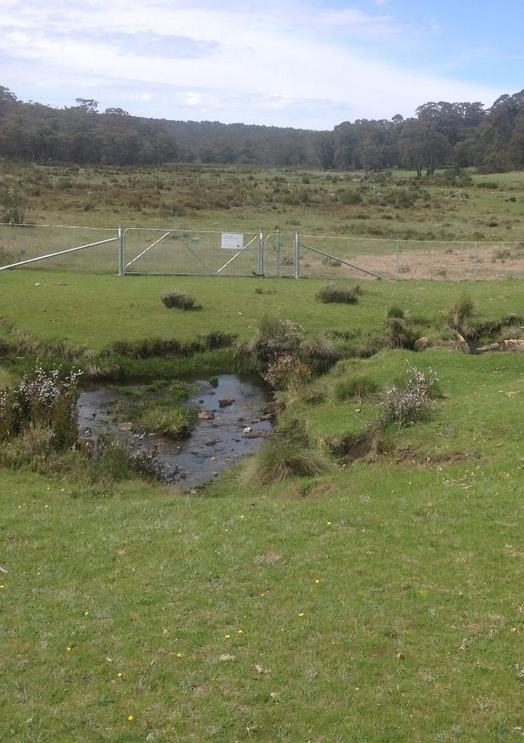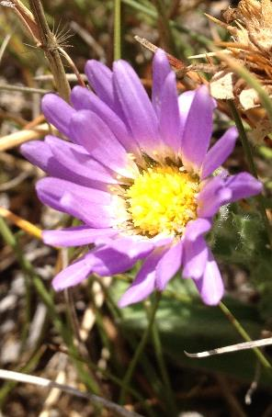

**Caption: Left:** The threatened Mountain Burr-daisy occurs at only one location (Spring Creek) where it is protected by a fenced exclosure, preventing it from being grazed and trampled by feral horses. **Right:** Mountain Burr-daisy, *Calotis pubescens*.

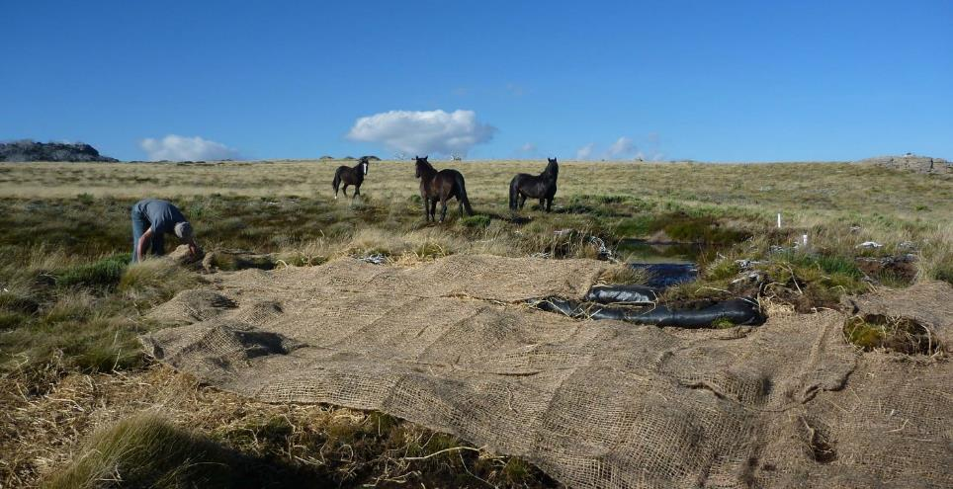

**Caption:** Feral horses at impact site undergoing restoration works, Bogong High Plains, Alpine National Park.

# Management actions

The following actions are designed to achieve the conservation goals of reducing the severe damage to vulnerable alpine vegetation communities and fauna habitats, particularly to riverine wetlands, alpine peatlands and streambanks, and to protect Aboriginal cultural heritage. The relationship between the actions specified below and the outcomes, outputs and measures specified at *Section 1.3* are summarised in *Table 6.1.*

## Control of feral horses

### Control of small and isolated populations

In accordance with the *Greater Alpine National Parks Management Plan* *(2016)*, isolated populations of horses, including any deliberately released horses, will be removed where feasible. This is to prevent further spread, and to protect vulnerable biodiversity values in the greater Victorian Alps.

|  |  |
| --- | --- |
| **Action:** | Maintain active surveillance programs to detect the emergence of populations of feral horses in new locations. |
| **Action:** | Immediately remove any feral horses that have invaded, or have been released to, new areas outside their current distribution in the Alpine National Park. |

The Bogong High Plains population of around 100 horses poses a significant threat to the significant number of high-altitude wetlands that occur in this area, as well as the rare snow patch communities with their specific plant associations that are adapted to prolonged snow cover. Reduction of this population to zero horses within three years is a management objective for this plan. There is a risk that horses may persist in low numbers in the Bogong High Plains through potential re-invasion from adjacent Crown lands in the Cobungra and Victoria river valleys, possible illegal release and/or escape of horses into the park, and this may require coordinated action across tenure. Ultimately, complete removal of feral horses from across the Bogong-Cobungra area would achieve permanent protection of environmental values across this area.

|  |  |
| --- | --- |
| **Action:** | Remove the Bogong High Plains population, monitor for reinvasion, and undertake further removals as required. |
| **Action:** | Develop partnerships with the Department of Environment, Land, Water and Planning to coordinate cross-tenure feral horse control in the Cobungra and Dinner Plain areas to prevent re-invasion of the Bogong High Plains and to protect environmental values. |

### Control of the established population in the eastern Alps

Over the coming years, management effort in the eastern Alps will be focused on reducing the damage caused by feral horses on vulnerable peatlands and streambanks (asset-based protection). Management of horses will target those areas that are damaged and are the most vulnerable, or are in good condition but have the potential to be impacted by the threat.

While small numbers of feral horses have been removed from the Alpine National Park over several years, an increased scale of removal is required. The scale and intensity of removal is ultimately determined based on whether horse impacts to peatlands and streambanks have been reduced to a level that can allow for recovery, while the rate of removal is constrained by the effectiveness of methods that can be employed safely and humanely.

To reduce measures of active erosion and damage to streambanks and wetlands, the annual rate of feral horse removal needs to be significantly increased. An adaptive approach will need to be applied, with enough horses removed to adequately protect park values and achieve a sufficiently low residual population in the eastern Alps. In the first year up to 500 feral horses may be removed. Following this, annual removal targets will be developed based on feral horse population surveys and monitoring and evaluation of feral horse damage to sites of high conservation value sites, including mossbeds, peatlands and streambanks.

|  |  |
| --- | --- |
| **Action:** | Increase the annual rate of removal of horses from the eastern Alps, particularly from areas of high conservation value. |
| **Action:** | Develop partnerships with the Department of Environment, Land, Water and Planning to coordinate cross-tenure feral horse control where required for the protection of environmental values. |

### Fenced exclusion

In the short to medium term, until feral horse numbers are brought under control, small fenced exclusion plots may be required for the highly localised protection of rare or threatened flora species that are at risk of extinction from the grazing or trampling impacts of feral horses, or where feral horse exclusion is part of the monitoring and evaluation of feral horse damage.

|  |  |
| --- | --- |
| **Action:** | Establish and maintain small fenced exclusion sites where required for highly localised protection of species at high risk of extinction, or for monitoring feral horse damage. |

### Selected removal methods

The reduction of feral horse numbers will primarily be delivered through two control methods: (i) passive trapping and rehoming where appropriate recipients are secured, and (ii) ground shooting of free-ranging horses using professional shooters. The sequencing of implementing trapping and rehoming, and the deployment of ground shooting may depend on environmental conditions, park accessibility and the extent of available rehoming opportunities.

|  |  |
| --- | --- |
| **Action:** | Conduct feral horse control according to established codes of practice and standard operating procedures. |

Trapping and rehoming

Horses for rehoming will be captured primarily using passive trapping. Trap operators will ensure that Parks Victoria’s strict operating standards and animal welfare conditions are met. Horses will only be trapped when appropriate rehoming recipients have been secured prior to any trapping activities and where horses can be transported safely and humanely, in accordance with relevant codes and standard operating procedures. Horses will only be trapped in areas where transport from the trap site can be done safely and humanely.

Rehoming opportunities will be offered through an expression of interest (EOI) process, open to suitably experienced horse rescue organisations or individuals that are willing to take receipt of and responsibility for captured horses. Captured horses will be transported offsite to the approved rehomer’s care. Feral horses then become the responsibility of the rehomer and must be provided with feed, shelter, clean water, veterinary care and be microchipped to enable monitoring and tracking of the surrendered horses.

Parks Victoria will seek advice from horse interest groups on how to advertise for, or identify, willing and appropriately skilled and equipped horse recipients. Parks Victoria welcomes community initiatives to expand rehoming capacity or to increase the rate of removal to meet that capacity while meeting appropriate safety and animal welfare standards, which could include privately run horse “hubs” that would receive horses to train and pass on.

|  |  |
| --- | --- |
| **Action:** | Continue implementing the Expression of Interest process and rehoming register to identify rehoming opportunities in advance of trapping horses. |
| **Action:** | Undertake trapping, and provide horses to organisations or individuals that are able to demonstrate they can provide suitable care for them. |
| **Action:** | Continue to work with stakeholders to improve rehoming capacity and outcomes. |

Shooting

In terms of minimising animal suffering, shooting of feral horses by contracted professional shooters has been proposed by a number of stakeholders and welfare organisations as a more humane approach than methods involving capture, transport and being put down as a final outcome (e.g. at a knackery). Professional shooters will be engaged to use specialist equipment to cull free-ranging horses by ground shooting under strict operational procedures. Shooting operations will be audited by independent expert equine veterinarians and strictly managed in terms of humane animal welfare and public safety standards.

As aerial shooting can be performed to standards that minimise animal suffering, aerial shooting may be applied in exceptional circumstances (as described in *Section 4.3*), or if other methods fail to remove sufficient horses to reduce ecological impacts.

Expert advice, guidance and review on the use of shooting (and other control methods) will form part of operational planning, and advice will be obtained from animal welfare experts, technical specialists, scientists and Parks Victoria’s Feral Horse Technical Reference Group.

|  |  |
| --- | --- |
| **Action:** | Implement feral horse removal by ground shooting using professional shooters, particularly in high priority conservation areas, to reduce environmental damage and minimise the potential for poor animal welfare outcomes. |
| **Action:** | Apply aerial shooting in response to exceptional circumstances as required, or if other methods cannot meet conservation or welfare objectives. |
| **Action:** | Seek and review expert advice on the use of shooting and other control methods to ensure best available practices are employed. |

## Euthanasia

Defined as the practice of intentionally ending a life in order to relieve pain and suffering, euthanasia is not a population control method, however it is applicable in some circumstances for park management.

Euthanasia of free-ranging or captive horses may be required when horses are injured, ill, or are in very poor body condition. Population reduction will reduce the likelihood of this occurring. Should euthanasia be required, Parks Victoria will:

* work with expert equine veterinarians to accurately assess feral horse condition to identify animals requiring euthanasia;
* use appropriately accredited and supervised Parks Victoria staff and/or professional shooters to carry out the shooting;
* conduct euthanasia consistent with the standard operating procedure for euthanasia in field conditions (Sharp 2016).

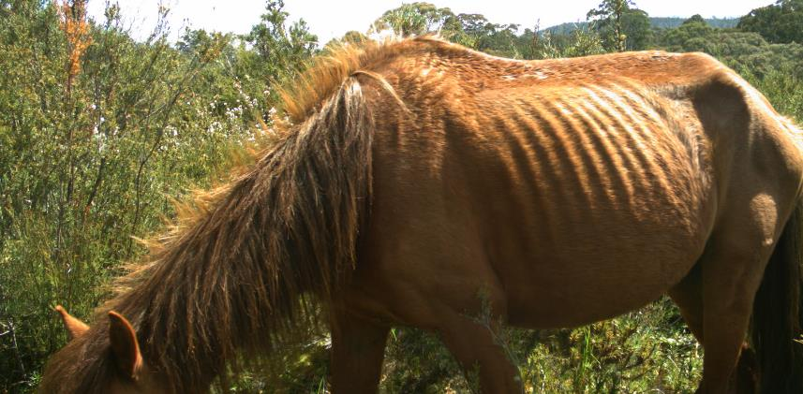

**Caption:** Emaciated feral horse, December 2019, Forlorn Hope, Alpine National Park.

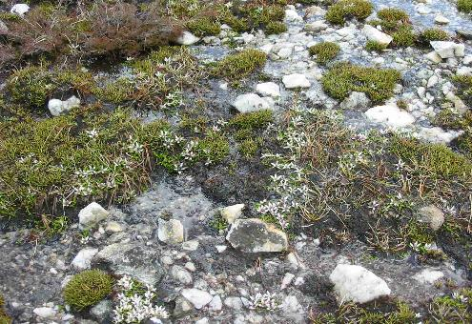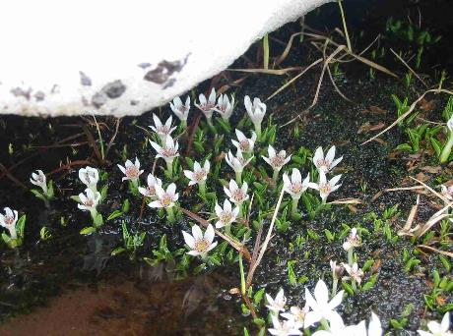

**Caption:** FFG-listed *Psychrophila introloba* Herbland Community, Bogong High Plains, Alpine National Park. Vegetation in this wet community can be easily dislodged by feral horse activity.

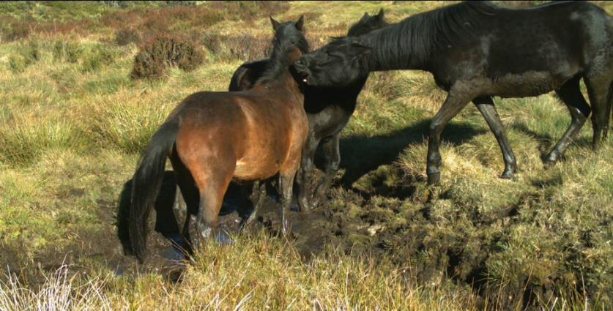

**Caption:** Feral horses wallowing in and damaging wetland vegetation, Mount Nelse, Bogong High Plains, Alpine National Park.

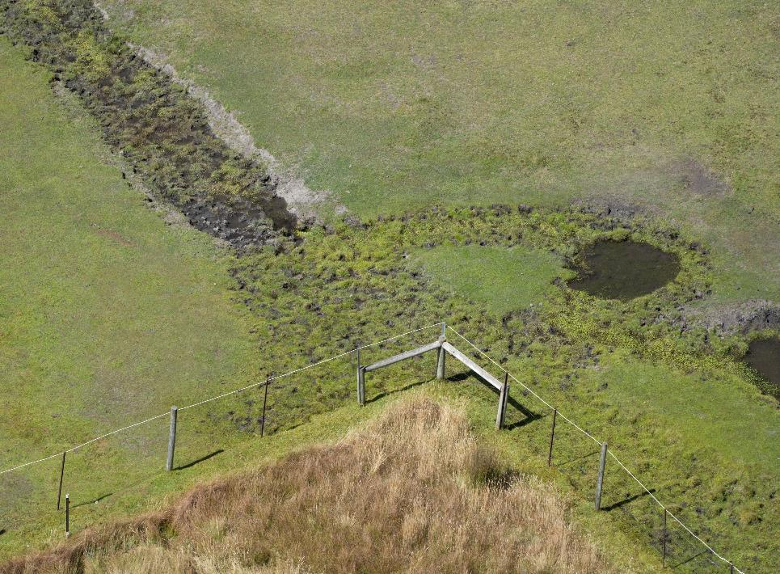

**Caption:** Horse exclusion plot and grazing impacts in March 2021, Native Cat Flat, Alpine National Park.

# Monitoring, evaluation and review

## Monitoring and evaluation

Parks Victoria is committed to an evidence-based approach to the management of natural and cultural values. Monitoring and evaluation are fundamental to that approach, helping to ensure that decisions are based on the best information available and that the effectiveness of management improves over time as knowledge increases. Monitoring provides the information necessary for evaluating how successful management has been, as well as identifying where changes in the management approach or resourcing are needed. Monitoring and evaluation of the feral horse management program will be structured according to the natural, cultural and animal welfare outcomes, the indicators and measures of change, and the deliverables (outputs) of humane feral horse control that are specified at *Section 1.3*.

The monitoring, evaluation and review (MER) actions are summarised in Table 6.1 below, classified by the themes of the feral horse control strategy set out in the *Greater Alpine National Parks Management Plan (2016)*, and the outcome measures and outputs set out in *Section 1.3* of this action plan.

An understanding of the **efficiency** of management will be gained from documenting the time, money and other resources invested, and the extent of management activities this has allowed, and will inform the resource needs for future management.

Changes in the size of feral horse populations will generally be more rapid than changes in the status of natural and cultural values. Monitoring horse populations provides short-term feedback on the **effectiveness of management**, indicating whether desired longer-term outcomes are likely to be met.

To determine the population size of most free-ranging animals over large landscapes, it is impossible to directly count the entire population by searching the entire area. Instead, a survey (sampling) approach must be used. Results of the survey are then analysed to estimate the size of the population in the landscape. To ensure that we have the most accurate and precise estimate for feral horse population surveys in 2014 and 2019, the surveys over the eastern Alps employed the same operational and statistical methods that were independently reviewed by experts in estimating wildlife abundance from the CSIRO and St Andrews University in Scotland . The Bogong High Plains population is also surveyed by helicopter, but uses a sight-resight (mark-recapture) survey method, which has been repeated every 2-3 years since 2005 (PV 2018a, Dawson & Miller 2008). Localised monitoring of horse numbers (or an index of abundance) will also be established at selected sites as part of long-term monitoring.

Ultimately, it is the condition of the natural and cultural values that Parks Victoria aims to protect through managing feral horse populations that is the fundamental test of the **effectiveness of management**, indicating whether longer-term conservation goals are being achieved. Although a wide range of natural assets in the eastern Alps and Bogong areas are affected adversely by feral horses, the current monitoring program is predominantly focused on the assessment of peatlands and streambanks. Monitoring will be implemented to determine the status of these natural values and how they change over time in association with any management implemented. Where possible, Parks Victoria will utilise or complement any existing monitoring programs or research.

The Victorian Alps have a rich cultural heritage that is important to Traditional Owners and the broader Victorian community. Heritage values include the physical as well as intangible attributes of the landscape, both of which may be damaged by feral horses. Culturally important sites such as middens, artefact scatters and burial sites are sensitive to disturbance, and feral horse management activities will be assessed prior to commencement of works, to ensure adequate management and protection measures are in place to mitigate the risk of harm to Aboriginal cultural heritage.

## Review

An annual review of operations will be undertaken to determine progress in the delivery of the management actions outlined in this plan, and the extent to which conservation and welfare objectives are being met.

To provide technical advice on the management approach and the evaluation of effectiveness, the existing *Feral Horse Technical Reference Group* will remain in place and will continue to provide review and further guidance for feral horse management operations.

The *Feral Horse Technical Reference Group* provides advice to Parks Victoria on management approaches, targets and control strategies, and has provided a technical review of the action plan’s proposals. Its members are independent experts (outside Parks Victoria) specialising in animal welfare, invasive species management, veterinary science, alpine ecology, Aboriginal cultural heritage, and social science. The advice of the group has been considered in development of this plan (FHTRG 2017).

**Table 6.1:** Summary of monitoring, evaluation and review (MER) actions, classified by the themes of the feral horse control strategy, and the outcome measures and outputs

| **Monitoring, evaluation and review actions across each of the strategy themes** | | |
| --- | --- | --- |
| **Prevent new populations establishing and remove isolated populations where feasible** | **Contain and reduce feral horse numbers in core, larger populations** | **Use the most humane, safe and effective horse control methods** |
| **MANAGEMENT ACTIONS:** | | **MANAGEMENT ACTIONS:** |
| **Action:** Maintain active surveillance programs to detect emerging populations of feral horses in new locations. | **Action:** Increase annual rate of removal of horses from the eastern Alps, particularly areas of high conservation values. | **Action:** Conduct feral horse control according to codes of practice and standard operating procedures. |
| **Action:** Immediately remove any feral horses that have invaded, or have been released to new areas outside their current distribution in the Alpine National Park. | **Action:** Develop partnerships with DELWP to coordinate cross-tenure feral horse control where required for the protection of environmental values. | **Action:** Continue implementing the Expression of Interest process and rehoming register to identify rehoming opportunities in advance of trapping horses. |
| **Action:** Remove all feral horses from the Bogong High Plains, monitor for reinvasion, and undertake further removals as required. | **Action:** Establish and maintain exclusion fencing where required to protect species at high risk of extinction or for monitoring and evaluation of feral horse damage. | **Action:** Undertake trapping, and provide horses to organisations or individuals that are able to demonstrate they can provide suitable care for them. |
| **Action:** Develop partnerships with DELWP to coordinate cross-tenure feral horse control in the Cobungra and Dinner Plain areas to prevent re-invasion of the Bogong High Plains and to protect environmental values. | **Action:**  Apply aerial shooting in response to exceptional circumstances as required, or if other methods cannot meet conservation or welfare objectives. | **Action:** Implement feral horse removal by ground shooting using professional shooters, particularly in high priority conservation areas reduce environmental damage and minimise potential for poor animal welfare outcomes. |
| **Action:** Continue to work with stakeholders to improve rehoming capacity and outcomes. | **Action:** Continue to work with stakeholders to improve rehoming capacity and outcomes. |  |
| **OUTPUTS:** | | **OUTPUTS:** |
| **OUTPUT:** Prevent establishment of any additional feral horse populations or any further extension of range. | | **OUTPUT:** Maximise animal welfare outcomes through clear standard operating procedures and monitoring of on ground activities. |
| **MER actions:**   * Seek, collate and validate field observations of feral horses from staff, researchers, park users * Targeted surveillance, including aerial search, to detect new populations or expansion of area occupied by feral horses. * Establish and maintain a register of feral horse occurrence observations | | **MER actions:**   * Collate and analyse welfare records for all removals * Evaluate results against standard operating procedures |
| **OUTPUT:** Removal of all feral horses from the Bogong High Plains. | **OUTPUT:** Significant reduction in the eastern Alps population through annual removals, particularly in areas of high conservation value. |  |
| **MER actions:**   * Conduct aerial survey of Bogong Cobungra area in 2021 and prepare report including temporal records from previous surveys. * Targeted investigation to confirm presence or absence of feral horses. * Periodically repeat aerial survey. | **MER actions:**   * Establish localised feral horse abundance monitoring at selected sites with and without horse removal. * Conduct aerial survey of eastern Alps area in 2021, (as per methods used in 2014 and 2019), and report including temporal records from previous surveys. * Periodically repeat aerial survey. |  |
| **OUTCOME: Regeneration or recovery of alpine peatlands and streambanks** | | **OUTCOME: Horse management conducted safely and humanely** |
| **MEASURE:** Reduction in pugging and streambank collapse caused by feral horses (across Bogong High Plains and eastern Alps). | | **MEASURE:** Minimise adverse impacts on horse welfare in the design and application of the selected horse control methods. |
| **MER actions:**   * Repeat relevant peatland sites and streambank segments from 2012 Australian Alps-wide assessment and/or 2020 rapid assessment* * Establish an ongoing stream morphology monitoring program. * Repeat monitoring of feral horse exclosures and unfenced control plots at Cowombat Flat and Native Cat Flat in 2024 [last completed 2019 (Wild Ecology 2019)]. * Ongoing mossbed monitoring (focussing on feral horse impacts). * Ongoing Australian Alps-wide mossbed condition assessment program (already established).   * Note: previous work [Robertson et al. (2019); Tolsma & Shannon (2018)] provides a basis for comparison to assess temporal changes. | | **MER actions:**   * Collate and analyse welfare records for all removals * Evaluate results against standard operating procedures * Seek and review expert advice on the use of shooting and other control methods to ensure best practices are employed |
| **MEASURE:** Optimise overall cost, efficiency and appropriateness of control methods |
| **MER actions:**   * Collate and analyse cost and efficiency data for control methods |
| **MEASURE:** Reduction in grazing damage on significant regenerating or restored vegetation. | |  |
| **MER actions:**   * Establish vegetation composition and structure monitoring program, including alpine mossbeds. * Investigate using existing remotely sensed imagery to assess broad changes in vegetation cover/productivity. * 2024 Monitoring of feral horse exclosures and unfenced control plots at Cowombat Flat and Native Cat Flat.   * Note that existing exclosures/fenced areas across the Victorian Alps may provide additional opportunity to document effects of horse grazing | |  |
| **MEASURE:** Improved distributions and abundances of vulnerable or threatened fauna species. | |  |
| **MER actions:**   * Addressing site occupancy and abundance of focal fauna species variation over time will rely on research and monitoring projects being done by other organisations. * Assessments of variation in the condition of habitat for focal fauna species over space and time will be addressed through abovementioned MER actions relating to ‘*Regeneration or recovery of alpine peatlands and streambanks*’ and to ‘*Reduction in grazing damage on significant regenerating or restored vegetation*’. | |  |

# References

AAS (1957). *A Report on the Condition of the High Mountain Catchments of New South Wales and Victoria*, Australian Academy of Science, Canberra.

AHA (2012). *Australian Animal Welfare Standards and Guidelines — Land Transport of Livestock*. Animal Health Australia, Canberra.

AVA (2013). *Control of feral horses and other Equidae*. Australian Veterinary Association policy. [Website accessed on 12/01/2021 at https://www.ava.com.au/policy-advocacy/policies/wild-animals/control-of-feral-horses-and-other-equidae/](https://www.ava.com.au/policy-advocacy/policies/wild-animals/control-of-feral-horses-and-other-equidae/)

Ball, C.G., Ball, J.E., Kirkpatrick A.W., and Mulloy, R.J. (2007). Equestrian injuries: incidence, injury patterns, and risk factors for 10 years of major traumatic injuries, *The American Journal of Surgery*, **193**(5), pp 636-640.

BOM (2019). *Special Climate Statement 72—dangerous bushfire weather in spring 2019*. Bureau of Meteorology, Commonwealth of Australia. [Website accessed on 12/01/2021 at http://www.bom.gov.au/climate/current/statements/scs72.pdf](http://www.bom.gov.au/climate/current/statements/scs72.pdf)

BOM (2020). Annual climate statement 2019. Bureau of Meteorology [Internet]. [Website accessed on 12/01/2021 at http://www.bom.gov.au/climate/current/annual/aus/2019/](http://www.bom.gov.au/climate/current/annual/aus/2019/)

Cairns S. (2019). *Feral Horses in the Australian Alps: the Analysis of Aerial Surveys Conducted in April-May, 2014 and April-May 2019*, Report to the Australian Alps Liaison Committee by GE & SC Cairns Consulting: Armidale, NSW. [Website accessed on 11/12/2020 at https://theaustralianalps.files.wordpress.com/2019/12/feral-horses-in-the-australian-alps-the-analysis-of-aerial-surveys-conducted-in-2014-and-2019-cairns-s-2019.pdf](https://theaustralianalps.files.wordpress.com/2019/12/feral-horses-in-the-australian-alps-the-analysis-of-aerial-surveys-conducted-in-2014-and-2019-cairns-s-2019.pdf)

Clarke JM, Grose M, Thatcher M, Round V & Heady C. (2019). *Ovens Murray Climate Projections 2019*. CSIRO, Melbourne Australia. [Website accessed on 11/12/2020 at https://www.climatechange.vic.gov.au/__data/assets/pdf_file/0034/429883/Ovens-Murray-Climate-Projections-2019_20200219.pdf](https://www.climatechange.vic.gov.au/__data/assets/pdf_file/0034/429883/Ovens-Murray-Climate-Projections-2019_20200219.pdf)

Clemann, N. (2009). *Survey and monitoring of threatened alpine herpetofauna: annual report for the 2008-2009 Season.* Arthur Rylah Institute for Environmental Research, Department of Sustainability and Environment, Heidelberg.

CoA (2008). *Commonwealth of Australia Gazette*, Special Gazette No. S237, 7 November 2008. [Website accessed on 11/12/2020 at https://environment.gov.au/heritage/places/national/australia-alps](https://environment.gov.au/heritage/places/national/australia-alps)

CoA (2019). *Australia’s Strategy for Nature 2019–2030*, Commonwealth of Australia. [Website accessed on 11/12/2020 at http://www.environment.gov.au/biodiversity/conservation/strategy](http://www.environment.gov.au/biodiversity/conservation/strategy)

DAF (2016). *Invasive animal risk assessment: Feral horse* Equus caballus. Department of Agriculture and Fisheries Biosecurity Queensland. [Website accessed on 27/08/2021 at https://www.daf.qld.gov.au/__data/assets/pdf_file/0004/51961/IPA-Feral-Horses-Risk-Assessment.pdf](https://www.daf.qld.gov.au/__data/assets/pdf_file/0004/51961/IPA-Feral-Horses-Risk-Assessment.pdf)

DAWE (2020). *Management Interventions For 119 Priority Animal Species*. Department of Agriculture, Water and the Environment. [Website accessed on 20/12/2020 at https://www.environment.gov.au/biodiversity/bushfire-recovery](https://www.environment.gov.au/biodiversity/bushfire-recovery)

DELWP (2017). *Protecting Victoria’s Environment – Biodiversity 2037*. Department of Environment Land Water and Planning, Melbourne, Victoria. [Website accessed on 11/12/2020 at https://www.environment.vic.gov.au/biodiversity/biodiversity-plan](https://www.environment.vic.gov.au/biodiversity/biodiversity-plan)

DEPI (2009). *Biosecurity Strategy for Victoria*. Biosecurity Victoria, Department of Environment and Primary Industry, Melbourne, Victoria.

DEPI (2010). *Invasive Plants and Animals Policy Framework,* Victoria. Department of Environment and Primary Industry, Melbourne, Victoria.

DJPR (2019). *Code of Practice for the Welfare of Horses, Revision 1*. Department of Jobs, Precincts and Regions, Melbourne, Victoria. [Website accessed on 11/12/2020 at https://agriculture.vic.gov.au/__data/assets/pdf_file/0008/538271/Code-of-Practice-for-the-Welfare-of-Horses.pdf](https://agriculture.vic.gov.au/__data/assets/pdf_file/0008/538271/Code-of-Practice-for-the-Welfare-of-Horses.pdf)

DSE (2013). *Advisory List of Threatened Vertebrate Fauna in Victoria- 2013*. Department of Sustainability & Environment, Melbourne. [Website accessed on 11/12/2020 at https://www.environment.vic.gov.au/__data/assets/pdf_file/0014/50450/Advisory-List-of-Threatened-Vertebrate-Fauna_FINAL-2013.pdf](https://www.environment.vic.gov.au/__data/assets/pdf_file/0014/50450/Advisory-List-of-Threatened-Vertebrate-Fauna_FINAL-2013.pdf)

Dawson, M. J., and Miller, C. (2008). Aerial mark–recapture estimates of wild horses using natural markings. *Wildlife Research* **35**, 365–370

Driscoll, D.A., Worboys, G.L., Allan, H., Banks, S.C., Beeton, N.J., Cherubin, R.C., Doherty, T.S., Finlayson, C.M., Green, K., Hartley, R., Hope, G., Johnson, C.N., Lintermans, M., Mackey, B., Paull, D.J., Pittock, J., Porfirio, L.L., Ritchie, E.G., Sato, C.F., Scheele, B.C., Slattery, D.A., Venn, S., Watson, D., Watson, M. and Williams, R.M. (2019). Impacts of feral horses in the Australian Alps and evidence-based solutions. *Ecological Management and Restoration*, **20**: 63-72.

Dyring J. (1990). *The impact of feral horses (Equus caballus). on sub-alpine and montane environments*, MAppSc thesis, University of Canberra: Canberra.

EES (2020). *Kosciuszko National Park wild horse control*. New South Wales Department ofEnvironment Energy and Science webpage. [Website accessed on 11/12/2020 at https://www.environment.nsw.gov.au/topics/animals-and-plants/pest-animals-and-weeds/pest-animals/wild-horses/kosciuszko-national-park-wild-horse-management/wild-horse-control](https://www.environment.nsw.gov.au/topics/animals-and-plants/pest-animals-and-weeds/pest-animals/wild-horses/kosciuszko-national-park-wild-horse-management/wild-horse-control)

EPSDD (2020). *Namadgi National Park Feral Horse Management Plan.* Environment, Planning and Sustainable Development Directorate, ACT Government, Canberra. [Website accessed on 11/12/2020 at https://www.environment.act.gov.au/parks-conservation/plants-and-animals/Biosecurity/pest-animals/feral_horse_management](https://www.environment.act.gov.au/parks-conservation/plants-and-animals/Biosecurity/pest-animals/feral_horse_management)

ENRM (2018) Integrated Management Plan for Feral Pigs in the Greater Alpine National Parks. Unpublished report to Parks Victoria, Ethos NRM Pty Ltd, Bairnsdale, Victoria.

FCA (2020). *Australian Brumby Alliance Inc v Parks Victoria Inc [2020] FCA 605*. Federal Court of Australia, File No. VID 1569 of 2018. [Website accessed on 11/12/2020 at https://www.judgments.fedcourt.gov.au/judgments/Judgments/fca/single/2020/2020fca0605](https://www.judgments.fedcourt.gov.au/judgments/Judgments/fca/single/2020/2020fca0605)

FHTRG (2017). *Control techniques – Issues summary*. Feral Horse Technical Reference Group 2017, Parks Victoria: Melbourne.

Freslov J., Mullet R., Hughes P., Kelly T., Johnson D., Shawcross W., Hunt P., Williams D., McGregor O., Collins S., Wines D. & Zipfer C. (2004). *Post Wildfire Indigenous Heritage Survey, Vol.1*, a report prepared for Parks Victoria and Department of Sustainability and Environment, AAV Report No.2833

Hampton, J.O., and Forsyth, D.M. (2016). An assessment of animal welfare for the culling of peri-urban kangaroos. *Wildlife Research* **43**, 261–266.

Hampton J.O., Edwards G.P., Cowled B.D., Forsyth, D.M., Hyndman, T.H., Perry, A.L., Miller, C.J., Adams, P.J., and Collins, T. (2017). Assessment of animal welfare for helicopter shooting of feral horses. *Wildlife Research* **44**, 97– 105.Havlik, H.S. (2010). Equestrian Sport-Related Injuries: A Review of Current Literature, *Current Sports Medicine Reports: September-October 2010*, **9**(5), pp 299-302.

HAP (2015). *Assessing the Humaneness of Wild Horse Management Methods, Kosciuszko National Park Wild Horse Management Plan*. A report on the outcomes of a Humaneness Assessment Panel assembled on behalf of the Independent Technical Reference Group (ITRG). Office of Environment and Heritage NSW, Sydney. [Website accessed on 11/12/2020 at https://www.environment.nsw.gov.au/-/media/OEH/Corporate-Site/Documents/Animals-and-plants/Pests-and-weeds/Kosciuszko-wild-horses/assessing-humaneness-wild-horse-management-methods-kosciuszko-wild-horse-management-plan-2015.pdf?la=en&hash=A4CD3A8B54E486DE0B758E0884CDF22640E436D3](https://www.environment.nsw.gov.au/-/media/OEH/Corporate-Site/Documents/Animals-and-plants/Pests-and-weeds/Kosciuszko-wild-horses/assessing-humaneness-wild-horse-management-methods-kosciuszko-wild-horse-management-plan-2015.pdf?la=en&hash=A4CD3A8B54E486DE0B758E0884CDF22640E436D3)

Hobbs, R.J., and Hinds, L.A. (2018). Could current fertility control methods be effective for landscape-scale management of populations of wild horses (*Equus caballus*) in Australia? *Wildlife Research* **45**, 195–207.

ITRG (2016). *Final report of the Independent Technical Reference Group: Supplementary to the Kosciuszko National Park Wild Horse Management Plan*. Report by the Independent Technical Reference Group to the NSW Office of Environment and Heritage: Sydney.

IUCN-CEM (2016). The IUCN Red List of Ecosystems. Version 2016-1. [Website accessed on 20/12/2020 at http://iucnrle.org](http://iucnrle.org/)

Jongman E. and L Hemsworth L. (2018). *Assessing welfare risks and impacts during roping of feral horses.* Unpublished report to Parks Victoria, Animal Welfare Science Centre, Faculty of Veterinary and Agricultural Sciences, University of Melbourne.

KRBA (2016). *Kimberley Rangelands Biosecurity Association Activity Report 2015-16*. [Website accessed on 20/12/2020 at: https://www.agric.wa.gov.au/sites/gateway/files/KRBA%20Annual%20Report%202015-2016%20pdf.pdf](https://www.agric.wa.gov.au/sites/gateway/files/KRBA%20Annual%20Report%202015-2016%20pdf.pdf)

McDougall K.L. (2005). Recovery of an eroding peat surface on the Bogong High Plains, Victoria, *Ecological Management & Restoration*, 6(3): 217-219.

NTG (2015). *Feral horse*. Northern Territory Government webpage. [Website accessed on 20/12/2020 at: https://nt.gov.au/environment/animals/feral-animals/feral-horse](https://nt.gov.au/environment/animals/feral-animals/feral-horse)

PV (2013). *Operating guidelines for feral horse capture by roping*, Parks Victoria: Melbourne.

PV (2015). Valuing Victoria’s Parks Accounting for ecosystems and valuing their benefits: Report of first phase findings. [Website accessed on 11/12/2020 at: https://www.forestsandreserves.vic.gov.au/media-releases/valuing-victorias-parks](https://www.forestsandreserves.vic.gov.au/media-releases/valuing-victorias-parks)

PV (2016). *Greater Alpine National Parks Management Plan*, Parks Victoria: Melbourne.

PV (2018a). 2018 Aerial Feral Horse Survey - Bogong High Plains and surrounding valleys. Parks Victoria report (unpublished), Mount Beauty.

PV (2018b). *Standard Operating Procedure, Feral horse capture by trapping*. Parks Victoria (unpub), Melbourne.

Norris, A, and T. Low (2005). *Review of the management of feral animals and their impact on biodiversity in the Rangelands: A resource to aid NRM planning*, Pest Animal Control CRC Report 2005, Pest Animal Control CRC, Canberra.

QGBQ (2016). *Feral horse*. Queensland Government Business Queensland webpage. [Website accessed on 20/12/2020 at: https://www.business.qld.gov.au/industries/farms-fishing-forestry/agriculture/land-management/health-pests-weeds-diseases/pests/invasive-animals/other/feral-horse](https://www.business.qld.gov.au/industries/farms-fishing-forestry/agriculture/land-management/health-pests-weeds-diseases/pests/invasive-animals/other/feral-horse)

Robertson, G., Wright, J., Brown, D., Yuen, K. and Tongway, D. (2019). An assessment of feral horse impacts on treeless drainage lines in the Australian Alps. *Ecological Management and Restoration*, 20: 21-30. [Website accessed on 11/12/2020 at: https://onlinelibrary.wiley.com/doi/10.1111/emr.12359](https://onlinelibrary.wiley.com/doi/10.1111/emr.12359)

SAC (2011). *Final Recommendation on a nomination for listing – Degradation and loss of habitats caused by feral horses (Equus caballus).* Scientific Advisory Committee*,* Department of Environment & Primary Industries: Melbourne.

Sharp, T. (2011a). *Ground shooting of feral horses*. Standard Operating Procedure - HOR001. PestSmart website. [Website accessed on 12/12/2020 at: https://pestsmart.org.au/toolkit-resource/ground-shooting-of-feral-horses/](https://pestsmart.org.au/toolkit-resource/ground-shooting-of-feral-horses/)

Sharp, T. (2011b). *Aerial shooting of feral horses*. Standard Operating Procedure - HOR002. PestSmart website. [Website accessed on 12/12/2020 at: https://pestsmart.org.au/toolkit-resource/ground-shooting-of-feral-horses/](https://pestsmart.org.au/toolkit-resource/ground-shooting-of-feral-horses/)

Sharp, T. (2011c). Mustering of feral horses. Standard Operating Procedure - HOR003. PestSmart website. [Website accessed on 12/12/2020 at: https://pestsmart.org.au/toolkit-resource/mustering-of-feral-horses](https://pestsmart.org.au/toolkit-resource/mustering-of-feral-horses)

Sharp, T. (2011d). *Trapping of feral horses*. Standard Operating Procedure - HOR004. PestSmart website. [Website accessed on 12/12/2020 at: https://pestsmart.org.au/toolkit-resource/trapping-of-feral-horses/](https://pestsmart.org.au/toolkit-resource/trapping-of-feral-horses/)

Sharp, T. (2016). *General methods of Euthanasia in field conditions.* Standard Operating Procedure – GEN001*.* PestSmart website. [Website accessed on 20/12/2020 at: https://pestsmart.org.au/pest-animals/general-methods-of-euthanasia-in-field-conditions](https://pestsmart.org.au/pest-animals/general-methods-of-euthanasia-in-field-conditions)

Sharp, T. and Saunders, G. (2011). *A model for assessing the relative humaneness of pest animal control methods (Second edition)*. Australian Government Department of Agriculture, Fisheries and Forestry, Canberra, ACT.

The Primary Agency (2016). *Stakeholder feedback regarding wild horse management in Barmah National Park and Greater Alpine National Parks,* A report to Parks Victoria by The Primary Agency: East *Melbourne*.

Tolsma, A and Shannon J (2018). *Assessing the Impacts of Feral Horses on the Bogong High Plains*, Victoria. Arthur Rylah Institute for Environmental Research. Unpublished client report for Parks Victoria, Department of Environment, Land, Water and Planning.

VSCA (2020). Supreme Court of Victoria - Court of Appeal: *Maguire v Parks Victoria [2020] VSCA 172 (25 June 2020)*. [Website accessed on 03/01/2021 at: http://www6.austlii.edu.au/cgi-bin/viewdoc/au/cases/vic/VSCA/2020/172.html](http://www6.austlii.edu.au/cgi-bin/viewdoc/au/cases/vic/VSCA/2020/172.html)

Walter M (2003). *The population ecology of wild horses in the Australian Alps*, Report to the Australian Alps Liaison Committee, Australian Alps National Parks Cooperative Management Program.

Wild Ecology (2019). Feral Horse Exclusion Plot Monitoring and Analysis 2019 monitoring. Unpublished client report for Parks Victoria, Wild Ecology.

Williams, R.J.; Wahren, C.H.; Stott, K.A.J.; Camac, J.S.; White, M.; Burns, E.; Harris, S.; Nash, M.; Morgan, J.W.; Venn, S.; et al. An International Union for the Conservation of Nature Red List ecosystems risk assessment for alpine snow patch herb fields, South-Eastern Australia. *Austral Ecology,* 2015, **40**, 433–443

Worboys, G. L., Driscoll, D. and Crabb, P. (2018). *Feral Horse Impacts: The Kosciuszko Science Conference – Conference Abstracts*, Australian Academy of Science, The Australian National University and Deakin University, Canberra. [Website accessed on 11/12/2020 at: https://www.science.org.au/files/userfiles/support/documents/kosciuszko-conference-abstracts.pdf](https://www.science.org.au/files/userfiles/support/documents/kosciuszko-conference-abstracts.pdf)

Worboys, G.L. and Good, R.B. (2011). *Caring For Our Australian Alps Catchments: Summary Report For Policy Makers*, Department of Climate Change and Energy Efficiency, Canberra. [Website accessed on 11/12/2020 at: https://theaustralianalps.files.wordpress.com/2014/01/catchmentrpt2011_summary.pdf](https://theaustralianalps.files.wordpress.com/2014/01/catchmentrpt2011_summary.pdf)

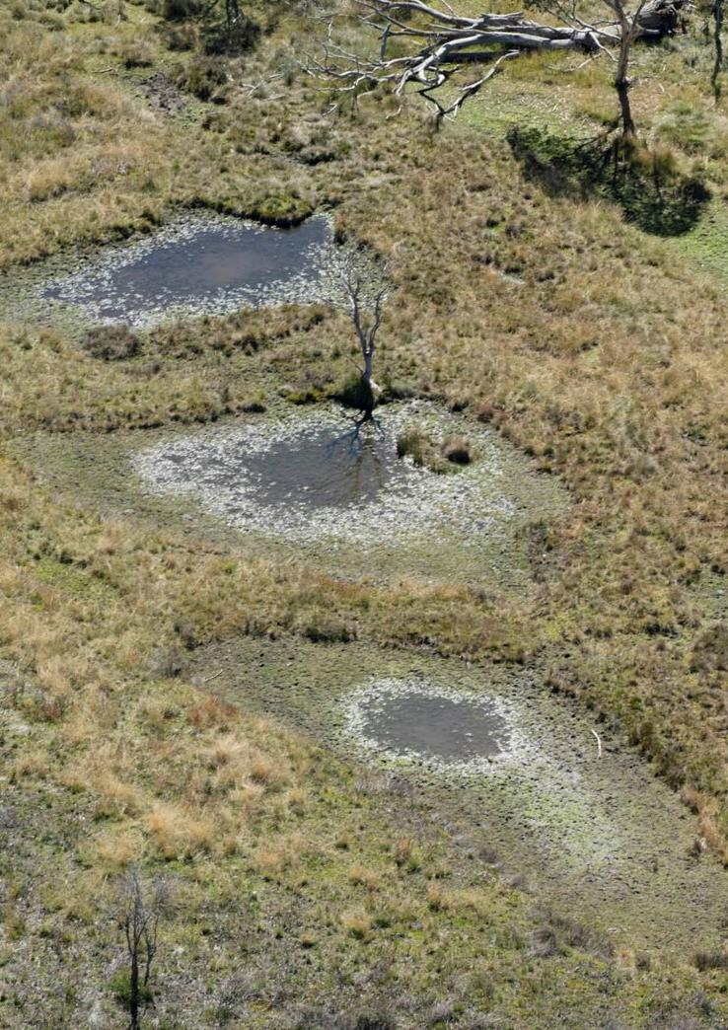

**Caption:** Evidence of wetland damage by feral horses, south of Davies Plain, Alpine National Park.

# Appendix 1 - Maps

## Maps 1 & 2 – Locality maps – Bogong-Cobungra and Eastern Alps

## Map 3 – Burn severity (across feral horse-occupied area)

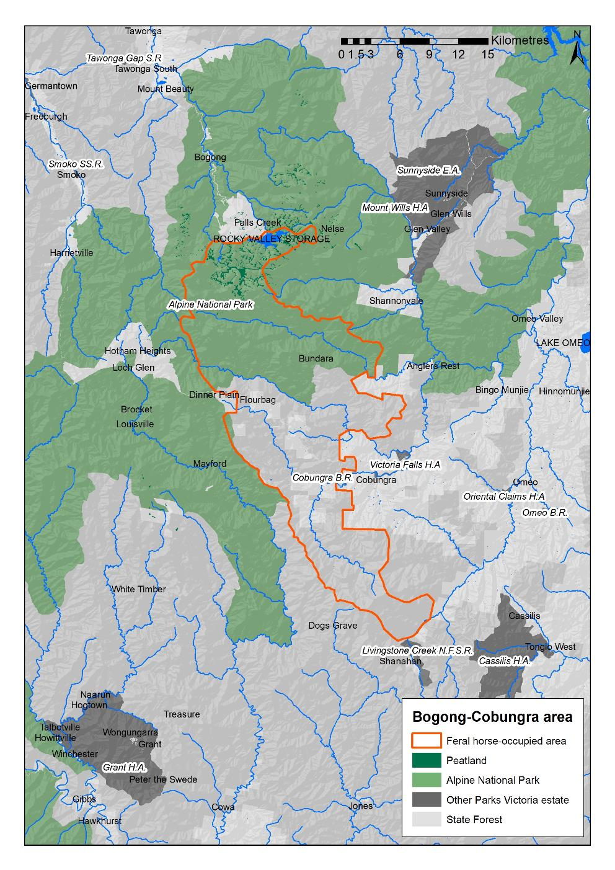

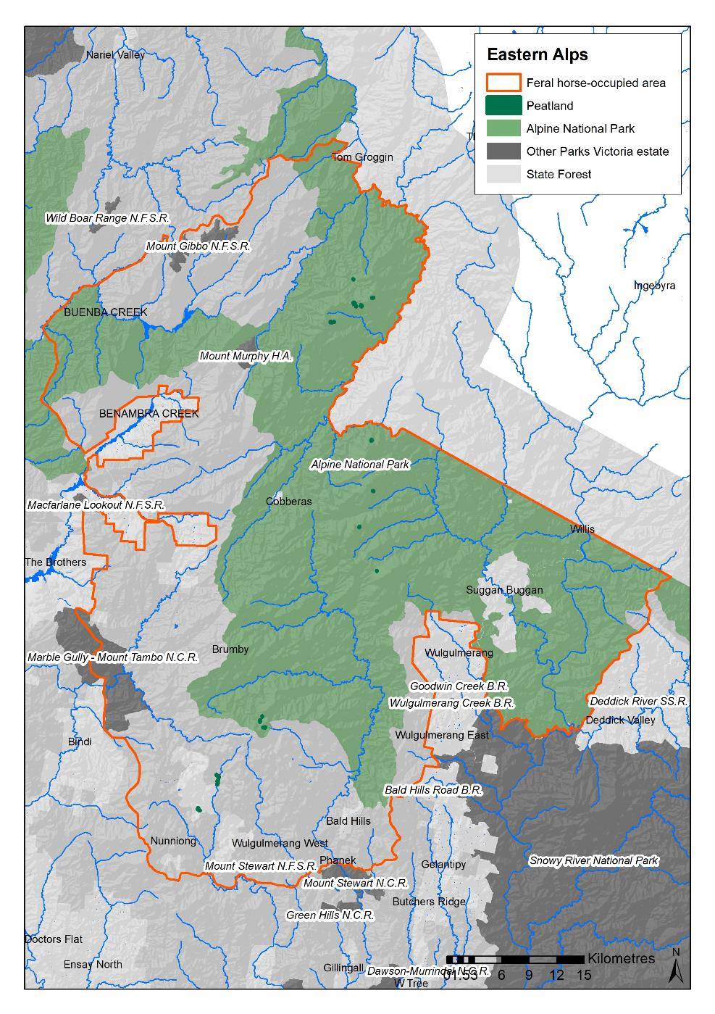

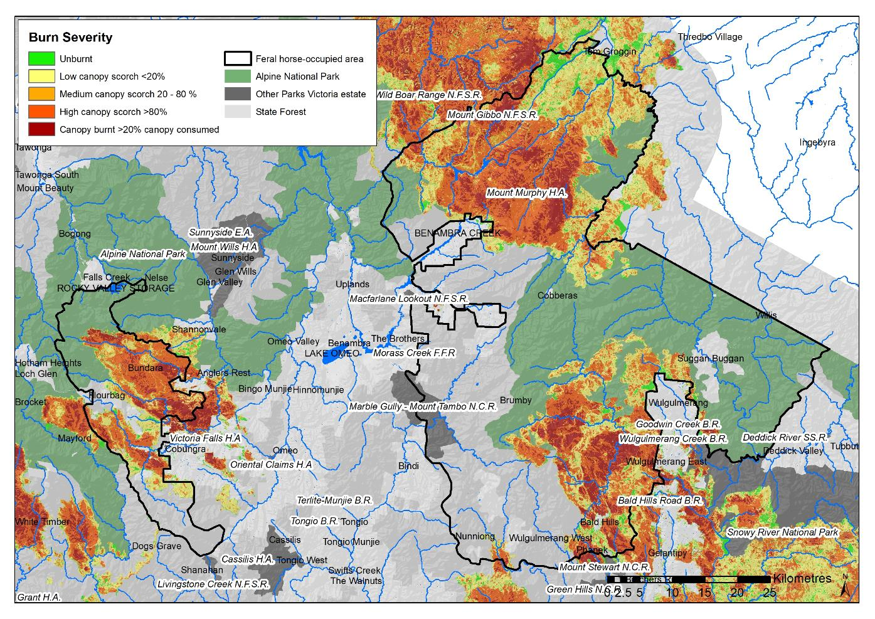

# Appendix 2

## Threatened species and communities

Threatened species and communities potentially at risk from feral horse activity in the eastern Victorian high country.

Sourced from: *Final Recommendation on a* *Nomination for Listing under the Flora and Fauna Guarantee Act 1988 (Potential Threatening Process): Degradation and Loss of Habitats Caused by Feral Horses* (Equus caballus) (Nomination No. 813) (SAC 2011).

EPBC = Commonwealth *Environment Protection and Biodiversity Conservation Act* 1999;

FFG = Victorian *Flora and Fauna Guarantee Act* 1988.

**Table A2.1:** Victorian floristic communities threatened by feral horse activity.

| **Floristic Community or Ecological Vegetation Class** | **EPBC status** | **Victorian status (FFG)** | **Main impacts of feral horse activity** |
| --- | --- | --- | --- |
| Alpine Bog Community | Endangered* | Listed | Trampling (DEWHA 2009[1]), disruption of plant regeneration, selective grazing leading to compositional changes, weed invasion, soil loss and loss of hydrological function. |
| Fen (Bog Pool) Community | Endangered* | Listed | Trampling (DEWHA 2009¹), disruption of plant regeneration, selective grazing leading to compositional changes, weed invasion and loss of hydrological function. |
| Alpine Snowpatch Community |  | Listed | Severe trampling, soil loss, displacement of vegetation, weed invasion, selective grazing leading to compositional changes. |
| *Caltha (Psychrophila) introloba* Herbland Community |  | Listed | Soil loss, displacement of vegetation, weed invasion |
| Montane Swamp Complex Community |  | Listed | Severe trampling, soil loss, displacement of vegetation, weed invasion, smothering by dung piles, selective grazing leading to compositional changes. |
| White Box-Yellow Box-Blakely's Red Gum Grassy Woodland and Derived Native Grassland | Critically Endangered |  | Soil loss, displacement of vegetation, weed invasion, selective grazing leading to compositional changes, interference with regeneration. There are high numbers of feral horses in the White Box Woodlands around the upper Snowy River. |

* Alpine Bog and Fen Pool communities are combined in the EPBC listing

**Table A2.2:** Officially listed or threatened fauna species potentially at risk from feral horse activity in the eastern Victorian high country.

| **Species** | **EPBC / FFG status** | **DSE 2013[2]; 2009[3])** | **Main impacts of feral horse activity** |
| --- | --- | --- | --- |
| Alpine Water Skink (*Eulamprus kosciuskoi*) | ‒ / Listed | critically endangered | Loss and degradation of habitat - alpine bog and fen communities. Trampling by feral horses is listed as a threat in the FFG Action Statement. |
| Alpine Bog Skink (*Pseudemoia cryodroma*) | ‒ / Listed | endangered | Loss and degradation of habitat - alpine bog and alpine fen (bog pool) communities, woodlands and heathlands |
| Alpine She-oak Skink (*Cyclodomorphus praealtus*) | Endangered / Listed | critically endangered | Loss and degradation of habitat - alpine tussock grasslands, alpine low heathlands. Trampling is listed as a threat in the FFG Action Statement. |
| Guthega Skink (*Liopholis guthega*) | Endangered / - | critically endangered | Loss and degradation of habitat - alpine heathland |
| Mountain Skink (*Liopholis montana*) | ‒ / ‒ | data deficient | Loss and degradation of habitat - alpine woodlands |
| Alpine Tree Frog (*Litoria verreauxii alpina*) | Vulnerable / Listed | critically endangered | Loss and degradation of habitat - alpine and subalpine wetlands, riparian zones and ephemeral pools. |
| Smoky Mouse (*Pseudomys fumeus*) | Endangered / Listed | endangered | Degradation of habitat - heathlands and montane woodlands. Increased access by foxes and wild dogs. |
| Broad-toothed Rat (*Mastocomys fuscus mordicus*) | Vulnerable / Listed | endangered | Loss and degradation of habitat - dense wet heathlands and grasslands. Increased access by foxes and wild dogs. |
| Alpine Spiny Cray (*Euastacus crassus*) | ‒ / Listed | rare | Loss and degradation of habitat - alpine streams. Trampling and water turbidity are threats in the FFG Action Statement. |
| Alpine Stonefly (*Thaumatoperla alpina*) | Endangered / Listed | vulnerable | Loss and degradation of riparian zones and degradation of instream habitat. Declines in water quality – direct bank erosion and sediment inputs to streams causing siltation, nutrient enrichment and other changes to water quality (e.g. dissolved oxygen, pH). |
| Mount Stirling Stonefly (*Thaumatoperla flaveola*) | ‒ / Listed | vulnerable |

**Table A2.3:** EPBC-listed, FFG-listed, or VROT plant species potentially at risk from feral horse activity in the eastern Victorian high country. (AROT = Australian Rare or Threatened status, VROT = Victorian Rare or Threatened status.)

| **Species** | **EPBC (AROT) / FFG status** | **VROT status[4]** | **Main impacts of feral horse activity** |
| --- | --- | --- | --- |
| Slender Parrot-pea (*Almaleea capitata*) | ‒ / Listed | vulnerable | Trampling of habitat - sub-alpine heathlands and stream fringes |
| Bogong Apple-moss (*Bartramia subsymmetrica*) | ‒ / Listed | endangered | Trampling, particularly of bogs and fragile stream edges in subalpine heathlands, bogs, and creeklines. In Victoria this species is restricted to the Bogong High Plains area. |
| Austral Moonwort (*Botrychium australe*) | ‒ / Listed | vulnerable | Trampling and loss of habitat - subalpine grassland and margins of bogs and streams. Intolerant of disturbance. |
| Dwarf Sedge (*Carex paupera*) | Vulnerable / Listed | vulnerable | Trampling and loss of habitat in alpine wet heathlands and bogs. Palatable to stock. |
| Marsh Tree-moss (*Climacium dendroides*) | ‒ / Listed | vulnerable | Trampling, particularly of bogs and fragile stream edges in bogs, swampy depressions and creeklines. Known only from 3 sites from near Dargo and the Bogong High Plains. |
| Cushion Rush (*Juncus antarcticus*) | ‒ / Listed | vulnerable | Trampling and loss of habitat - Caltha introloba Herbland Community, Alpine Snowpatch Community and bog margins |
| Snow Daphne (*Kelleria laxa*) | Vulnerable / Listed | endangered | Trampling of damp grass |
| Hump Moss (*Meesia muelleri*) | ‒ / ‒ | rare | Trampling and damage to habitat - boggy grasslands |
| Marsh Leek-orchid (*Prasophyllum niphopedium*) | ‒ / Listed | endangered | Trampling and loss of habitat - alpine wet heathlands and bogs. Observed to be directly impacted (Coates et al. 2002¹.) Trampling and grazing are listed as threats in the FFG Action Statement. |

¹ Coates F, Jeanes J, Pritchard A (2002) 'Recovery Plan for Twenty-five Threatened Orchid Taxa of Victoria, South Australia and New South Wales 2003-2007.' Department of Natural Resources and Environment, Heidelberg.

# Appendix 3

## Biosecurity approach

A principle in invasive species management throughout Australia, whether the target species be plant or animal, is the identification of the level of threat. Management objectives can be determined using a *biosecurity approach* that directs investment to one of four levels of action: prevention, eradication, containment and asset protection. This is a model approach advocated in Victoria’s Invasive Plants and Animals Policy Framework (DEPI 2010 - Figure A3).

Large and uncontrolled populations of feral horses provide a potential reservoir for exotic diseases such as equine influenza (DAF, 2016), and the spread of such disease to domestic livestock, including horses, is a biosecurity risk, with potential economic and human health implications. Feral horse control would be a preventive action to address this risk, applying the approach being taken to manage impacts on biodiversity and catchments.

***Prevention* involves preventing an invasive species from establishing in an area and offers the most cost-effective approach to managing the threat posed by a high-risk invasive species.**

***Eradication* involves removing every individual of the target species from an area and preventing re-colonisation. Eradication is generally only feasible for small isolated populations, often in the early stages of establishment.**

***Containment* involves implementing measures to eradicate outlying (satellite) infestations and preventing spread beyond the boundaries of core infestations (those that are too large and well established to eradicate).**

**The *Asset protection* approach involves focussing the management of an invasive species in areas where reducing its adverse effects provides the greatest benefits for protecting and restoring specific high value assets.**

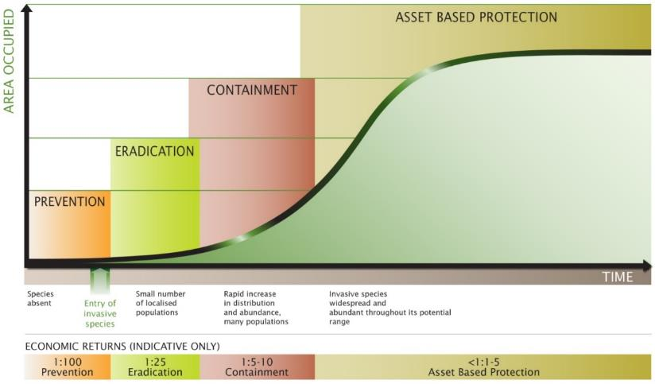

**Figure A3.1:** The generalised invasion curve showing objectives appropriate for each stage of invasion/establishment and the reduction seen in the economic returns of managing an invasive species as it becomes more widespread and established (DEPI 2010).

Feral horse management in the Alpine National Park will apply a combination of prevention, removal or eradication of small populations where feasible, containment and asset protection objectives. In the eastern Alps, asset protection will take the form of localised removal of horses from areas of high biodiversity or catchment value and a generalised reduction in population abundance.

Back Cover:

Native Cat Flat in March 2021, showing the effects of overgrazing and trampling by feral horses, with grass mown down to the ground surface, streambank vegetation completely removed, trampling evident along the complete length of the stream, and the only remaining habitat for wetland-dependent fauna occurring within the fenced exclosures.

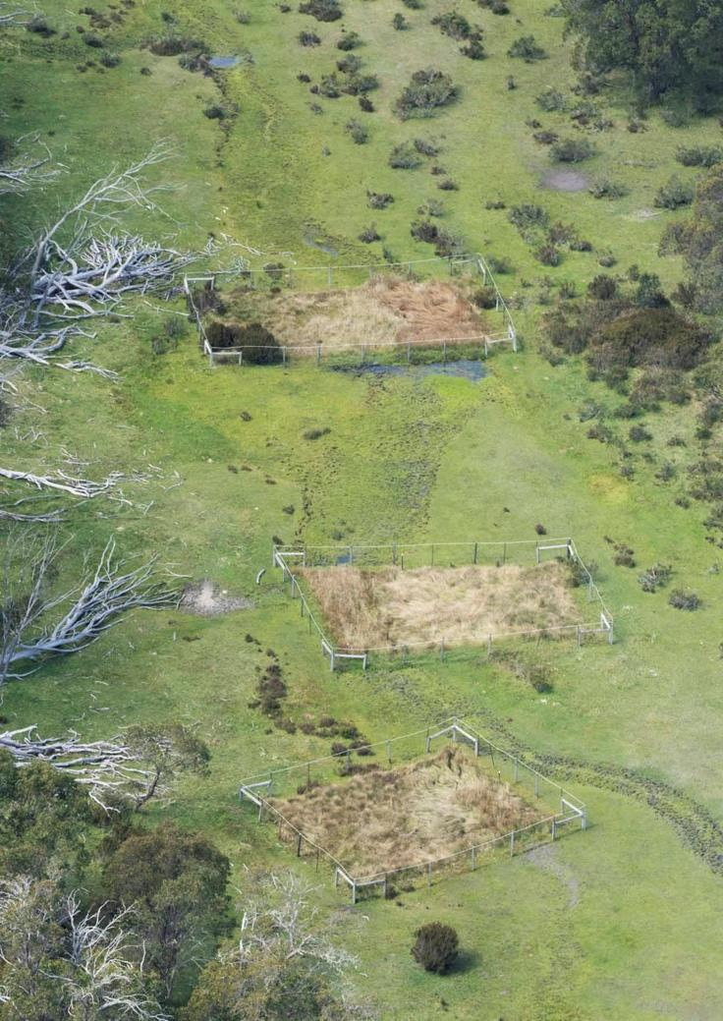



1. DEWHA (2009) *Alpine Sphagnum Bogs and Associated Fens, a Nationally Threatened Ecological Community, EPBC Policy Statement 3.16.* Department of the Environment, Water, Heritage and the Arts, Canberra.
2. DSE (2013) = *Advisory List of Threatened Vertebrate Fauna in Victoria – 2013*
3. DSE (2009) *= Advisory List of Threatened Invertebrate Fauna in Victoria – 2009*
4. Advisory list of rare or threatened plants in Victoria -2014