Future direction – A healthy environment where people can connect with one another while being immersed in nature and culture.

There is a considerable body of research that indicates that time spent in nature, including parks and plantings, brings appreciable health benefits and contributes to population health outcomes
as identified in the Victorian Public Health and Wellbeing Plan 2015-2019 and the accompanying Population Health and Wellbeing Outcomes Framework. Albert Park provides an important setting for people to visit, gather and participate in events.

A greater amount and variety of flora and fauna species will encourage people to spend more time in the park, and to return often, as they are more likely to experience something new each time they visit. There are opportunities for park users to have both an incidental and active engagement with Albert Park’s environmental setting, in the following ways:
- Incidentally – through an increased presence of flora and fauna, as people are undertaking their regular activities (e.g. running, social gatherings, sporting events); and
- Actively – through the provision of interpretation and structured activities for school and community groups to learn about biodiversity in Albert Park.

Programs and spaces will need to be adaptable for a healthy community and to cope with climate change.
- Initiative 1 – quality amenities and facilities

A suite of high quality, contemporary facilities is required to support increases in visitation projected during the course of Albert Park renewal over the next 25 years. This will include:
- Increased tree planting
- An identified hierarchy of walking and cycling trails
- Boardwalks and decks
- Public toilets with universal access
- Benches, seating and tables
- Shelters
- Drinking fountains
- Fencing, bollards and rubbish bins
- Way finding, signage and interpretation.

The aim of the master plan is to ensure these facilities are considered holistically as a collection of complementary materials, design and elements which together contribute to the sense of place of Albert Park.

The public use of shared facilities and amenities associated with clubrooms will be considered, to minimise the number of buildings and structures within the park. Refer to Theme three ‘Healthy and active”.

Action:
Develop a series of design and development parameters to provide guidance on the design of park assets and facilities.

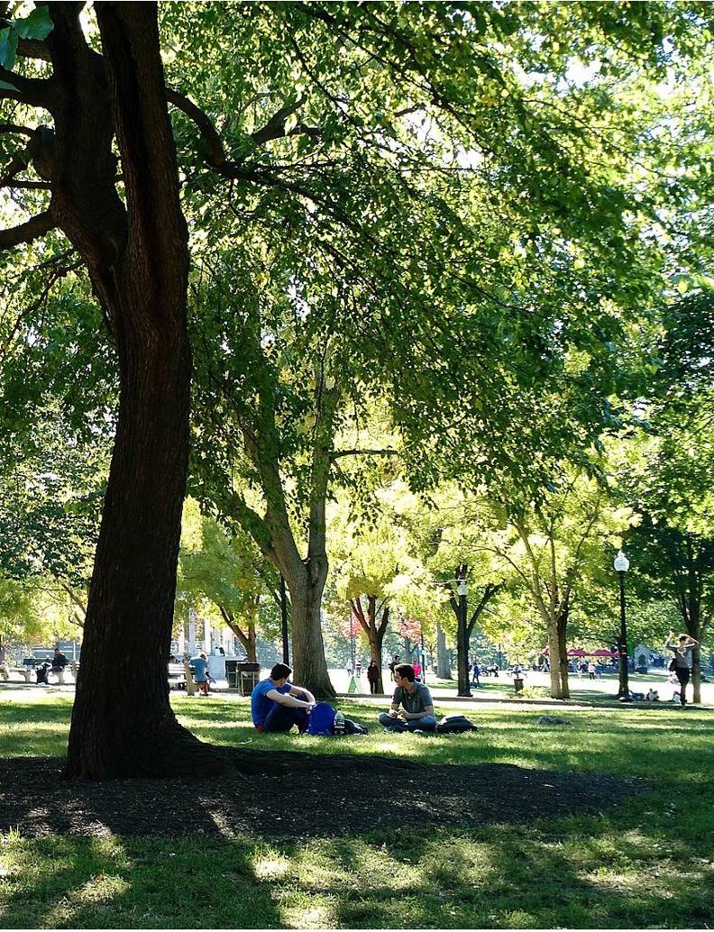

Image: Open Woodland Photo credit: Phoebe2018.
Page: 63

A healthy urban parkland

- Initiative 2 – flexible event spaces

Albert Park will provide flexible and adaptable spaces of varying scale that will enable multiple events of various sizes and duration to occur simultaneously within the park. The aim of the master plan is to provide event spaces that will be developed in coordination with the programming for the use of the sporting fields.

Many of the current event spaces within Albert Park are located alongside and occasionally on the highly utilised sporting fields. With Albert Park continuing to be an important parkland venue for numerous Melbourne events, additional pressure is placed on access, traffic congestion, availability and the quality of playing surfaces.

Events that attract participant numbers in the order of 100 to 3,000+ people will continue to be accommodated, ensuring there is a demonstrated community benefit (as outlined in the City of
Port Phillip, Open Space Strategy, 2009). Further investigation of events working with the sporting fields programming will be explored, so that the maximum availability for sports on high quality playing fields is prioritised. This will take into account any possible remediation works required post event to ensure the fields are at optimum quality for play. These areas would be suitable for hosting medium sized events and smaller community events.

Any major future changes to the park will require the current event locations and sizes to be reviewed for greater access and use of under-utilised areas of the park.

Events run and operated by tenants within their leased premises will continue to be accommodated within the management of the park.

Major events – approximately 3,000 guests
The Noel Clarke and Barry Dixon sporting fields will remain the location for major events. The aim of the master plan is for all events to coordinate with the sporting fields programming, prioritising club
sport availability on high quality playing fields. As an alternative, the Pelican Lawn and Ibis picnic/event areas can be combined to provide the space to cater to smaller large events.

Major event areas will include the following features:
- A large open lawn area suitable for a temporary stage and festival space, with good vehicular access
- Establishment of trees, which over time will provide much-needed shade and shelter surrounding the events area
- Permanent plug and play points for event exhibitors, ensuring easy access to power, water and data
- New all-abilities access public amenities facilities co-located with another building.

Medium-scale events – 1,000 to 2,999 guests Medium scale events and community events that attract up to 2,999 people have multiple location options available in the park.
These areas will include an open lawn area including trees for shade and character. To accommodate event infrastructure, access to power, water and communications will be provided in specific all weather locations.

Small-scale events – 100 to 1,000 guests
Smaller events and community events that attract up to 1,000 people have multiple locations available in the Park. These areas include:
- the leafy urban plaza located at the Fitzroy Street end of the park
- the open lawn amphitheatre adjacent ‘Carousel’
- the area behind the St Kilda Park Primary School; and
- Grebe Picnic Area.

Action:
Include flexible event spaces in ongoing planning of Albert Park for planned and social events including a schedule for the upkeep of the event spaces.

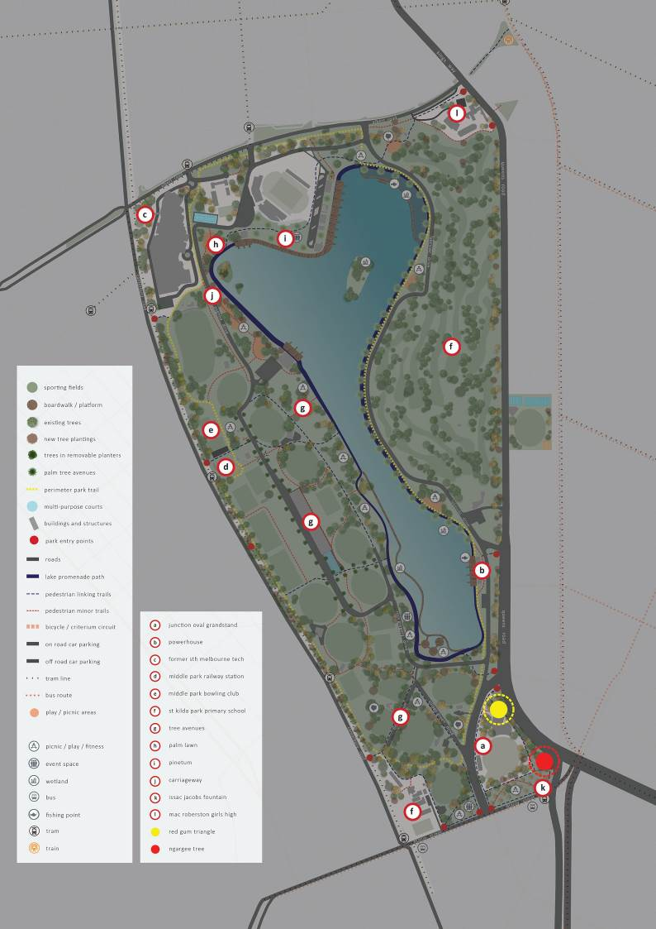

0 50 100 250

Page: 65

Initiative 3 – recognise and celebrate cultural heritage

The master plan will reference the park heritage through any new design. The aim of celebrating the culture and heritage of the park is to ensure the layering of the park’s history is recognised and embedded into its future.

Prior to European occupation, the area that is Albert Park was a swampland and lagoon, and a valuable food source for Traditional Owners, whose understanding of Country through their knowledge systems allowed them to live off the land.

Over the past 200 years, the landscape has been highly modified, making it difficult to read Country as a knowledge system, in the way of Traditional Owners. Successive waves of swamp drainage, grazing, land filling, and establishment of formal plantings have all shaped the park, as it appears today. The many layers of the park’s natural and cultural history are subtly woven through the site.

Albert Park has experienced multiple waves of redesign and development in response to changing aspirations. Originally covering around 600 hectares in size, the current 255 hectare park has been shaped by settlement pressures, wars and elite sports. Notable existing features of the park include the Ngargee (Corroboree) Tree and select avenues of trees, the carriageway near the Queens Road boundary, and the Blackie Ironmonger stand at the Junction Oval.

Initial discussions with the Traditional Owners need to be further developed to ensure their aspirations for the immediate area, surrounding the Ngargee (Corroboree) Tree and for the greater park, are realised prior to any further works within this area. More interpretation of the European heritage is also proposed, and will need to be developed as part of an overall Interpretation Strategy.
The Ngargee (Corroboree) Tree
The Ngargee Tree is an old River Red Gum and is highly significant for the Traditional Owners of the area, due to its age.

The aim for the immediate area surrounding the Ngargee Tree is to be further developed in collaboration with the Traditional Owners of the area, to ensure their aspirations for the site are realised.

The Ngargee Tree is included in Victoria’s National Trusts of Australia Register of Significant Trees.
The Ngargee Tree and its immediate environs are culturally important to the Traditional Owners as a living link to a pre-settlement time. Contemporary use of this place is for contemplation and learning about the cultural and natural history of the area.

Initial discussions with Boon Wurrung foundation, Bunurong Land Council Aboriginal Corporation and Wurundjeri Land Council identified their respective aspirations. Further discussions will be required to determine an agreed direction for the space prior to any additional planting works being undertaken in this area.

The Red Gum Triangle
Located on the north side of the Junction Oval, the Red Gum Triangle provides a snapshot of the indigenous vegetation of the area, that can be accessed via a low key pedestrian path.

The aim of the master plan is to ensure continued support for the retention of the indigenous character of the Red Gum Triangle area and providing pedestrian access for an educational and immersive experience located in a highly urbanised area.

The Red Gum Triangle boasts stands of Red Gums and other native trees, with its characteristic native under storey, providing a picturesque, shaded pocket of local, indigenous vegetation.

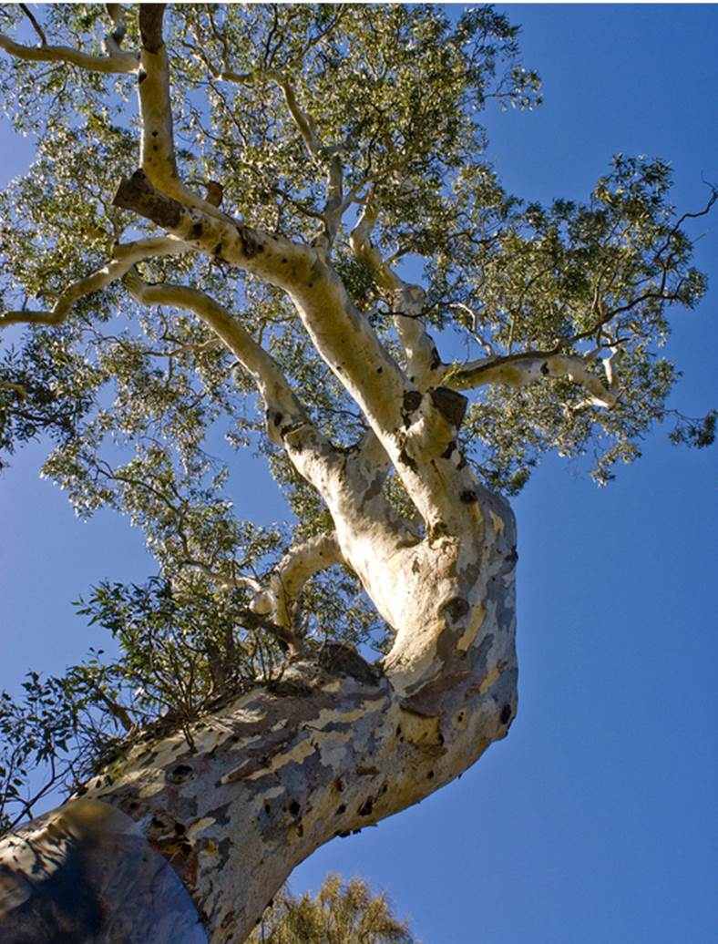

Image: Ngargee Tree, Albert Park, Melbourne
Photo credit: Parks Victoria, 2018.

Largely the result of work by park volunteers to date, continued support for indigenous restoration will ensure this unique character endures for many decades to come.

Visitors will be encouraged to meander along a defined path, developing a greater appreciation and understanding of the area’s original vegetation. This pocket of remnant vegetation established around the historic Ngargee Tree provides an opportunity to build volunteer services and educational programs.

A secondary pedestrian path will connect the Red Gum Triangle with the Ngargee Tree environs to the south and, north to the perimeter path.

European heritage
European heritage sites listed on the Victorian Heritage Register, including those immediately neighbouring the park, will be conserved and incorporated into an Interpretation Strategy.

The master plan aim is to ensure the layering of the park’s heritage is recognised and celebrated into the future.

The Interpretation Strategy will include other relevant registered sites under the Victorian Heritage Register and any identified on the Victorian Heritage Inventory.

Other cultural elements that will be incorporated into the Interpretation Strategy include the gates at the Aughtie Drive entrance at Albert Road, and the Isaac Jacobs Memorial Fountain. Currently located in the south eastern corner of the Park, adjacent to Fitzroy Street, the fountain will be relocated within the park and away from the park boundary.
Action:
Develop an interpretation plan to consider Albert Park’s cultural and historic values. Protect the cultural values and engage directly with Traditional Owner groups to determine agreed course of action for cultural values and heritage.

10.0 Theme three - healthy and active

Healthy parks, healthy people

The City of Port Phillip is the most densely populated local government area (LGA) within inner Melbourne with more than 50% of its residents living in high density units, flats and apartments. Although Albert Park is not the only public open space within the municipality, it does provide nearly 40% of the available public open space for the City of Port Phillip.

Albert Park provides and will continue to provide a range of open space facilities that are easily accessible and cater to the increasing needs of
municipal, metropolitan and regional communities including national and international visitors.
The Albert Park Master Plan will increase the capacity of sporting reserves by upgrading facilities and grounds in order to promote and provide for foundation level sports opportunities including
increasing junior and female sporting pursuits. This is equally supported by a key recommendation of the ‘City of Port Phillip Open Space Strategy 2009’.

High quality surfaces and increasing access to paths and walking tracks aim to provide greater and diverse opportunities for walking, which was identified as
the most popular activity in both the ‘City of Port Phillip Open Space Strategy 2009’ and Albert Park Master Plan engagement process.

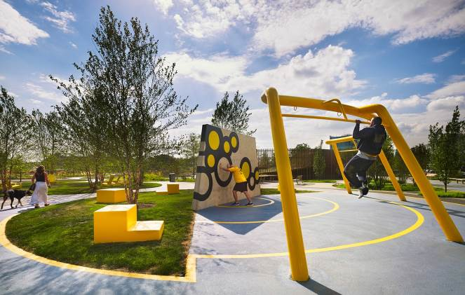
Image: Active Play, Melbourne Photo credit: Parks Victoria, 2018.
Page: 69

Future direction – an adaptable and diverse urban park that is enjoyed and valued for relaxation, sports and recreation.

    - Initiative 1 – programming sports ground use

Albert Park will ensure access to sports fields for training and games by developing more efficient programming and sharing of sporting grounds and facilities.

The aim of the master plan is to provide sporting grounds and facilities to cater to the increase in participation rates of diverse sports and greater team diversity and numbers.

A number of opportunities have been considered to increase the availability of sporting grounds while minimising impacts on existing tenants and ensuring major events are not affected.

In the medium-term, the current location and general layout is considered appropriate. Future changes to the use of the Sporting Precinct area will require broader precinct context consideration for integrated and holistic outcomes.

To provide for a greater carrying capacity and to better cater for future demand, Parks Victoria will work with the sporting clubs to increase the potential for greater diversity and participation.
Developing efficient programming and the sharing of sporting grounds and facilities is based on ‘best practice’ approach, both locally and internationally, to deal with the increased pressure on existing
sporting grounds. The implementation will be staged over time.

Where pavilions and clubrooms require significant upgrade, consideration could be given to shared use needs and public accessibility to amenities and facilities. Albert Park will remain a state wide
destination for organised amateur sports, attracting players and clubs from around Melbourne.

The key challenge for the future is how to provide an adequate range of high quality sports grounds as visitation and demand increases over time.
    - Initiative 2 – increase resilience and performance of sports grounds

In order to cater to increasing demand, further investigation of new and emerging technologies such as synthetic surfaces and new hybrid grasses will be undertaken with the aim of increasing resilience and availability of sports fields.

Where sports grounds are to be upgraded, the size, configuration and surface type should be
reconsidered in light of the available technology and specific needs.

Action:
Detail plans for the upgrade of sports grounds and facilities for future upscale of sport participation and use. Develop an efficient program for the shared use and activation of sports grounds
to maximise use and minimise impact and maintenance.

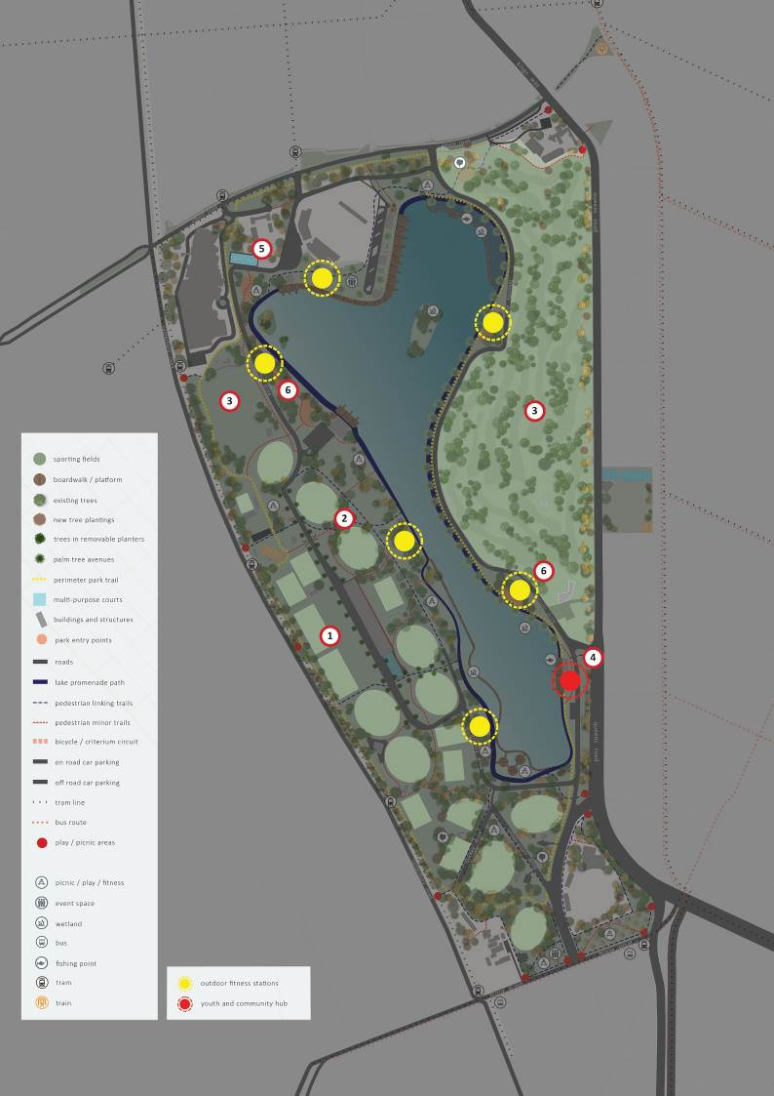

0 50 100 250

Page: 71

Health and activity

    - Initiative 3 – retain a golfing offer

The aim within the master plan is to retain the current 18 hole golf course and golf driving range at Albert Park in their current location. A key feature
of the existing golf course is the well established planting and tree cover. This landscape adds to the significant character of Albert Park. Increased tree planting throughout Albert Park will build on and support the landscape character of the current golf course.

Parks Victoria will assess the golf offer provided at the golf course and golf driving range and consider a competitive allocation process for a future offer, in accordance with policy and legislative requirements.

Guiding principles for golf have been prepared by key stakeholders including golf clubs, current lessees and Parks Victoria to direct future actions
and improvements to the golfing offer in Albert Park. (Refer Section 12.0 Appendices: Appendix C)

Action:
Use the principles for golf in Albert Park to determine future improvements to the golfing offer in Albert Park.

    - Initiative 4 – youth and community social hub

The aim of the social hub is to provide an outdoor space that encourages young people to gather and participate in informal sports and activities. It is
a common space and a place to meet and catch up with friends, a similar social function of MSAC. Immediately located south-east of MSAC, on the
Lake Promenade alongside the fitness park, outdoor facilities, structures and spaces are proposed
that complement Albert Park’s existing recreation opportunities.

Targeting young people and those visiting MSAC, it will cater to a variety of exercise opportunities, such as parkour, table tennis and half-court basketball, encouraging social interaction.

Action:
Deliver a youth and community social hub that facilitates and builds on social connectivity and visitor amenity and health.
    - Initiative 5 – multi-use courts

The multi-use courts provide important recreation spaces for children and youth as well as overflow spaces for the school and community. The objective is to provide programmable opportunities for the multi-use of a highly desired space.

The courts are designed to cater a range of activities including activities such as netball, basketball, volleyball, 5-a-side soccer and other similar activities. The courts will cater for both school programming and casual ‘drop-in’ sessions by locals out of school hours.

School drop-off and pick-up, together with parking are all programmable opportunities of the multi- use courts. An additional flat grassed open space between the school and Lakeside Stadium will also be able to be used in the same manner.

Action:
Provide programmable opportunities for the multi- use courts given they are highly desired spaces.

    - Initiative 6 – outdoor fitness

In line with Parks Victoria’s Healthy Parks, Healthy People philosophy, fitness equipment that incorporates natural fitness elements will be located close to the Melbourne Sports and Aquatic Centre, with a greater number of facilities located at specific intervals along the Lakeside Promenade.

An outdoor fitness park with a range of equipment will provide fitness opportunities for a diversity of skills, ages and abilities. The aim of this outdoor fitness park is to contribute to and encourage the health and fitness of visitors to Albert Park.

This will supplement the existing opportunities that are provided in the surrounding City of Port
Phillip, and will provide a location for serious fitness devotees, those who thrive on group activities, and pushing the fitness envelope.

Action:
Plan and deliver outdoor fitness spaces to cater to a diversity of participants that facilitate and contribute to the health of park visitors.

Health and activity

1 Initiative 7 – contemporary play spaces

The park’s vegetation and a number of play spaces will provide a diverse range of play experiences targeting the varying and different needs of visitors.

The objective of the master plan includes a major interest in a diverse range of play spaces, with further research to be undertaken for existing play space offers within the neighbouring area. Many visitors come to Albert Park with their children to play. Play spaces provide an engaging activity for children of parents visiting to participate in walking, sports or picnicking. Most of the play spaces are located adjacent to the Lake Promenade, making them easily accessible. Facilities including shade, toilets, water fountains and fitness stations are important in supporting play experiences.

Family play space
The family play space provides an engaging experience for the entire family, with larger adult and family-scale natural and constructed play equipment encouraging interaction between parents and
their children, providing an important adjunct to traditional play equipment. It will be located closer to Albert Road.

Nature play space
Nature play provides greater opportunities for engagement with the natural and cultural
environment of Albert Park, by encouraging activities that may involve modifying and interacting with the natural landscape. Nature play can be experienced across the park, in particular within areas of native vegetation adjacent to the Lake Promenade, and specifically on the western side. These areas act as adaptable open space – a place for nature play, a place to picnic and a place for gatherings.

Creative and densely planted, these spaces create opportunities for more intense nature play. These areas of thick plantings are scattered around the lake and adjacent to the community playground.

Page: 73

Adventure play space
The adventure play space creates an exciting and energetic play environment for older children encouraging exploration and discovery. An obstacle course provides a range of challenging tasks for children of varied ages, through a combination of the natural environment interspersed with unstructured play features.

All abilities and needs play space
All play spaces in Albert Park will provide for opportunities to integrate play for all age groups, interests, abilities and needs. A play space focusing particularly on special needs, such as those required for children on the autism spectrum, with hearing, sight or visual impairment or mobility limitations
will be located along the northern end of the Lake Promenade. This play space will form part of an overall play strategy to provide greater opportunities and access to amenities for all.

The existing toilet block at the north-western corner of the lake will be remodelled to provide for all

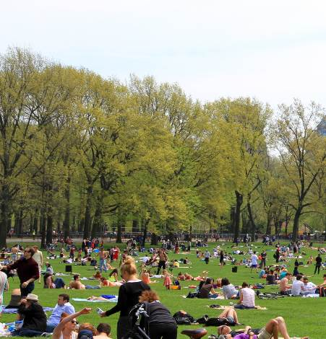
Image: Central Park, New York Photo credit: ngfbruno, 2018.

abilities, including a changing places facility, suitable for people with severe and profound disabilities. The increase in palm canopy of the adjacent Palms Lawn will provide a more comfortable and shade
amenity, connecting the play space, changing places facility through to the boat shed with its sail-ability program for people of all abilities.

The relatively flat topography of Albert Park, together with an increase in high quality opportunities for all abilities activities and access will label Albert Park as an exemplar park and a destination of choice.

Community space
The timber play structure of the Middle Park Community Playground is to be upgraded to meet current play standards. An adjacent new nature- based play space primarily targeting early teenage children will make up the community play space.

Wetland play space
The wetland playspace sits adjacent to the Lake Promenade and engages with the lake. It will provide
a simple and elegant water play experience in a natural setting. Like most water parks, the attraction is around the interplay and control of water such as water sprays, channels and control of water through building of dams and opening sluice gates.

The wetland play space adds to the range of combined picnic/play/fitness experiences located around Albert Park.

Fitness opportunities will be incorporated into the spaces to allow for casual fitness activities to be undertaken in a relaxed environment by parents of children.

Action:
Deliver a series of play spaces along a defined park journey and landscape narrative to cater to the diversity of visitors and young people that explore, investigate and experience the various environmental aspects of the park and lake.

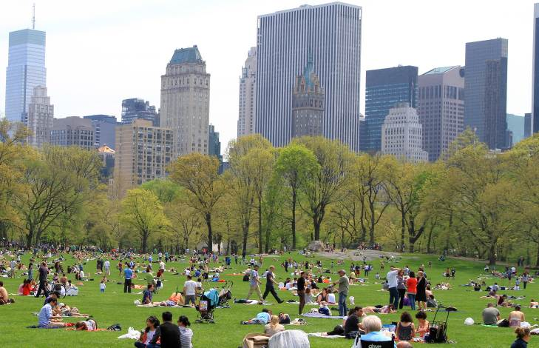

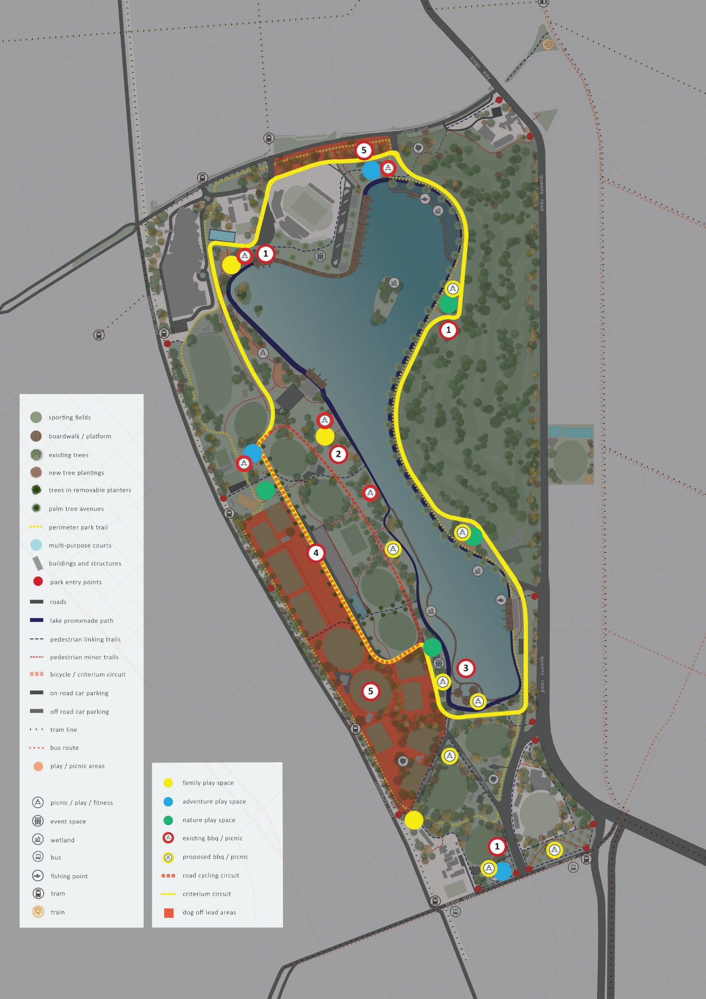

0 50 100 250

Page: 75

Health and activity

- Initiative 8 – revitalise picnic areas

Four existing picnic and barbecue facilities located around the Lake Promenade will be improved with an additional six to be created.

Albert Park’s picnic facilities are outdated and under-provisioned; the aim of the master plan is to undertake a significant expansion and upgrade to cater to future demand and meet contemporary standards and cultural needs.

Picnicking is particularly popular with different cultural communities who may gather in larger groups to celebrate events. Facilities that cater for cultural needs and practices as well as large groups are an attractor, including appropriately sized and arranged tables and spaces, toilets and type of barbecue facilities.

Albert Park will provide a greater opportunity for visitors to enjoy and connect with nature in attractive and sheltered environments. The four existing picnic and barbecue facilities to be improved include:
- Coot picnic area
- Swan picnic area
- Lakeside Drive (adjacent Eastern Woodlands)
- North of Cormorant picnic area.

The six new picnic areas will include:
- Wetlands picnic area (near Queens Road Slip Road)
- Nature play picnic area (between the lake and the golf course)
- Various locations along the western side of the Lake Promenade
- Near the Fitzroy Street interface
- Adjacent to the Ross Gregory Oval on the north- eastern side (including barbecue facilities)
- Southern wetlands (including barbecue facilities).
Action:
Upgrade existing picnic and barbecue facilities and provide additional picnic and barbecue facilities to accommodate greater visitation to and use of the park.

- Initiative 9 – lakeside platforms

The aim of the master plan is to create increased engagement opportunities with the lake and lake edge. The placement of occasional lakeside platforms located along the Lake Promenade will provide a range of different functions supporting yachting, rowing, fishing and model boat racing.

Integrating platforms into the design of the lake edge will provide the opportunity for walkers and joggers to stay close to the water. Continued access and views for park businesses and water based clubs will be maintained and enhanced.

Action:
Deliver a series of lakeside platforms that engage with the lake to provide greater and more flexible opportunities for interaction, education and interpretation.

- Initiative 10 – criterium circuit and road cycling

The aim of the master plan is to provide adaptable multi-use and functional spaces wherever possible and adapting existing infrastructure to create such opportunities. One initiative is to create a criterium circuit and on-road cycling route using existing pavement infrastructure.

The criterium circuit will utilise a section of Aughtie Drive and Aughtie Walk on the western side of the park.

•
An iconic new feature of Albert Park, the wetland picnic area will consist of a number of individual decks leading off the boardwalk, providing an innovative new experience consisting of a network of small retreat spaces, each unique and distinctive in its location, which respond to the aquatic environment of the wetland. Together with the wetlands play space, this creates a major new destination for families.

An additional programming opportunity exists for a cycling street circuit, utilising existing road infrastructure around the entire lake. Further
consultation with Cycling Victoria, and local cycling clubs will be required to ensure that any circuit can be designed to provide for a breadth of functions from local competitions through to elite events, while continuing to function as a park at other times.
This programming is responsive to the ‘Shrine to Sea’

cycling and pedestrian initiative that looks to create a major pedestrian and cycle link to run along Albert Road and enable connection into Albert Park.

Action:
Develop a criterium circuit and on-road cycling route utilising existing pavement infrastructure for programmed use.

- Initiative 11 – dog off-lead areas

The master plan aim is to continue to cater to the dog walking activity at the park and to retain dedicated dog off-lead areas.

Dog walking is an important recreational activity and many visitors to the park prefer to walk their dogs
off-lead. Defined dog off-lead areas provide this opportunity while reducing the risks to other park users.

With the opening of the new South Melbourne Park Primary School in 2019, the dedicated dog off-lead area along the Albert Park Road park interface has been reduced. The section directly in front of the new school, from Aughtie Drive to Lakeside Drive has been removed for the safety of the local school children.

The existing dog off-lead area on the western side of the park will remain to its current extent.

Action:
Continue to provide dedicated dog off-lead areas for visitor and dog walker needs, focusing on the social aspects and visitor safety.

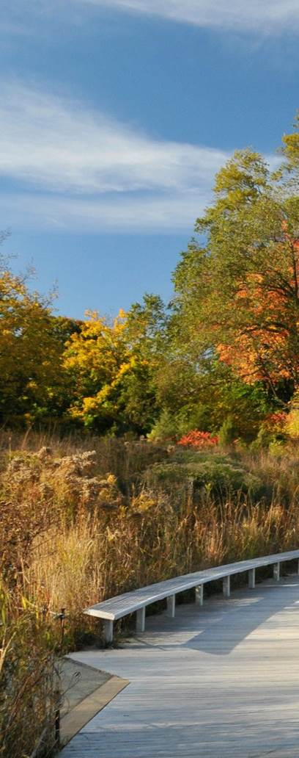
Page: 77
Image: Boardwalk
Photo credit: HorsePunchKid

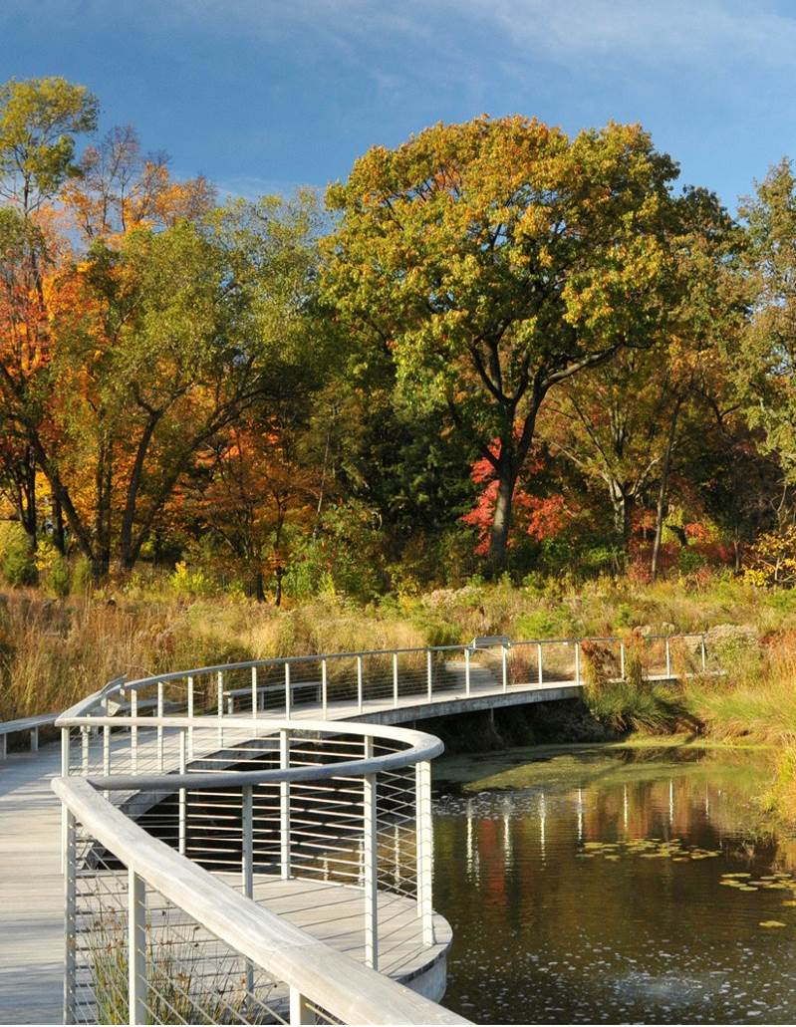

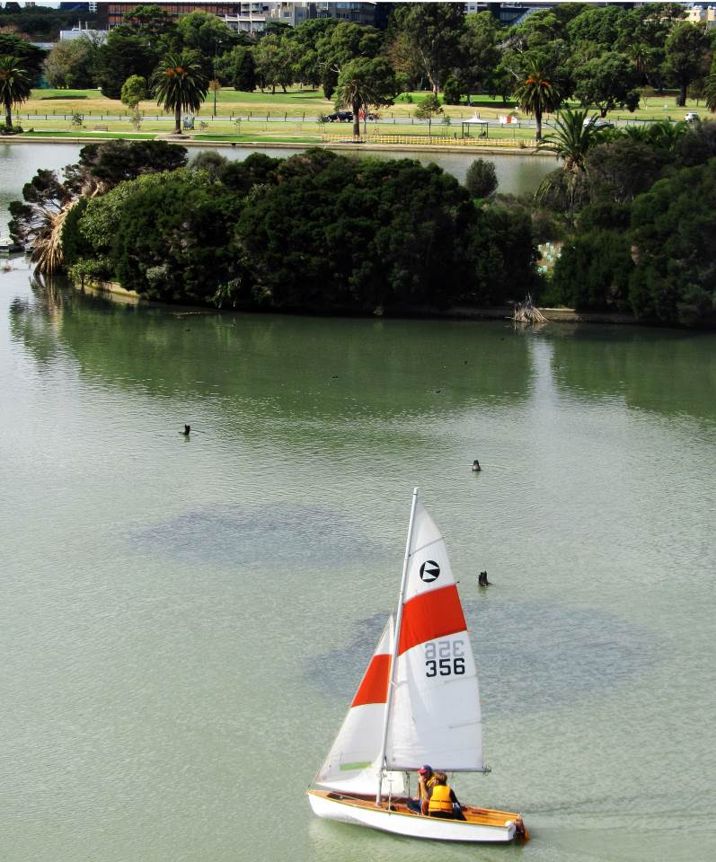

Page: 79

Image: Sailing, Albert Park Lake
Photo credit:

Implementation strategy

A strategy for the future

Implementation methodology

Page: 80

This chapter outlines an implementation strategy and governance framework to support delivery of the master plan’s 25-year shared community vision. It describes the broad process to be followed over time for achieving the master plan’s vision, for sustainability of the park into the future and key criteria against which management decisions can be made.

Due to the complexity of functions and operations at Albert Park, actions will be implemented incrementally over time as leases expire and new opportunities arise, visitation and demands change and as funding is made available to support the associated capital works program.

The implementation strategy provides initial guidance based on a preliminary cost plan which identifies broad costs for the key initiatives in the master plan. More detailed business cases will be required to secure government and private sector investment.

The master plan proposes adaptation and activation of the site to meet the changing needs of the City of Port Phillip and Melbourne’s growing population.

The programming and construction of new infrastructure and facilities will follow industry and government best practice, provide flexibility, support a diversity of complementary uses and provide resilience and sustainability into the future.

This plan does not represent a commitment to implement any or all recommendations, which will be staged over time and are subject to available funding and resources.
In the design and development of project recommendations, other project costs to make allowances for are as follows:
- Contingencies
- Treatment of contaminated material
- Statutory planning advice
- Services including lighting and irrigation
- Escalation
- Consultants fees
- Cultural heritage planning
- Traditional Owner engagement
- Management and operations planning
- Project management fee.

In the delivery of project recommendations, other project costs to make allowances for are as follows:
- Staging of works
- Art work
- Latent ground conditions
- Relocation of existing services
- Legal and marketing
- Rock excavation.

Consideration of these cost factors and the probable order of cost for ongoing maintenance and management, at the initiation of projects, will provide a better understanding of whole of life project cost.

PLANNING
DIRECT SETTING
INFRASTRUCTURE

Preliminary upfront development of overall landscape design, plans, strategies and frameworks to help support the ongoing stages of implementation.
Long term
7 -10 years

- Establish stakeholder reference groups to input into initial design phases.
- Develop a series of park management and asset development aims, guidelines, parameters and principles.
Short term
1 - 3 years
- Develop whole of park landscape plan including furniture, lighting and signage style guide.
- Plan, design and integrate ﬂexible event spaces, sports ﬁelds, open spaces and broader landscape.
- Develop an interpretation strategy.
- Review the current vehicle access and parking approach and key traﬃc management issues.
Medium term
4 - 6 years
Any new built works including wetland, picnic facilities, playgrounds, Fitzroy Street urban space setting etc.

- Protect and conserve cultural values.
- Continue to provide dedicated oﬀ-lead dog areas.
- Protect and undertake speciﬁc planting for Gunn Island.

- Implement parking and road traﬃc management plan.
- Deﬁne and formalise park entrances, diﬀerentiating primary and secondary entrances.
- Improve and upgrade a 5km lakeside promenade.
- Create a walking path loop through the park.
- Implement improved bicycle network through the park.
- Provide a criterion cycling circuit.
- Upgrade sports grounds and facilities.
- Extend park character to Albert
Road.

Other partnerships
- Consider safe pedestrian access
across Queens Road to Albert
Park.
- In collaboration with
government agencies enhance
the pedestrian access along
Fitzroy Street and at St Kilda
Road Junction.
Infrastructure that utilises existing setting or features for example parking, criterion circuit, walkways, promenade etc.

- Upgrade existing and install new picnic and barbeque facilities and other park furniture.
- Implement new signage and wayﬁnding.
- Deliver a youth and community social hub.
- Deliver outdoor ﬁtness spaces.
- Deliver a series of play spaces
catering to diverse age groups
and abilities.

- Deliver a holistically integrated lake and lakeside interface including wetland.
- Deliver lake edge wetlands with access via a boardwalk system.
- Deliver a series of lakeside platforms for greater lakeside activation, engagement, education and interpretation.
- Deliver a wetland play space.

Other partnerships
- Public Transport Victoria links to
park
- City of Port Phillip Fitzroy Street
Upgrade

PROGRAMMING MANAGEMENT

The programs and initiatives for activation of the park and engagement with visitors to promote health and wellbeing, education and social connectivity.

- Deliver social and
community-based programs and
events.
- Promote outdoor health,
wellbeing and ﬁtness programs.
- Connect with health and
wellbeing sector to develop and
coordinate programs for
engaging with patients.
- Review and implement
park-wide planting including
avenue tree planting.

- Deliver programs with partner organisations for social sustainability, health and wellbeing and universal inclusion.
- Develop and implement lakeside and wetland education programs.
- Implement a learning in nature program speciﬁc to Albert Park.
- Promote outdoor play and learning through play spaces.

- Develop a sports ground, courts and facilities programming and management plan.
- Provide programmable opportunities for multi-use courts.
- Implement lakeside and wetland education programs.

Other partnerships
- Consider opportunities for social
enterprises, pop ups, artist and
arts programs and temporary
art installations.
The ongoing and future manage- ment issues for the eﬀective operation and presentation of Albert Park.

- Strengthen and consolidate Traditional Owner partnerships.
- Establish a management system for events spaces and social and community based events.
- Manage the sports programming to cater to increased user needs.
- Establish a clear plan and communication plan for stakeholders, advisory forums, groups and clubs.
- Ensure all design features meet with and comply with universal access principles.
- Remove and avoid landscape clutter.
- Prioritise pedestrian access, public transport nodes and hubs.
- Consolidate and maintain the road traﬃc management plan.
- Consider the best opportunity for 18 hole golf course to meet the guiding principles for Albert Park.
- Manage an equitable process for lease agreements and ground/ﬁeld use.

- Develop a healthy and active lake strategy including a watercraft and ﬁshing management approach.
- Manage the process for potential new buildings aligning with principles as prescribed in the master plan.

Appendices

12.1 Appendix A - Governance, partnerships and cost planning

Governance

Albert Park is managed by Parks Victoria as Committee of Management, within the Parks Victoria Act, current legislation and government policy.

Parks Victoria reports to its Board which in turn reports through the Department of Environment Land, Water and Planning (DELWP) to the Minister for Energy, Environment and Climate Change (the Minister). Annual reporting and business planning is undertaken as an organisation with funds allocated to park management
and operations on an annual basis through the State budget.

A capability-based management model with the requisite skills and expertise is critical
in providing the authorising environment to effectively support implementation of the master plan. It is recommended that this include a combination of Parks Victoria staff directly involved on-site, supported by
technical and professional staff who provide similar functions at a state wide level.

Management decisions regarding investment, prioritisation and partnerships can then be made in accordance with government policy and to meet the future needs of Melbourne. The master plan is a key reference document to support decision making, providing a
clear strategic vision and parameters for its successful implementation.

Key management decisions for the future of Albert Park are determined by the Parks Victoria Board, with certain functions and decision-making authority delegated to
management. Parks Victoria will continue as the land manager and advocate to expand its resources and capability to implement the master plan and adapt to changes in visitation. Parks Victoria will manage all relationships with park visitors, community members, stakeholders, volunteers, contractors, tenants, and partnerships or agreements. Parks Victoria will continue
to manage all site programming (e.g. community use, events, interpretation and education activities).

Partnerships

Successful delivery of the master plan
will depend on partnerships with external
organisations, community and stakeholder
groups and the private sector to deliver the
full spectrum of opportunities.

Future uses will be conducive to the strategic future vision for the natural, built and operational environment of Albert Park. It will aim to combine community, social enterprise, health and wellbeing, entertainment, food and beverage, culture, arts, commercial, education and events-related visitor experiences that align with the endorsed master plan.

Future partnerships and commercial agreements associated with occupancy at Albert Park will be subject to legislation and government policy. This will be managed through development under existing agreements, through direct negotiations,
or by competitive Expression of Interest processes managed in line with Parks Victoria EOI Essentials (parkweb.vic.gov.au/about-us/ doing-business-with-us/expressions-of- interest).
Cost planning

The aim of the cost planning is to provide an estimate of the magnitude of likely costs, to support the long-term strategic intent of the master plan.

With the ongoing development and implementation of the master plan business case(s) will be required to accurately define the capital investment, operational and
full life-cycle costs for specific initiatives to secure funding.

The ongoing operational and park management costs are an important part of the ongoing sustainable function of Albert Park. However, they are excluded from the initial cost planning as they are beyond the scope of the master plan, difficult to estimate and will be dynamic as implementation of the master plan progresses.

In addition to Shaping Our Future, Parks Victoria’s strategic plan, a range of government policies, strategies and
guidelines pertaining to urban growth and liveability, open space, health, recreation, nature, biodiversity and transport provide further direction for the Albert Park Master Plan.

Theme: celebrate the lake

Plan Melbourne 2017-2050 is the Victorian Government’s metropolitan planning strategy which aims to ensure that Melbourne grows to be more sustainable, productive and liveable. The plan outlines the value of parks and waterways to Melburnians in terms of scenic values, habitats for flora and fauna, and opportunities for recreation. It includes
a number of strategies to improve the health and accessibility of our waterways, including the adoption of an integrated water management approach and the establishment of more trees in the city.

Protecting Victoria’s Environment
- Biodiversity 2037 is the Victorian
Government’s strategy to stop the decline of
the State’s biodiversity and achieve overall
biodiversity improvement over the next 20
years. The strategy recognises that nature has
a key role to play in liveability, and that the
Victorian natural environment is Melbourne’s
biggest tourist attraction. It appreciates the
need to encourage more people to value
and protect our natural assets; and includes
the ambitious aim that all Victorians will be
connecting with nature by 2037. Another key
goal described in the strategy is to achieve
a natural environment which is healthy by
improving the overall extent and condition of
land, waterways, coasts and seas.
The most recent State Government open space strategy, Linking People and Spaces 2002, sets a framework for a linked network of open space throughout greater Melbourne for all to enjoy as a part of everyday life. The strategy identifies that Melbourne’s world- class network of parks, trails and waterways has been planned, fought for and created over the last 140 years. This network provides many recreational, cultural, ecological and economic benefits that are essential to the city’s healthy functioning and liveability.
The strategy calls for the development of diversity in recreational opportunities at both land and water destinations to enable more Melburnians to develop even deeper connections to their parks.

Theme: adaptable open space

Plan Melbourne 2017–2050 recognises that Melbourne is renowned for its buildings, parks, creative culture and liveability. The plan sets a 35-year blueprint for a vibrant Melbourne which evolves by keeping up with the changing and growing needs of
its people, and endures by retaining the characteristics that attracted people to the city in the first place. The plan identifies that between 2015 and 2051, Melbourne is projected to grow by 3.4 million people, from a population of 4.5 million to almost 8 million, requiring another 1.6 million dwellings and 1.5 million jobs. It highlights
that Melbourne offers residents and visitors a wide range of options for employment, entertainment, education, recreation and living, and states that the city’s parks are just some of the venues for events and festivals that make Melbourne such a vibrant and creative city. A key policy in the plan is to
strengthen the integrated metropolitan open space network and Melbourne’s civic legacy of great places, including major cultural and sporting precincts and venues.

The Linking People and Spaces chapter recognises that Melbourne’s open space is part of the city’s identity, is the foundation of urban liveability, and is a source of considerable community satisfaction and pride. Guiding principles of sustainability, equity of access, partnerships, diversity and flexibility/responsiveness underpin
the vision of the strategy which identifies that open space planners should provide for nature conservation, recreation and play, formal and informal sport, social interaction, and peace and solitude. Albert Park is identified as being in the inner region defined in the strategy. Given that
an established open space network exists in the region, the main themes identified for the future are managing high demand and potential conflict, and maintaining existing infrastructure to meet increased demand pressures.

The City of Port Phillip Open Space Strategy (2009) seeks to develop the municipality into a city where public open spaces define the city’s character and respond to its people’s need for places to rest, recreate and be inspired. Albert Park forms nearly 60% of public open space in Port Phillip and is used by a large proportion of residents from Albert Park, St Kilda Road and South Melbourne. Continuing to offer open space that is diverse and can accommodate the future needs of a growing population in an established urban environment is identified as a key challenge. The Strategy also identifies the high demand for additional off road trails to support walkers and cyclists to realise the benefits of engaging in physical activity.
Theme: celebrate nature and culture

Bringing nature closer to where people live, work and travel is a key direction outlined
in Protecting Victoria’s Environment - Biodiversity 2037. On the basis that a healthy environment is fundamental to a healthy society, the plan identifies that more needs to be done to enable Victorians to access nature, including increasing people’s awareness and understanding of the
environment and how they can act to protect it. Providing and improving natural spaces, and developing facilities and programs in the right places will give people from multiple cultures more opportunities to experience nature. With almost one in five Australians having a disability of some type, the plan also states that people with disabilities should have easy access to the benefits of nature.

The Victorian Public Health and Wellbeing Plan 2015-2019 aims to achieve a Victoria free of the avoidable burden of disease
and injury, so that all Victorians can enjoy the highest attainable standards of health, wellbeing, and participation at every age. The plan identifies that interaction with nature in Victoria’s parks and open spaces, and participation in sport and recreation, make an important contribution to reducing chronic disease risk factors, increasing social inclusion and building strong communities. Reported health benefits include increased work productivity, faster recovery rates from surgery, reduced blood pressure, mitigation of the symptoms of hyperactivity disorder, reduced medication rates, strengthened
immune systems, physiological benefits from improved fitness, psychological benefits from improved attentional capacity and stress reduction. The Healthy Parks Healthy People approach, created by Parks Victoria, actively promotes these benefits.

The Victorian Memorandum for Health and Nature 2017 commits the State Government to supporting and enabling an integrated, whole of government approach that recognises the benefits of healthy parks for the health and wellbeing of all Victorians. Through the memorandum,
the Victorian Government is committed to encouraging communities to interact more with nature, because being in nature is good for health and is a highly cost-effective health improvement strategy. The memorandum calls for the development of new health
and nature-focused initiatives to benefit under-represented groups such as culturally diverse communities, people with disabilities and families from lower socio-economic backgrounds. Such initiatives are to be delivered through closer collaboration across sectors, all levels of government, businesses and the wider community to maximise the physical and mental health benefits to all Victorians of spending time in, enjoying and actively caring for the environment.

The creation of a network of green spaces supporting biodiversity conservation and the provision of opportunities to connect people with nature are key policies in Plan
Melbourne 2017 – 2050. The plan describes that the urban heat-island effect can cause urban areas to be up to 4º Celsius hotter than in the surrounding non-urban areas. Greening cities can provide cooling benefits and increase the community’s resilience to extreme heat events. To mitigate the impacts of these increased average temperatures into the future, Plan Melbourne advocates the maintenance and enhancement of Melbourne’s urban forest of trees and vegetation on properties, lining transport corridors, on public lands, roofs, façades and walls.

Resilient Melbourne (2016) is the first resilience strategy for Greater Melbourne. It is a joint project of 32 metropolitan councils, Melbourne’s academic, business and community sectors, and the Victorian Government, all supported by the 100
Resilient Cities program which was pioneered by the Rockefeller Foundation. It includes a key aim to: “Enable strong natural assets and ecosystems alongside a growing population”. It recognises that Melbourne’s parks, forests, gardens and wetlands are critical for the livelihoods and wellbeing of Melburnians, by cleaning the air, reducing noise, regulating the climate, filtering water and providing places of recreation.

The plan acknowledges that Melbourne’s natural assets are coming under increasing pressure as more developments are needed to support our growing population. It also acknowledges that climate change poses
a real threat via increased temperatures leading to higher levels of heat-related illness and death, and rising sea levels causing erosion and inundation of the city’s coastal areas. The plan calls for extending and linking existing efforts to strengthen our natural assets and the ecosystem services they provide; promotion of new and cost effective ways to manage our natural resources
more effectively and reduce environmental damage; and exploration of imaginative ways to put nature back into communities.

The City of Port Phillip Open Space Strategy (2009) highlights the popularity of Albert Park for residents of the local municipality. It also recognises the regional role that Albert
Park plays for sporting activity and as a venue for State-significant events.

Active Victoria (2017), the State Government’s strategic framework for sport and recreation, provides a basis for a stronger sport and active recreation system to create better health, social, liveability and economic outcomes for the entire community. This requires coordinated and integrated action
by all levels of government working with the people and organisations that make up Victoria’s sport and recreation sector.
The framework identifies that a growing and ageing population, changing lifestyles, increased female participation in sport, limited availability of land in inner urban

areas and the need for increased resilience and capacity all need to be addressed to create a more active population. This is supported by the Commonwealth Physical Activity Guidelines and ‘Move It’ campaign.

Theme: access and movement

The Inner Melbourne Action Plan 2016- 2026 guides a collaborative and consistent approach to the future growth, development and enhancement of inner Melbourne. Developed as a collaborative partnership between the Cities of Melbourne, Port Phillip, Stonnington, Yarra and Maribyrnong, the plan aims to strengthen the liveability, attraction and prosperity of the region. It outlines a series of strategies and actions including linking regional open space, linking and improving transport routes, minimising traffic congestion and increasing public transport use.

The City of Port Phillip Open Space Strategy (2009) identifies the need to pursue access improvements across Queens Road into Albert Park.

Theme: a sustainable and healthy park

Plan Melbourne 2017–2050 recognises that Melbourne needs to be a more sustainable and resilient city that manages its land, biodiversity, water, energy and waste resources in a much more integrated way. Climate change is described as a key economic, social, environmental and
public health issue, and there needs to be recognition, understanding and preparedness for the projected impacts of climate change and rising sea levels. Plan Melbourne also states that Melbourne’s green spaces
provide important areas of habitat for biodiversity conservation as well as enabling opportunities for people to enjoy regular contact with nature. As Melbourne grows, habitat loss and waterway degradation is posing increasing threats to native flora
and fauna populations. Creating a network of green spaces that support biodiversity
conservation and opportunities to connect with nature, and protecting and enhancing the health of urban waterways are key policies in the plan.

While the primary focus for the City of Melbourne’s Urban Forest Strategy: Making a Great City Greener 2012 – 2032 and the actions recommended in it cover the public realm for which the City of Melbourne
is directly responsible, the strategy does provide sound evidence and guidance for the management of vegetation within Albert
Park. The strategy recognises that Melbourne is facing the significant challenges of climate change, population growth and urban heating; placing pressure on the built fabric, services and people of the city. The strategy states that a healthy urban forest can play a critical role in mitigating the effects of climate change to maintain the health and liveability of Melbourne.

Specific directions outlined in the strategy are to increase canopy cover (from 22%
to 40% in the City of Melbourne), increase urban forest diversity, improve vegetation health, improve soil moisture and water quality, improve urban ecology and inform and consult the community.

12.3 Appendix C: Albert Park Reserve golf principles

These principles were developed by Albert Park golf stakeholders including lessees, community clubs, Golf Australia and Parks Victoria representatives.

Parks Victoria and the Albert Park golf stakeholders have committed to working collaboratively to ensure that the golfing facilities continue to meet the needs of the community into the future.

Golf is one of Victoria’s most popular organised sports with over 300,000 participants from a wide range of age groups. It generates health and wellbeing benefits and supports regular social interactions for the community.

Only 3 kilometres from Melbourne’s CBD, Albert Park Reserve is popular for a range of activities including dog walking, jogging, cycling, and is home to over 40 community
based sports clubs who regularly use the 21 fields and ovals as well sailing and rowing on the lake. The 18-hole Golf Course and Golf Driving Range are valued features of the reserve providing for a diverse range of sporting and recreational opportunities and the golf course provides landscape amenity and habitat value.

The purpose of these principles is to ensure that all parties have a common understanding and focus for the continued future of golf in the reserve and to support the overarching Parks Victoria Albert Park Master Plan, which sets out the 25-year
vision for the activation and development of Albert Park Reserve. The Master Plan reflects that the 18-hole golf course and driving range will remain at the existing locations within the Albert Park Reserve.

The principles reflect the social and recreational importance that golf experiences provides to Albert Park and the community now and into the future. They will underpin any future investment strategies
- Social principles

Contemporary and viable

- Develop a contemporary golfing offer that reflects the needs of current
and future golfers. This includes establishing a more diverse program offer that will attract a broader range of golf participants, that also considers
viability in terms of economic, social and environmental return.
- Use innovations to enhance the quality of the golfing experiences for current and future users.

Social and cultural connection

- Maintain the established social connection to golfing in the park.
- Celebrate the Victorian Traditional Owners and their Countries by prominently showcasing the connection of Albert Park Reserve with Traditional Owners.
- Celebrate and promote the historical connections of community golf clubs to the Albert Park Golf Course.

Amenity of Golfing Facilities

- Enhance the golfing facilities by improving amenities for community gathering and connectedness, including provision of shade and shelter
- Ensure the golf course experience at Albert Park ranks amongst Melbourne’s best
- Diversify the activities on offer at the golfing facilities to support broader health and wellbeing outcomes for the local community and maximising the use of the facilities.

Safety

The safety of golf facility users and broader park users must be a priority for management.

Inclusiveness

- Promote inclusiveness in golf participation by ensuring that facilities are universally designed to cater for the needs of all users.
- Place a focus on better meeting the facility needs for people from culturally and linguistically diverse (CALD) backgrounds, people with disabilities, LGBTI, youth and older people and others not traditionally engaged with the sport of golf.
- Place a focus on better meeting the facility needs for women and girls.
- Create a welcoming environment for all demographics that is a place of social cohesion and interaction. Develop programs, activities and events that will proactively increase diverse participation and overcome barriers, including affordability.

- Environmental principles

Resilient to change and natural values protection

- As key features of one of Melbourne’s most loved metropolitan parks, it is important that the golf course and golf driving range mitigate against the
impacts of climate change to ensure they can cater for increased use as Melbourne continues to grow. In particular, mitigate against climate change stressors, such as drought and extreme weather events.
- Continue to integrate the golf course into the broader environmental considerations for Albert Park Reserve. This includes maintaining strong turf management practises to minimise the
need for active inputs (such as pesticides or water). Sustainable precinct water practices will be considered.
- Ecological communities that contain native flora and fauna will be nurtured to promote connected habitats for wildlife with exotic flora species used, where appropriate, from a landscape perspective.
- Plan for the renewal of the existing tree character and, where possible,
strengthen the contribution that the golf course and golf driving range make to cooling the city, habitat connectivity and landscape amenity.

Resilient supporting infrastructure

- Maintain high quality facilities, playing surfaces and turf.
- Maintain assets so they are fit-for- purpose and enhanced where the need arises.

- Profiling golf principles

Working together to profile golf at Albert Park

- Recognise that all stakeholders have a role to play in profiling the golf course and golf driving range facilities at Albert Park, which offer the closest standard length public golf course to Melbourne CBD and a highly accessible range abutting the light rail.
- Develop consistent communications and key messaging to capitalise on the unique golfing experiences offered at Albert Park.
- Widely promote Albert Park golf course and driving range as major attractions for national, international and corporate users.

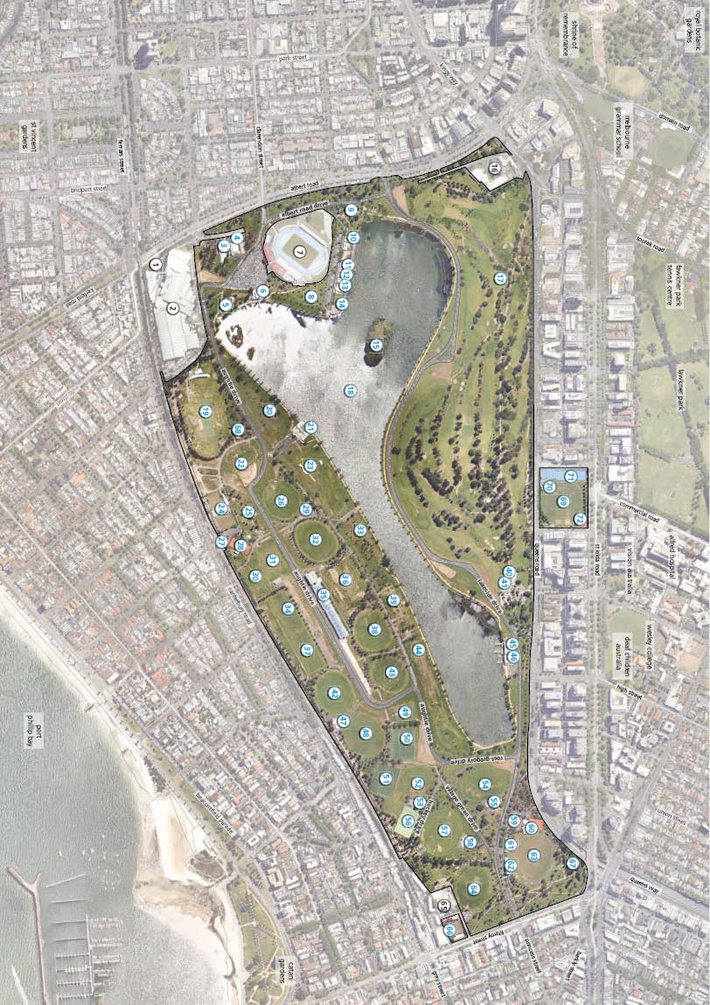
Appendix D: Existing conditions

