Point Nepean National Park
  - Visitor Guide
Point Nepean is one of Victoria’s most beautiful coastal landscapes. During its rich history, it has played an important role in shaping the early settlement, quarantine and defence of Victoria. The park is located at the very tip of the Mornington Peninsula, with outstanding coastal scenery and panoramic views of Bass Strait, the Rip and Port Phillip. Explore the military forts and tunnels and the historic Quarantine Station, view the memorial where Prime Minister Harold Holt went missing and enjoy the natural environment.
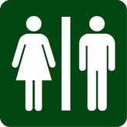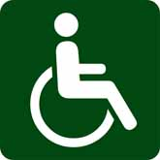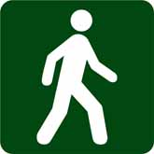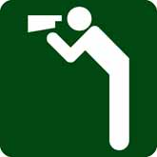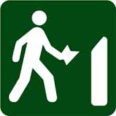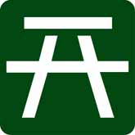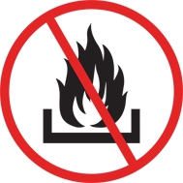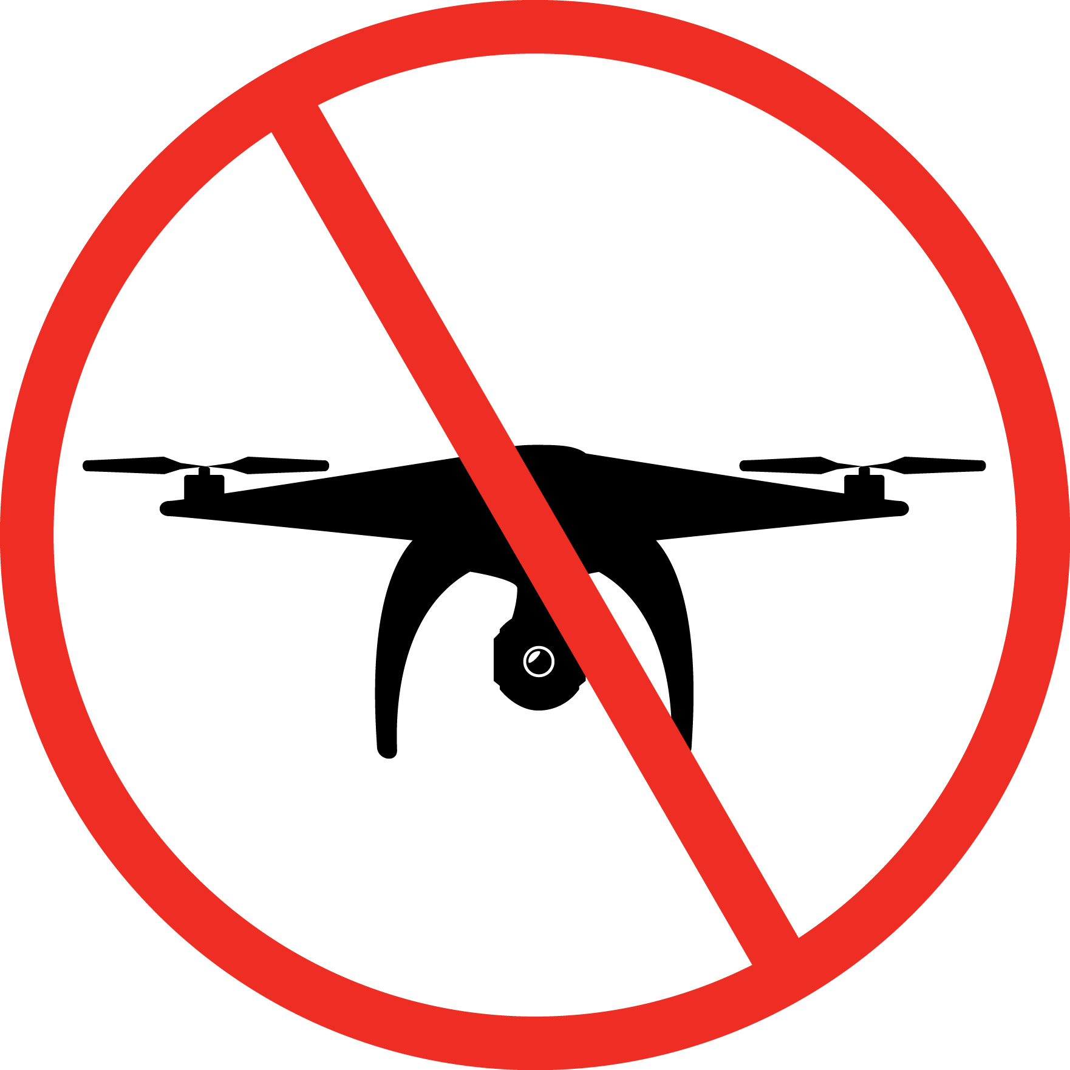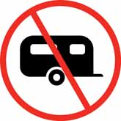

Opening hours
Point Nepean National Park is open daily. Vehicles, pedestrians and cyclists can enter or exit the park at any time. The Point Nepean Visitor Information Centre located in the Quarantine Station is open daily from 10am, except Christmas day.

Getting there

Point Nepean is located 90km from Melbourne. Visitors can take a train from Melbourne to Frankston and the 788 PT bus to Portsea, with thelast stop right at the park entrance. If driving, take the Eastern Freeway (M3) and Mornington Peninsula Freeway (M11). The Queenscliff to Sorrento passenger ferry operates on the hour from 7am to 6pm, catch the 788 PT bus from Sorrento .

Getting around the park
Visitors can park at the front entrance, Quarantine Station or at Gunners Cottage.
Cycling is a great way to discover this vast 560ha park. Visitors can bring their own bikes or hire bikes from local tourism operators. Cycling is permitted in the Quarantine Station (on roads, trails and grassed areas), along Defence Road to Fort Nepean and along Coles Track, which is a shared path. Helmets must be worn.
Bicycles cannot be taken into the Fort Nepean precinct, the Range Area, Wilsons Folly tracks or along the beach. There are bike racks at Fort Nepean, Fort Pearce, Cheviot Hill and the Quarantine Station. A lock is recommended when leaving your bike.
Two all-terrain beach wheelchairs (adult and youth size) and one standard wheelchair are available from the Information Centre, free of charge, for visitors who have mobility issues. Please phone to book the wheelchairs or visit the Information Centre on the day to arrange use.
A hop on, hop off shuttle bus service operates from 10.30am to 4.00pm daily (extended hours in daylight savings), except Christmas day. The bus can accommodate standard wheelchair access however some large, motorised wheelchairs and the adult sized all-terrain beach wheelchair cannot be taken on the bus. The bus timetable is available from the Information Centre, at designated stops and online. Tickets are purchased from the driver using cash or credit card. Ticket fares are available for adults and child / concession and are all day passes, there are no one-way fares. Group bookings can be arranged by calling (03) 5986 5666 or email rosebudcharter@venturabus.com.au.
Quarantine Station to Fort Nepean is 4.5km via the most direct road route and takes approximately 1.15hrs to walk (one way).

Things to see and do
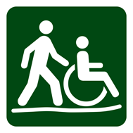 | Quarantine Station – 1km, 30 minutes – 2 hours
Discover almost 50 heritage listed buildings and artefacts spanning over 150 years. The Quarantine Station was established in 1852. From 1952 the buildings housed the Army Officer Cadet School and later the School of Army Health. Take the 700m coastal track from the Parade Ground to connect to the Bay Trail (Portsea to Rosebud) via Police Point Shire Park.
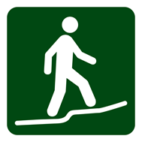 | Wilsons Folly Track – 1.7km, 40 minutes one way
This track links London Bridge in Mornington Peninsula National Park with Point Nepean. It is an extension of the longer Coastal Walk from Cape Schanck (part of the 100km Mornington Peninsula Walk circuit) and passes through Coastal Banksia stands, Moonah woodland and native grasslands.
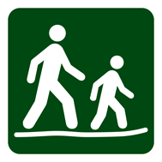 | Bay Beach Walk – 2.8km, 1 hour one way
This walk along the bay beach can be accessed at Quarantine Station and Observatory Point, via Coles Track. Remnants of the former quarantine cattle jetty still exist at Observatory Point and is an ideal location to view Port Phillip.

Range Area Walk – 1.8km, 45 minutes one way
This walk meanders through coastal scrub and a former army Rifle Range. Climb the Monash Light tower stairs and take in sweeping views of the entire national park and coastline. The Range was used to train army cadets to use firearms. The walk links the Quarantine Station with Cheviot Hill and provides access to the Happy Valley Track.

Gunners Cottage and Walter Pisterman Heritage Walk – 1km, 45 minutes return
Gunners Cottage is the original Master Gunners house. Explore burials of shipwreck victims in the nearby Point Nepean Cemetery. The Walter Pisterman Heritage Walk links to the bay and Observatory Point picnic area. Portable gas barbecues cannot be used in this area, no drinking water is available beyond the Quarantine Station.

Cheviot Hill and Harold Holt Memorial

– 750m, 30 minutes
Cheviot Hill is the park’s highest point. With its World War II fortifications, it overlooks Cheviot Beach, the site where former Australian Prime Minister Harold Holt disappeared in 1967. The Happy Valley loop track starts here.

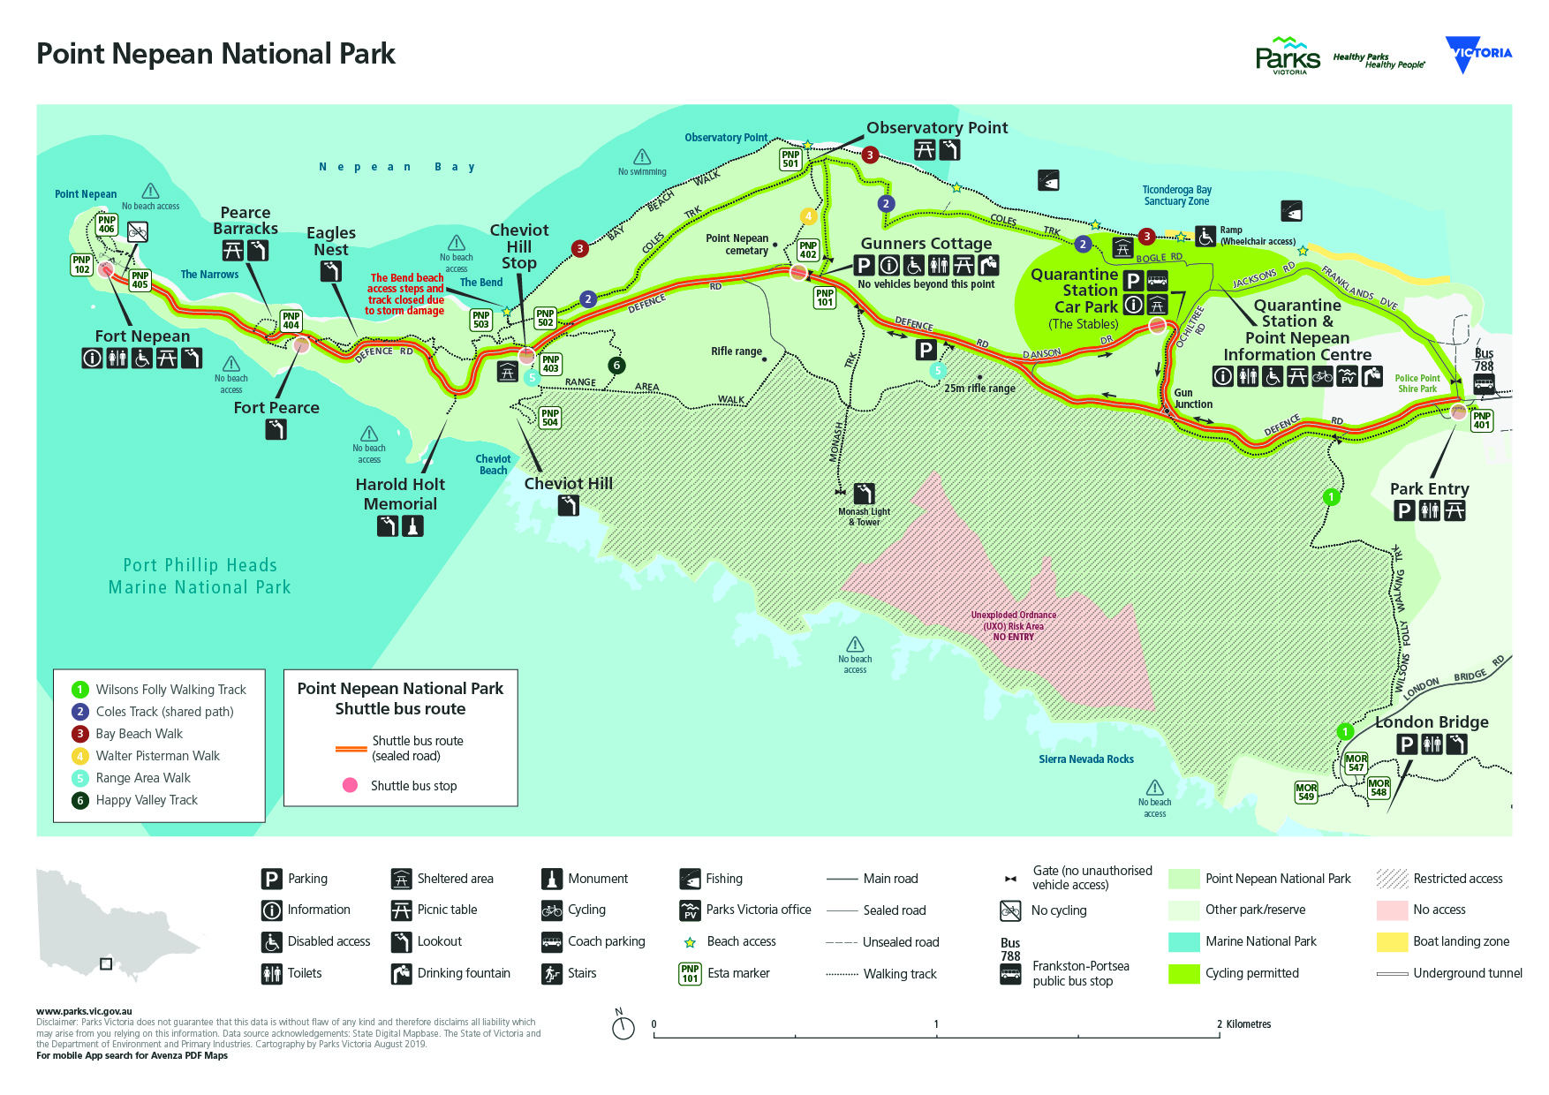
Campground (Discovery Tents)
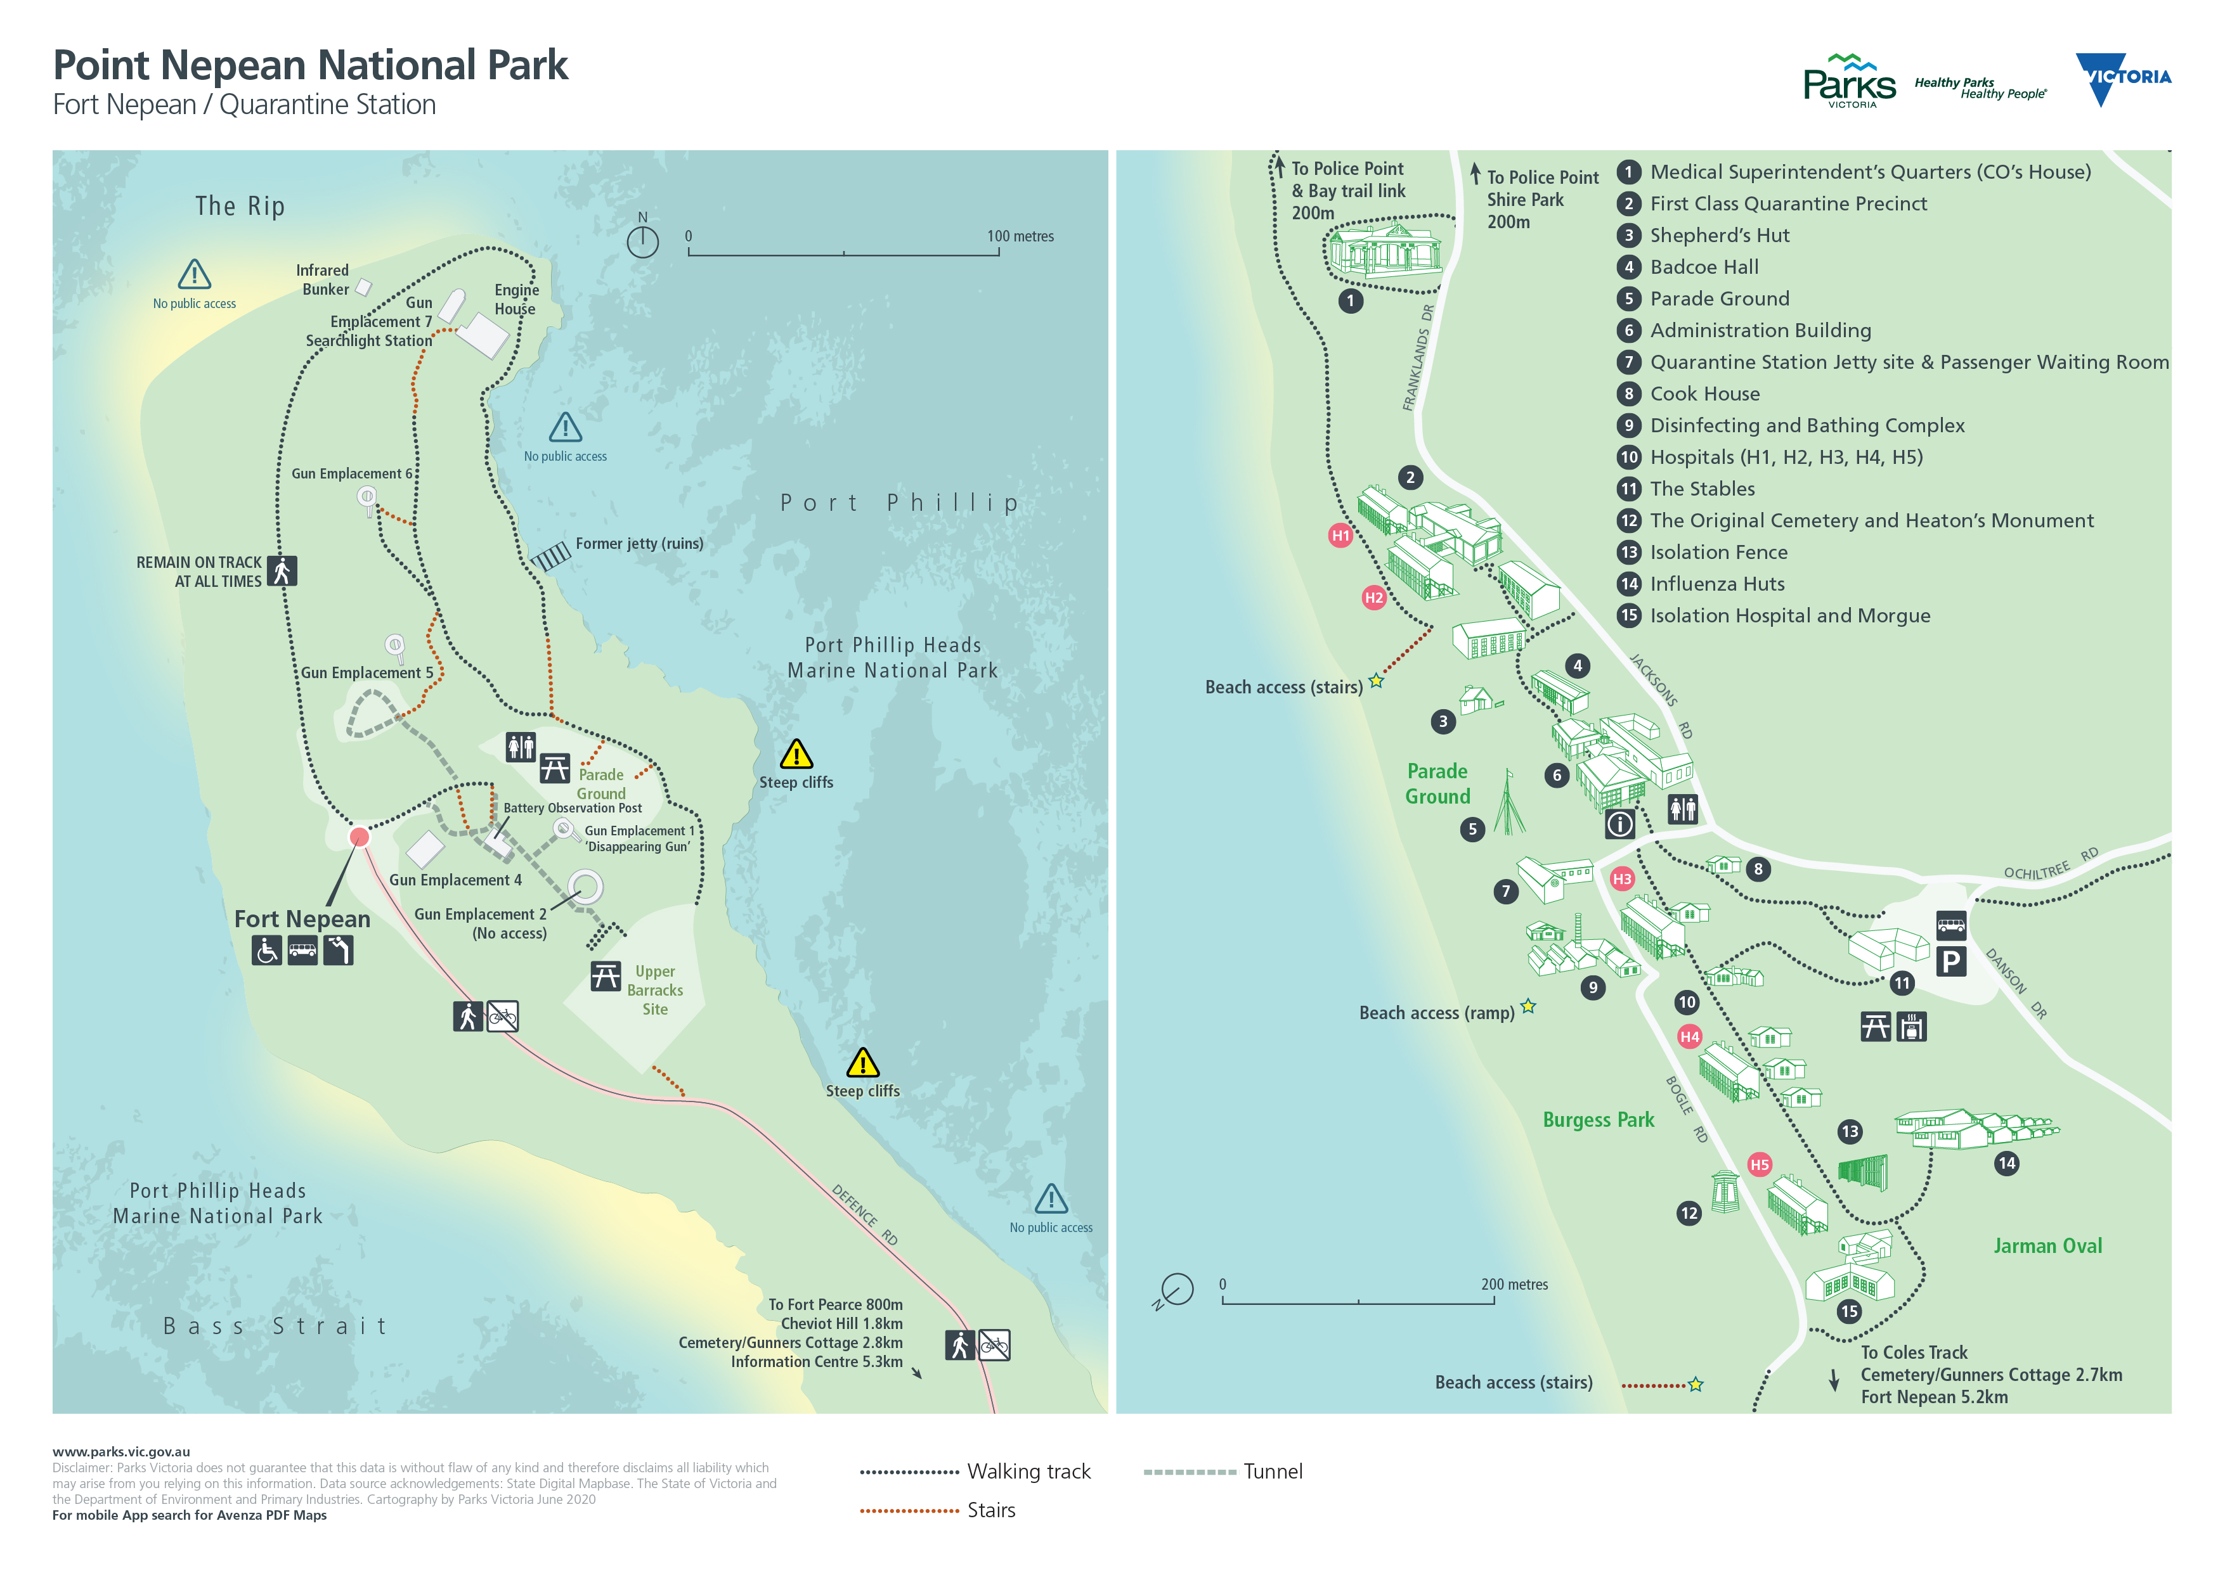
Campground (Discovery Tents)

Pearce Barracks, Fort Pearce and Eagles Nest

– 800m, 45 minutes
Fort Pearce was established in 1911 and designed to take advantage of the 6-inch Mark VII guns being introduced to coastal defence at that time. The Pearce Barracks site is where many of the army personnel stationed at Point Nepean lived. Eagles Nest was the site of Australia’s largest Disappearing Gun. Explore the fortifications and lookouts with stunning views of Bass Strait and Port Phillip.

Fort Nepean – 1km, 1 -2 hours
Located at the very end of the peninsula, Fort Nepean enables visitors to discover a series of military fortifications dating back to the 1880s, where you can explore tunnels, forts and gun emplacements.
Port Phillip was one of the most heavily defended harbours in Australia. The first shot of the British Empire in WWI and the first Australian shot of WWII were fired from Gun Emplacement 6, earning a unique place in Australian military history.

Self-guided tours
Audio tours offering an insight into the history and cultural significance of the park are available on iPod’s with headphones for daily loan (at no cost) from the Information Centre. Self-guided brochures are also available in the park for the Quarantine Station and forts area.

Mornington Peninsula Walk – 100km, 1 - 2 days

The Mornington Peninsula Walk can be completed in sections or as an approximately 100km continuous circuit around the perimeter of Southern Peninsula linking Point Nepean with the Bay Trail, Coastal Walk and the Two Bays Walking Track.

Visitor facilities and campground
The Information Centre is located in the Quarantine Station, an easy 180m walk from the main car park.
An undercover BBQ and picnic shelter is available at the Quarantine Station Car Park. Picnic facilities are also provided at the Parade Ground, front entrance car park, Observatory Point and Fort Nepean. There are no café facilities. Drinking water is only available at the front entrance and at the Quarantine Station precinct.

Discovery Tents
Located within the historic Quarantine Station precinct, the pre-pitched Discovery Tents offer a unique opportunity to camp under canvas within an idyllic coastal environment.
Pre bookings are essential https://bookings.parks.vic.gov.au/point-nepean-discovery-tents#/accom/142540
Campervans, caravans, camper trailers, vehicle rooftop tents and BYO tents are not permitted in the national park. Nearby bayside foreshore reserves and towns host a wide range of caravan, camping and roofed accommodation options.

Flora, fauna and marine life
The remnant flora and fauna of Point Nepean is of very high significance. A remote and protected location, it is home to many native animals including the White-footed Dunnart, Long-nosed Bandicoot, Black Wallaby, Echidna, Singing Honeyeater and Hooded Plover. The park comprises a large intact area of remnant coastal vegetation. Native plants and vegetation communities include Coastal Moonah Woodland, Coastal Dune Scrub, remnant grasslands and threatened orchids.
Surrounding Point Nepean is Port Phillip Heads Marine National Park showcasing a great diversity and abundance of marine flora and fauna. It provides habitat for a variety of fish and shellfish, migratory shorebirds, marine invertebrates, features dramatic underwater gorges, colourful sponge gardens, tall kelp forests and sea-grass beds.

History

Aboriginal history
Point Nepean is part of Bunurong Country. The people of the Kulin nation lived on and around this land for over 35,000 years. The interaction with settlers and ceremony make it an important cultural place.

Early settlement
Point Nepean had some of the earliest European settlement in Victoria, including pastoral activities and lime burning. Shepherd’s Hut, located in the Quarantine Station, is one of the earliest intact limestone buildings in Victoria. Its cellar dates to 1845.

Quarantine
Established in 1852, the Quarantine Station was the place for new arrivals quarantine purposes in Victoria until 1979 and closed in 1980. In 1999, selected buildings were used to accommodate Kosovo refugees.

Defence
The entrance to Port Phillip was the most heavily fortified port in the Southern Hemisphere. Fort Nepean is considered to be one of the best examples in Australia of a major defence fort complex.

National park
After World War II, soldiers were removed from the forts and the buildings and fortifcations declared redundant. The area remained closed to the public and was used as an occasional firing range and army training ground until 1988 when, as part of the Bicentennial celebrations, control of the site was transferred to Victoria, declared a national park and progressively opened to the public.

Caring for the park and visitor safety
Help us look after this park by remembering these guidelines
- Dogs, cats and other domestic animals are prohibited
- All plants, animals, historic artefacts and geological features
are protected - leave the park as you find it and keep to tracks
- Take all rubbish with you when you leave
- Do not feed or leave food where it is accessible to wildlife
- Fires are prohibited - portable gas barbecues may be used in the Quarantine Station
- Access to the surrounding ocean coastline and Marine National Park areas are prohibited for conservation and safety reasons
- Swimming at the bay beach is not advised due to strong currents
- Fishing is permitted from the Quarantine Station shoreline
- Boat landing only in designated areas at the Quarantine
Station
- Permits are required for organised tours, events, weddings, commercial photography, filming, remote controlled drones

Be prepared and stay safe
For emergency assistance call Triple Zero (000). If there is a green emergency marker sign near you, read the location information on the marker to the operator. Point Nepean National Park is in the Central fire district. Bushfire safety is a personal responsibility. Anyone entering parks and forests during the bushfire season needs to stay aware of forecast weather conditions. Check the Fire Danger Rating and for days of Total Fire Ban at emergency.vic.gov.au, on the VicEmergency smartphone app or call the VicEmergency Hotline on 1800 226 226. No fires may be lit on Total Fire Ban days.
On Catastrophic Fire Danger Rating days this park will be closed for public safety. Warnings signs may be erected, but do not expect a personal warning. Do not enter the prk. If you are already in the park, leave the night before or as early as possible in the morning.
Check the latest conditions before you visit at www.parks.vic.gov.au or call 13 1963.

